Microsoft Cloud Workshops

Modern Cloud Apps Lab Guide

February 2017

© 2017 Microsoft Corporation. All rights reserved. This document is confidential and proprietary to Microsoft. Internal use only. This document is for informational purposes only. MICROSOFT MAKES NO WARRANTIES, EXPRESS OR IMPLIED, IN THIS SUMMARY.

This document is provided "as-is." Information and views expressed in this document, including URL and other Internet Web site references, may change without notice. You bear the risk of using it.

Some examples are for illustration only and are fictitious. No real association is intended or inferred.

## Contents

Modern cloud apps hackathon 1

Modern cloud apps hackathon answers 32

# Modern cloud apps hackathon

## Overview

The Modern cloud apps Hackathon is a hands-on exercise that will challenge you to implement an end-to-end scenario using a supplied sample that is based on Microsoft Azure App Services and related services. The scenario will include implementing compute, storage, security, and scale using various components of Microsoft Azure. The Hackathon can be implemented on your own, but it is highly recommended to pair up with other members at the Hackathon to model a real world experience much closer and to allow each member to share their expertise for the overall solution.

## Requirements

* Microsoft Azure subscription
* Local machine or a virtual machine configured with:
  + Visual Studio 2015 Community Edition Update 3
  + Azure SDK 2.9.+ for Visual Studio
    - <http://go.microsoft.com/fwlink/?linkid=518003&clcid=0x409>

## Lab structure

This lab has two sets of instructions. The first is a high-level set of instructions that is designed for attendees that have previous experience with managing and building .NET web apps. The second is a traditional hands-on lab guide that is designed for attendees that do not.

## Exercise 1: Environment setup

In this exercise, you will set up your environment for use for the rest of the exercises. This will involve downloading the sample application and creating a Visual Studio Online Team Project.

### Task 1: Setup a Development Environment

If you do not have a machine setup with Visual Studio 2015 Community and Azure SDK 2.9 complete this task.

1. Create a virtual machine in Azure using the Visual Studio Community 2015 Update 3 and SDK 2.9 on Windows Server 2012 R2 image.

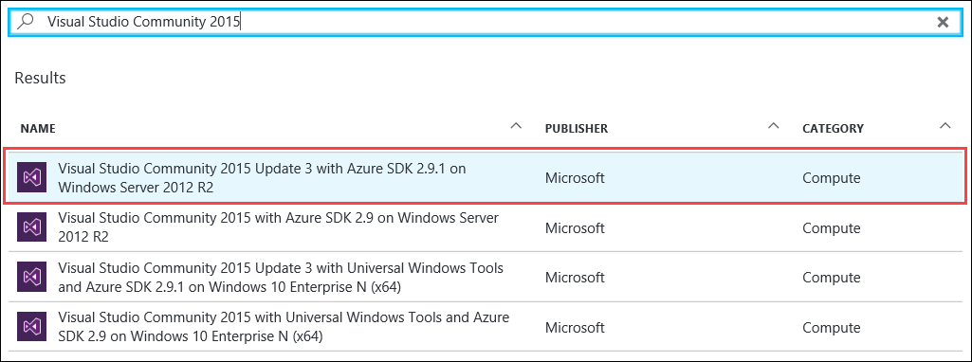

It is highly recommended to use a DS2 or D2 instance size for this VM.

### Task 2: Disable IE Enhanced Security

Note: Sometimes this image has IE ESC disabled, and sometimes it does not.

1. On the new VM you just created, click the **Server Manager** icon.



1. Click **Local Server**.

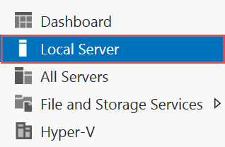

1. On the right side of the pane, click **On** by IE Enhanced Security Configuration.



1. Change to **Off** for Administrators and click **OK**.

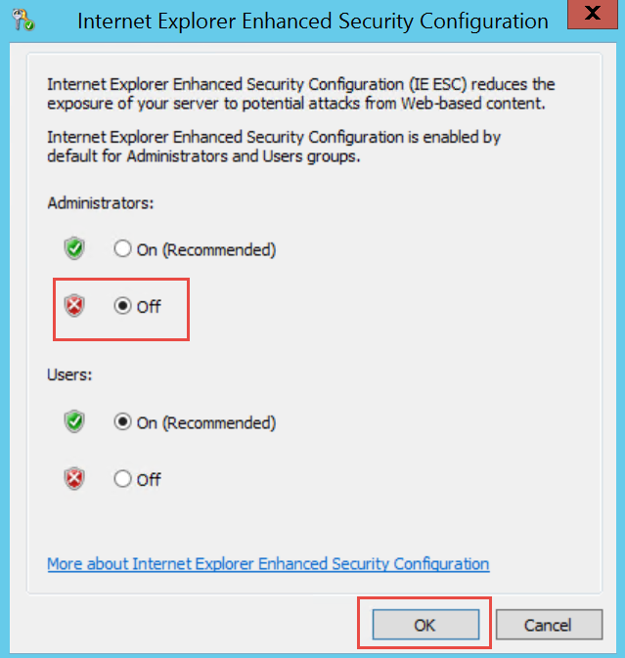

### Task 3: Install SQL Server Management Studio

1. On the new VM, download and install SQL Server Management Studio.  
   <https://msdn.microsoft.com/en-us/library/mt238290.aspx>

### Task 4: Validate Connectivity to Azure

1. From within the virtual machine, Launch Visual Studio 2015 and validate that you can login with your Microsoft Account when prompted.
2. Validate connectivity to your Azure subscription. Launch Visual Studio, open Server Explorer from the View menu, and ensure that you can connect to your Azure subscription.

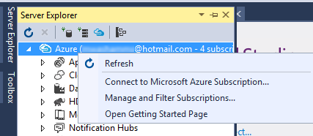

### Task 5: Download and explore the Contoso Sports League sample

1. Create a new folder on your C: drive named **Hackathon**.
2. Download the sample application from here: https://opsgilityweb.blob.core.windows.net/cebootcamp-feb-2017/Modern%20Cloud%20App%20Hackathon%20-%20Strudent%20Files.zip and extract to the **Hackathon** folder.

Note: The link above is case sensitive.

1. From the **Contoso Sports League** folder under **Hackathon**, open the Visual Studio Solution file: **Contoso.Apps.SportsLeague.sln**.
2. The solution contains the following projects:

|  |  |
| --- | --- |
| Contoso.Apps.SportsLeague.Web | Contoso Sports League e-commerce application |
| Contoso.Apps.SportsLeague.Admin | Contoso Sports League call center admin application |
| Contoso.Apps.SportsLeague.WorkerRole | Handles receipt generation for orders |
| Contoso.Apps.SportsLeague.Data | Data tier |
| Contoso.Apps.SportsLeague.Offers | API for returning list of available products |
| Contoso.Apps.PaymentGateway | API for payment processing |

### Task 6: Create a new Azure Resource Group

1. Within the Azure Management Portal, open the **Resource groups** tile and click **Add**.

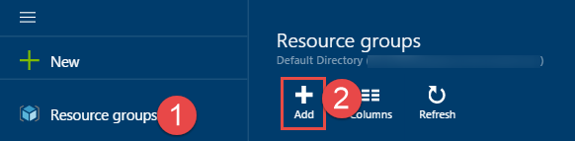

1. Specify the name of the resource group as **contososports**, and choose the Azure region you want to deploy the lab to. This resource group will be used throughout the rest of the lab. Click **Create** to create the resource group.

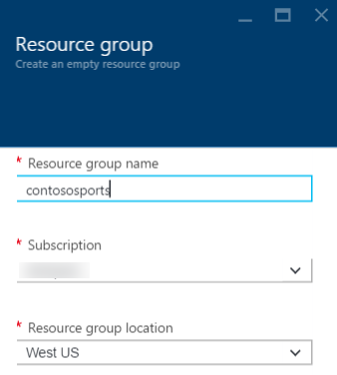

## Exercise 2: Proof of concept deployment

Contoso has asked you to create a proof of concept deployment in Microsoft Azure by deploying the web, database, and API applications for the solution and then validating that the core functionality of the solution works. Ensure all resources use the same resource group that was created in the beginning of the lab.

### Help references

|  |  |
| --- | --- |
| SQL firewall | https://azure.microsoft.com/en-us/documentation/articles/sql-database-configure-firewall-settings/ |
| Deploying a web app | https://azure.microsoft.com/en-us/documentation/articles/web-sites-deploy/ |
| Deploying an API app | https://azure.microsoft.com/en-us/documentation/articles/app-service-dotnet-deploy-api-app/ |
| Accessing an API app from a JavaScript client | https://azure.microsoft.com/en-us/documentation/articles/app-service-api-javascript-client/ |

### Task 1: Deploy the e-commerce website, SQL database, and storage

### Tasks to complete

* Create the resources in Microsoft Azure needed to deploy the e-commerce web app, database, and storage.
* Specify the configuration settings to connect to the resources in the e-commerce Web App’s Application Settings in Azure.
* Deploy the e-commerce application to Microsoft Azure.

### Exit criteria

* The web application should display locally. (Right-click the project and click **view in browser**.)
* The web application should display in Microsoft Azure by navigating to its [web app name]**.azurewebsites.net** URL.
* Click the **STORE** link to ensure that connectivity to the database is successful.

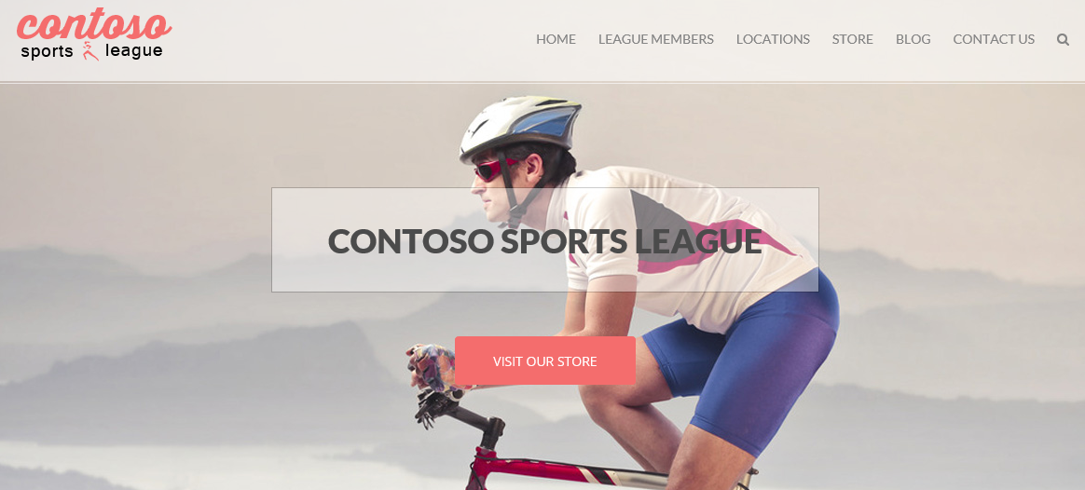

### Task 2: Setup SQL Database Geo-Replication

### Tasks to complete

* Configure Readable Geo-Replication for the SQL Database created in Task 1 by setting up a Secondary database in the other Azure Region in the pair.
* Force Failover to the Secondary database.
* Specify the connection string for the Secondary database in the e-commerce Web App’s Application Settings in Azure, and test the Web App.
* Revert the Failover test so the original database is Primary.

Manually forcing the Failover to the Secondary database is optional. The process of performing the Failover, testing it, and then reverting back to the Primary database can take up to 30 minutes to complete. If you have time, it is recommended that you complete these steps.

### Exit criteria

* The web application should display locally when connected to the Secondary database in the Failover test (Right-click the project and click **view in browser**.)
* Click the **STORE** link to ensure that connectivity to the Secondary database is successful.
* The web application should display locally when connected to the Primary database after the Failover test has been reverted.
* Click the **STORE** link to ensure that connectivity to the Primary database is successful.

### Task 3: Deploying the call center admin website

### Tasks to complete

* Create the resources in Microsoft Azure needs to deploy the call center admin website.
* Specify the configuration settings to connect to the resources in the call center admin Web App’s Application Settings in Azure.
* Deploy the call center admin website application to Microsoft Azure.

### Exit criteria

* The web application should display locally. (Right-click the project and click **view in browser**.)
* The web application should display in Microsoft Azure by navigating to its [web app name]**.azurewebsites.net** URL.

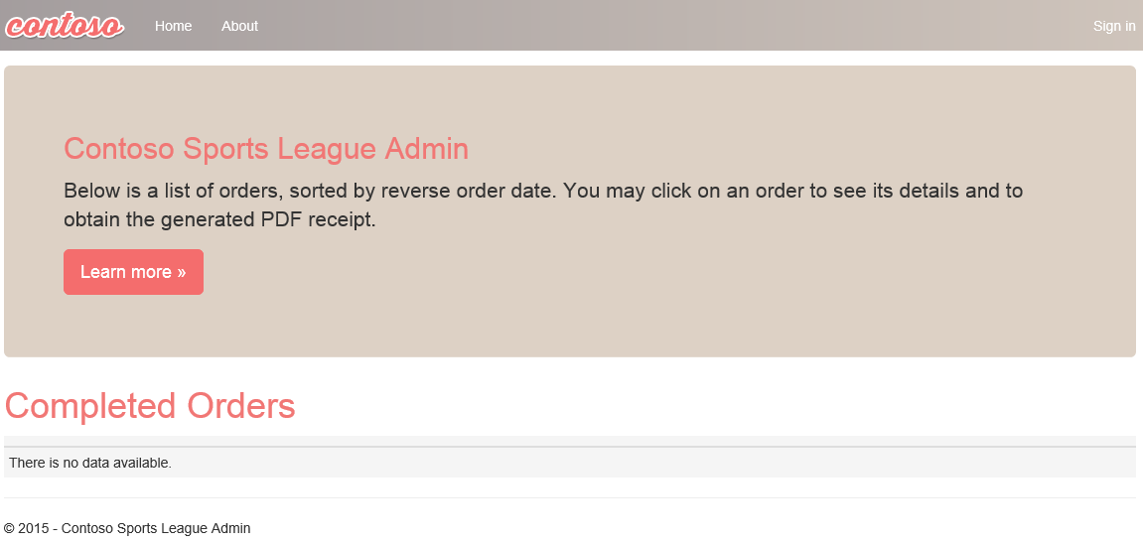

### Task 4: Deploying the payment gateway

### Tasks to complete

* Create the resources in Microsoft Azure and deploy the payment gateway API application.

### Exit criteria

* Please note the URL of the deployed API app for future reference.

### Task 5: Deploying the offers web API

### Tasks to complete

* Create the resources in Microsoft Azure and deploy the offers API application.
* Specify the configuration settings to connect to the created resources in the Web Apps Application Settings in Azure.

### Exit criteria

* Please note the URL of the deployed API app for future reference.

### Task 6: Update and deploy the e-commerce website

### Tasks to complete

* Update the e-commerce application to reference the new API applications.
* Deploy the updated e-commerce site to the Azure website.
* Verify the configuration by placing a test order on the e-commerce site and ensure the order appears on the admin site.

### Exit criteria

* The web application should display locally.
* The web application should display in Microsoft Azure by navigating to its [web app name]**.azurewebsites.net** URL.
* The home page should render a list of products with images underneath the Today’s Offers heading.
* The e-commerce application should render the products catalog without errors.
* A test order should be rendered in the call center admin application after being submitted through the e-commerce site.

## Exercise 3: Identity and security

The Contoso call center admin application will only be accessible by users of the Contoso Active Directory environment. You have been asked to create a new Azure AD Tenant and secure the application so only users from the tenant can log on.

### Help references

|  |  |
| --- | --- |
| What is Azure AD? | https://azure.microsoft.com/en-us/documentation/articles/active-directory-whatis/ |
| Azure Web Apps authentication | https://azure.microsoft.com/en-us/documentation/articles/active-directory-authentication-scenarios/ |
| View your access and usage reports | https://msdn.microsoft.com/en-us/library/azure/dn283934.aspx |
| Custom branding an Azure AD Tenant | https://msdn.microsoft.com/en-us/library/azure/Dn532270.aspx |

### Task 1: Provide the identity solution for the call center application

Note: Tasks 1, 2, and 4 are optional and require global admin permissions on the Azure AD Tenant. Task 3 is also optional, but does require the permission to create an app in the Azure AD tenant.

### Tasks to complete

1. Enable Azure AD Premium on your existing Azure AD Tenant
2. Create a new user in your Azure AD tenant
3. Enable Azure AD authentication with your existing Azure AD tenant on the call center admin web app and validate you can log in with the new user within that tenant.
4. Customize the branding by providing a banner and tile logo, a large illustration, and custom text, and then validate the branding is applied. The logo files can be found in the folder you extracted the starter files to.

### Exit criteria

* The call center application should only allow users that log in through the customized Azure AD form access to the application.
* The custom branding should be displayed on the logon page.

## Exercise 4: Load testing and monitoring

To validate the scalability of the application and to configure telemetry, you have been asked to configure Microsoft Azure Application Insights and perform a web load test using Visual Studio Online.

### Help references

|  |  |
| --- | --- |
| Run performance tests on your app | http://blogs.msdn.com/b/visualstudioalm/archive/2015/09/15/announcing-public-preview-for-performance-load-testing-of-azure-webapp.aspx |
| Application Insights Custom Events | https://azure.microsoft.com/en-us/documentation/articles/app-insights-api-custom-events-metrics/ |
| Enabling Application Insights | https://azure.microsoft.com/en-us/documentation/articles/app-insights-start-monitoring-app-health-usage/ |
| Detect failures | https://azure.microsoft.com/en-us/documentation/articles/app-insights-asp-net-exceptions/ |
| Monitor performance problems | https://azure.microsoft.com/en-us/documentation/articles/app-insights-web-monitor-performance/ |

### Task 1: Configure the application for telemetry

### Tasks to complete

* Configure a method to capture telemetry information for the application for the server and client side.
* Complete the implementation of the TrackException and TrackEvent method in Helpers\TelemetryHelper.cs.
* Republish the web application with telemetry enabled.

### Exit criteria

* Verify that when you browse to the website, the telemetry data appears.

### Task 2: Test the application

#### Tasks to complete

* Submit several test orders to verify that telemetry is capturing custom events.
* Simulate a load test of at least 250 users browsing the home page over a 5-minute time frame.

#### Exit criteria

* You should be able to view the average response time for the simulated load test.

### Task 3: Analyze the load test results

#### Tasks to complete

* Use the monitoring capabilities of your telemetry solution to identify failures from the test (if any).
* Use the monitoring capabilities of your telemetry solution to identify performance issues from the test.

#### Exit criteria

* The telemetry solution should show custom events captured by the application such as new orders.
* The telemetry solution should show performance numbers such as the number of sessions and average response time.

## Exercise 5: Automating backend processes

Contoso wants to automate the process of generating receipts in PDF format and alerting users when their orders have been processed.

### Help references

|  |  |
| --- | --- |
| Deploying WebJobs using Visual Studio | https://docs.microsoft.com/en-us/azure/app-service-web/websites-dotnet-deploy-webjobs |
| Creating a logic app | https://azure.microsoft.com/en-us/documentation/articles/app-service-logic-create-a-logic-app/ |
| Logic app connectors | https://azure.microsoft.com/en-us/documentation/articles/app-service-logic-connectors-list/ |

### Task 1: Enable receipt generation

#### Tasks to complete

* Configure and deploy Contoso’s existing receipt generation as a Web Job.
* Submit a test order and view receipt through the call center admin application.

#### Exit criteria

* Receipt should be downloadable from the call center application.

### Task 2: Order notifications

Note: Explicit instructions are given here due to the Logic App service being in constant change and in preview with limited documentation.

#### Subtask 1: Configure your Twilio trial account

1. If you do not have a Twilio account, sign up for one for free at the following URL:   
   [**https://www.twilio.com/try-twilio**](https://www.twilio.com/try-twilio).

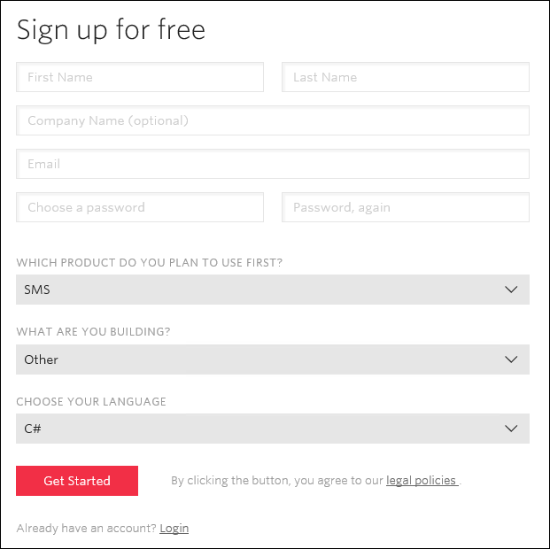

1. When you sign up for a free Twilio trial, you be asked to verify your personal phone number. This is an important security step that is mandatory for trying Twilio.  
   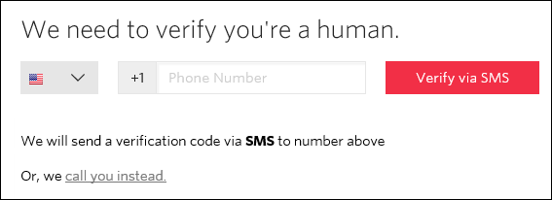
2. Click **All Products & Services**  
   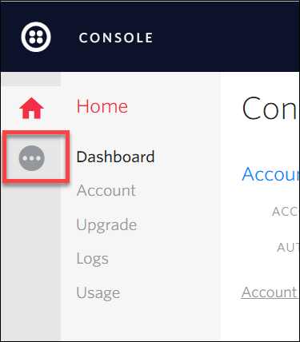
3. Click **Phone Numbers**.  
   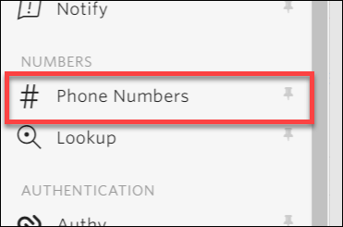
4. Click **Get Started**.  
   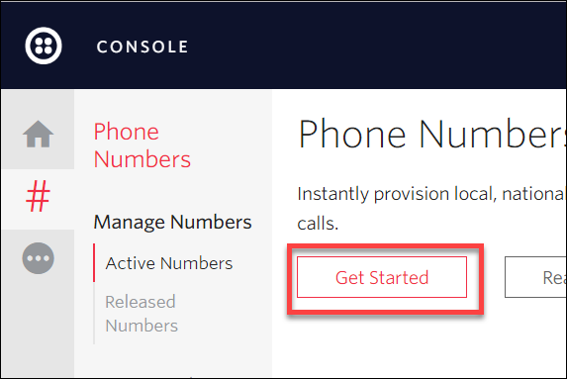
5. Click the **Get your first Twilio phone number** button.  
   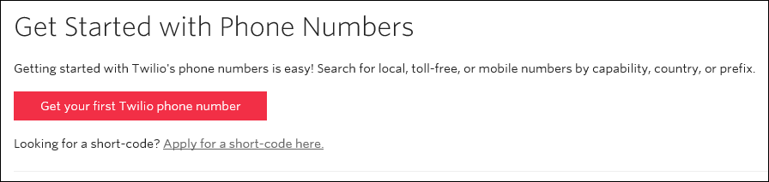
6. Record the **Phone Number**, then click the **Choose this Number** button on the Your first Twilio Phone Number prompt, and then click **Done**

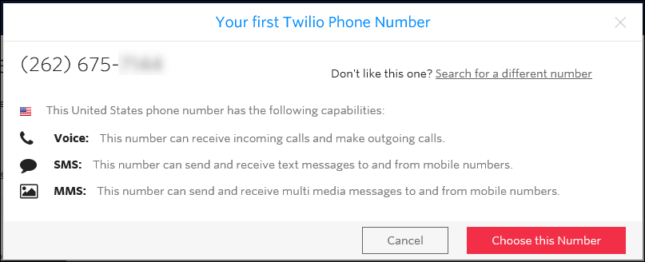

1. Click **Home**, and then record the **Account SID** and **Auth Token** for use when configuring the Twilio Connector.  
   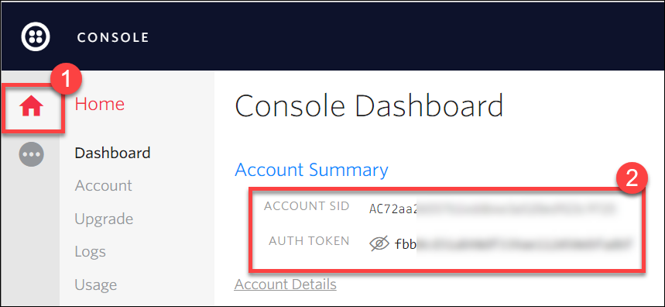

#### Subtask 2: Create a new logic app

1. Open **SQL Server Management Studio** and Connect to the SQL Database for the **ContosoSportsDB** database.  
   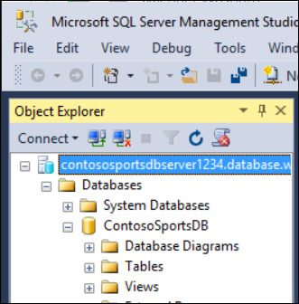
2. Under the **ContosoSportsDB** database, expand **Programmability**, right-click **Stored Procedures**, then click **New**, and **Stored Procedure…**  
   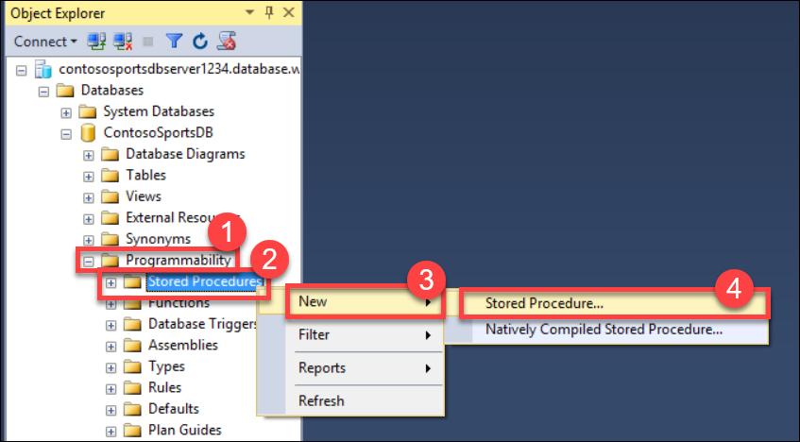
3. Replace the Stored Procedure Template code with the following:

CREATE PROCEDURE [dbo].[GetUnprocessedOrders]

AS

declare @returnCode int

SELECT @returnCode = COUNT(*) FROM [dbo].[Orders] WHERE PaymentTransactionId is not null AND PaymentTransactionId <> '' AND Phone is not null AND Phone <> '' AND SMSOptIn = '1' AND SMSStatus is null

return @returnCode

GO

1. Click **Execute** in the toolbar or press the **F5** key.  
   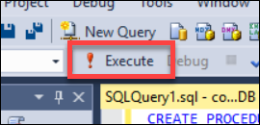
2. Delete the SQL script for the Stored Procedure from the code editor, and replace it with the following:

CREATE PROCEDURE [dbo].[ProcessOrders]

AS

SELECT * FROM [dbo].[Orders] WHERE PaymentTransactionId is not null AND PaymentTransactionId <> '' AND Phone is not null AND Phone <> '' AND SMSOptIn = '1' AND SMSStatus is null;

UPDATE [dbo].[Orders] SET SMSStatus = 'sent' WHERE PaymentTransactionId is not null AND PaymentTransactionId <> '' AND Phone is not null AND Phone <> '' AND SMSOptIn = '1' AND SMSStatus is null;

1. Click **Execute** in the toolbar or press the F5 key.  
   
2. Open the Azure Management Portal (<http://portal.azure.com>), click **+New**, then **Web + Mobile,** and then **Logic App.**

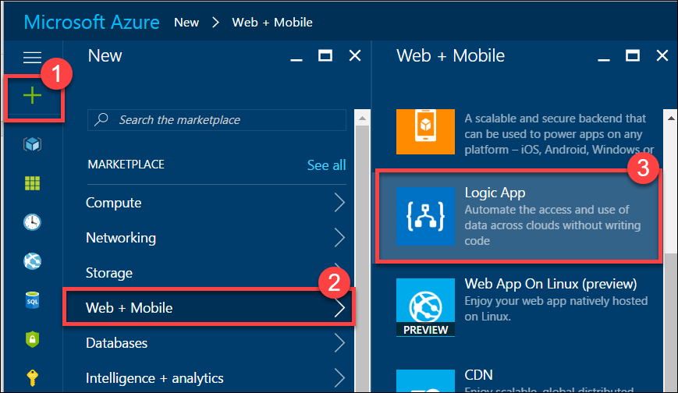

1. On the **Create logic app** blade, assign a value for **Name**, and set the **Resource Group** to **contososports**.

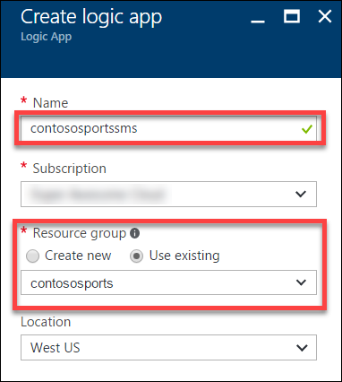

1. Open the Logic App by clicking **More services** > **Logic Apps**, and click the Logic App you just created.



1. Select the **Blank LogicApp** Template.  
   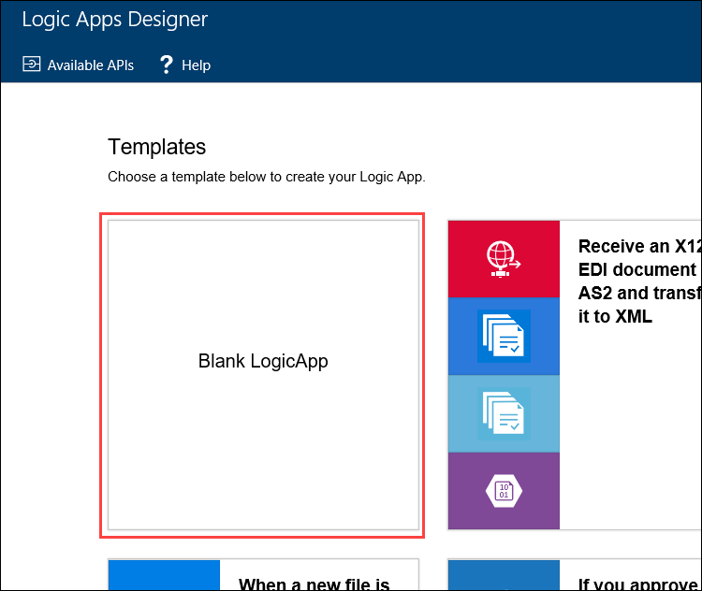
2. On the **Logic Apps Designer**, click **Recurrence**.

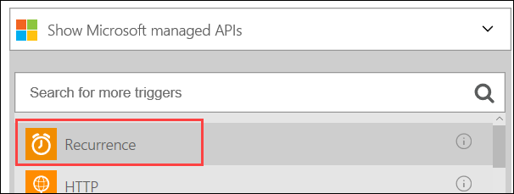

1. Set the **FREQUENCY** to **MINUTE**, and **INTERVAL** to 1.

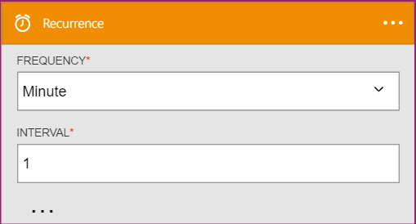

1. Click the **New Step**, and then click **Add an action**.

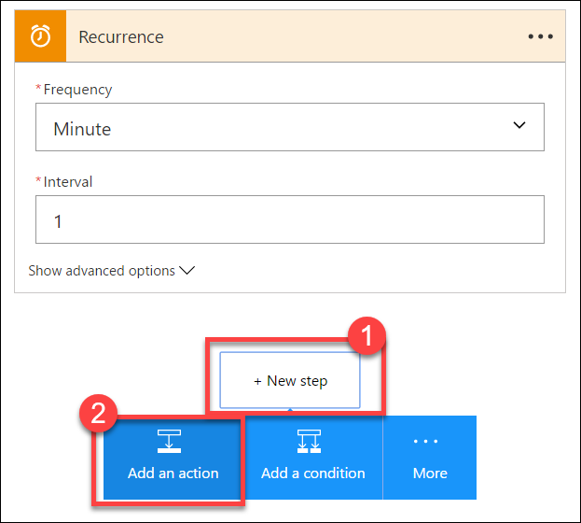

1. Type **SQL Server** into the filter box, and click the **SQL Server – Execute stored procedure** action.

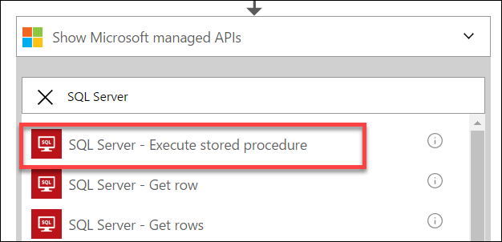

1. The first time you add a SQL action you will be prompted for the connection information. Name the connection **ContosoDB**, input the server and database details used earlier, and then click **Create**.   
   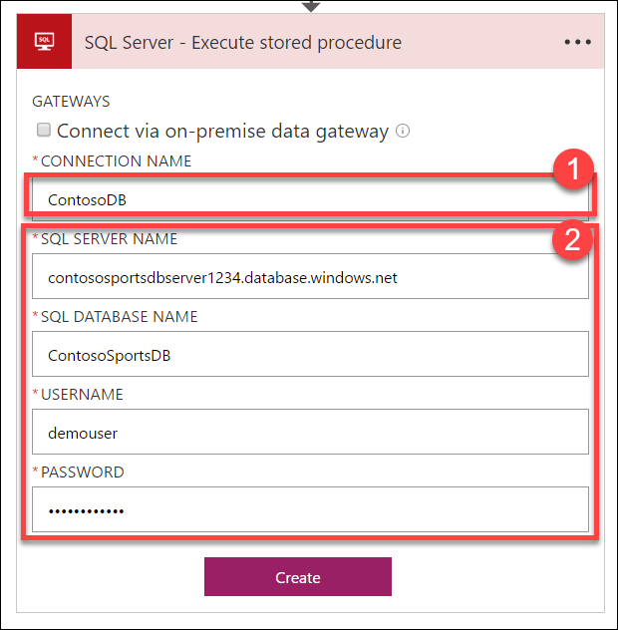
2. Select the **[dbo].[GetUnprocessedOrders]** stored procedure from the drop-down menu on the **Procedure Name** field.

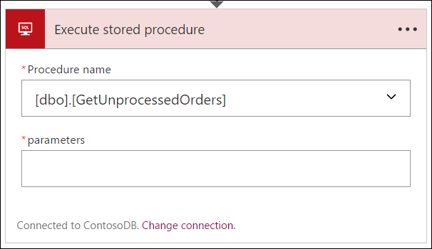

1. Click **New Step** and click the **Add a condition** link.

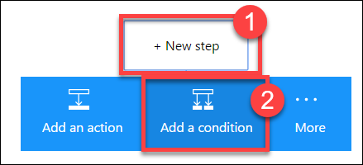

1. Specify **ReturnCode** for the OBJECT NAME, set the RELATIONSHIP to **is greater than**, and set the VALUE to **0**.

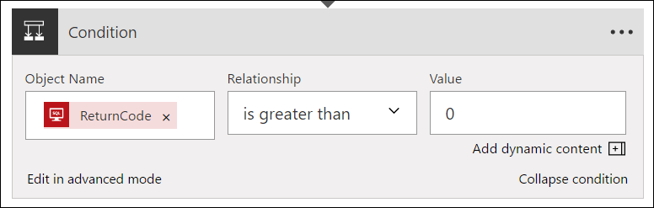

1. Click the **Add an action** link on the **If yes** condition.

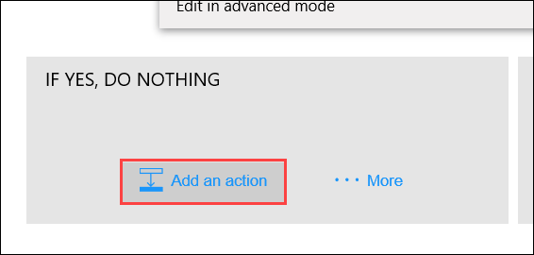

1. Type **SQL Server** into the filter box, then click the **SQL Server – Execute stored procedure** action.

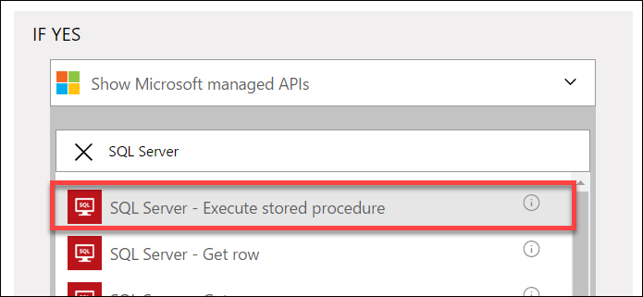

1. Select the **ProcessOrders** stored procedure in the Procedure name drop-down menu.

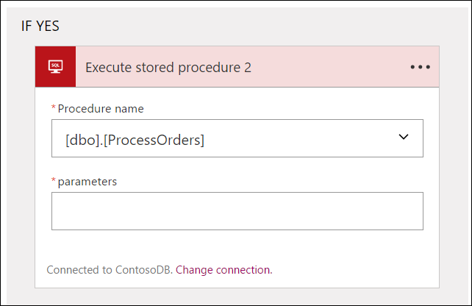

1. Click the **Add an action** link.

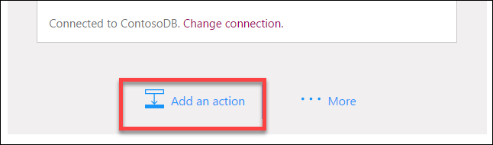

1. Type **Twilio** in the filter box, then click the **Twilio – Send Text Message (SMS)** connector.

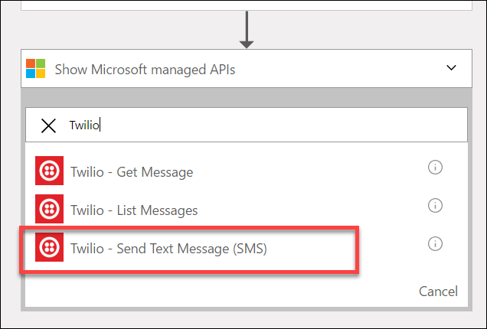

1. Set the **Connection Name** to **Twilio**, specify your Twilio **Account SID** and **Authentication Token**, and then click the **Create** button.

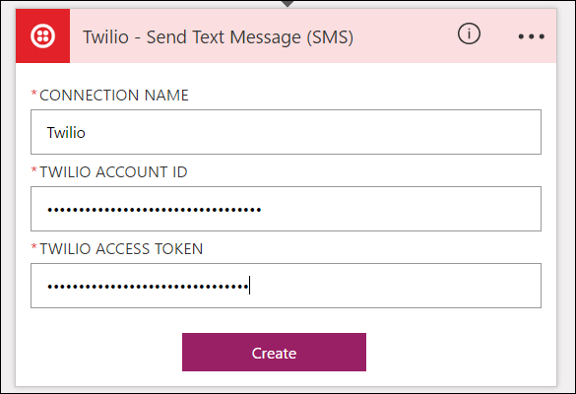

1. Using the drop-down menu, select your Twilio number for the **FROM PHONE NUMBER** field. Specify a placeholder phone number in the **TO PHONE NUMBER**, and a **TEXT** message.  
   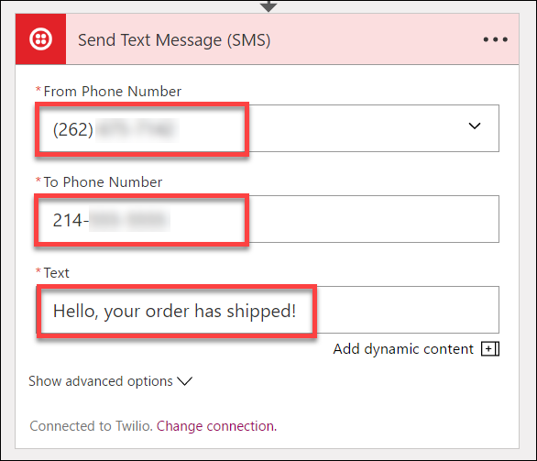
2. On the **Logic Apps Designer** toolbar, click the **Code View** button.

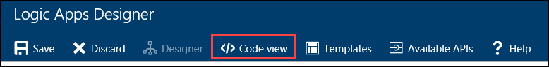

1. Find the **Send_Text_Message_(SMS)** action, then modify the body property of the Twilio action:

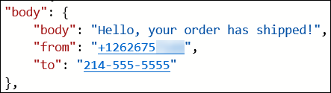

1. Add the following code between Hello and the comma.

**@{item()['FirstName']}**

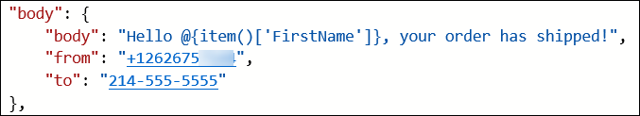

1. Modify the **to** property to pull the phone number from the item.

**@{item()['Phone']}**

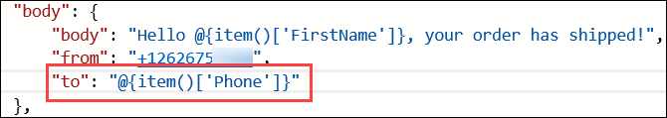

1. Immediately before the **Send_Text_Message_(SMS)** create a new line and add the following code:

"forEach_email": {

"type": "Foreach",

"foreach": "@body('Execute_stored_procedure_2')['ResultSets']['Table1']",

"actions": {

1. Remove the **runAfter** block from the **Send_Text_Message_(SMS)** action.  
   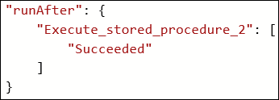
2. Locating the closing bracket of the **Send_Text_Message_(SMS)** action, then create a new line after it and add the following code:

},

"runAfter": {

"Execute_stored_procedure_2": [

"Succeeded"

]

}

}

1. After the code for the **Send_Text_Message_(SMS)** has been modified to be contained within the **forEach_email** action, it should look like the following:

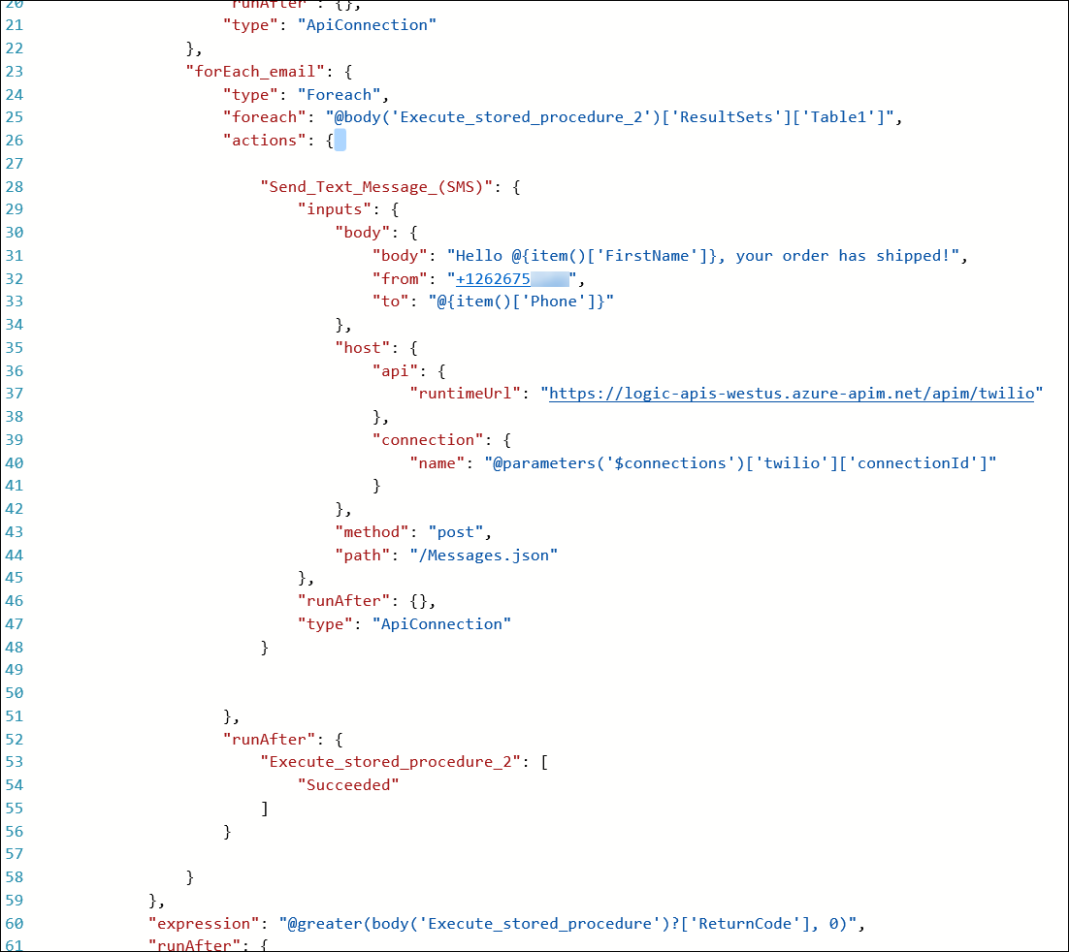

1. Click **Save** on the toolbar to enable the logic app.

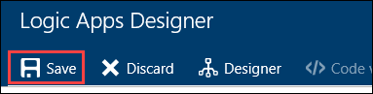

1. Your workflow should look like below, and you should receive a text for each order you have placed

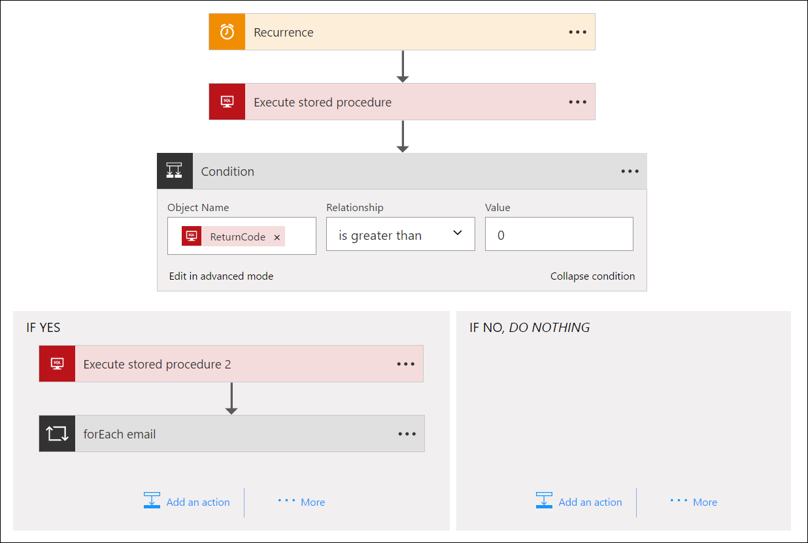

## Exercise 6: Create SQL Data Warehouse

Contoso wants to setup a SQL Data Warehouse in Microsoft Azure to enable data analytics capabilities.

### Help references

|  |  |
| --- | --- |
| Create an Azure SQL Data Warehouse | https://azure.microsoft.com/en-us/documentation/articles/sql-data-warehouse-get-started-provision/ |
| SQL Data Warehouse Migration Utility | https://azure.microsoft.com/en-us/documentation/articles/sql-data-warehouse-migrate-migration-utility/ |
| Introduction to Azure Data Factory Service | https://azure.microsoft.com/en-us/documentation/articles/data-factory-introduction/ |

### Task 1: Create SQL Data Warehouse

#### Tasks to complete

* Create the resources in Microsoft Azure for a SQL Data Warehouse
* Migrate the **Orders** and **OrderDetails** tables from the database into the SQL Data Warehouse using the Migration Utility

#### Exit criteria

* A SQL Data Warehouse has been provisioned in Microsoft Azure
* The **Orders** and **OrderDetails** tables schema and data has been migrated into the SQL Data Warehouse

### Task 2: Configure Azure Data Factory

#### Tasks to complete

* Create the resources in Microsoft Azure for a Data Factory
* Configure a **Copy data** Pipeline on the Azure Data Factory to continuously migrate data from the **Orders** and **OrderDetails** tables within the Azure SQL Database to the Azure SQL Data Warehouse.

#### Exit criteria

* The Data Factory Pipeline runs every 15 minutes to keep the SQL Data Warehouse **Orders** and **OrderDetails** tables continuously synchronized.

# Modern cloud apps hackathon answers

## Overview

This portion of the lab is designed to help *only* if you are blocked or do not have any experience with Azure developer tools or services.

## Exercise 1: Environment setup

In this exercise, you will set up an environment to use for the rest of the exercises.

### Task 1: Setup a Development Environment

If you do not have a machine setup with Visual Studio 2015 Community and Azure SDK 2.9 complete this task.

1. Create a virtual machine in Azure using the Visual Studio Community 2015 Update 3 and SDK 2.9 on Windows Server 2012 R2 image.



It is highly recommended to use a DS2 or D2 instance size for this VM

### Task 2: Disable IE Enhanced Security

Note: Sometimes this image has IE ESC disabled, and sometimes it does not.

1. On the new VM you just created, click the **Server Manager** icon.



1. Click **Local Server**.



1. On the right side of the pane, click **On** by IE Enhanced Security Configuration.



1. Change to **Off** for Administrators and click **OK**.



### Task 3: Install SQL Server Management Studio

1. On the new VM, download and install SQL Server Management Studio.  
   <https://msdn.microsoft.com/en-us/library/mt238290.aspx>

### Task 4: Validate Connectivity to Azure

1. From within the virtual machine, Launch Visual Studio 2015 and validate that you can login with your Microsoft Account when prompted.
2. Validate connectivity to your Azure subscription. Launch Visual Studio, open Server Explorer from the View menu, and ensure that you can connect to your Azure subscription.



### Task 5: Download and explore the Contoso Sports League sample

1. Create a new folder on your C: drive named **Hackathon**.
2. Download the sample application from here: https://opsgilityweb.blob.core.windows.net/cebootcamp-feb-2017/Modern%20Cloud%20App%20Hackathon%20-%20Strudent%20Files.zip and extract to the **Hackathon** folder.

Note: The link above is case sensitive.

1. From the **Contoso Sports League** folder under **Hackathon**, open the Visual Studio Solution file: **Contoso.Apps.SportsLeague.sln**.
2. The solution contains the following projects:

|  |  |
| --- | --- |
| Contoso.Apps.SportsLeague.Web | Contoso Sports League e-commerce application |
| Contoso.Apps.SportsLeague.Admin | Contoso Sports League call center admin application |
| Contoso.Apps.SportsLeague.WorkerRole | Handles receipt generation for orders |
| Contoso.Apps.SportsLeague.Data | Data tier |
| Contoso.Apps.SportsLeague.Offers | API for returning list of available products |
| Contoso.Apps.PaymentGateway | API for payment processing |

### Task 6: Create a new Azure Resource Group

1. Within the Azure Management Portal, open the **Resource groups** tile and click **Add**.

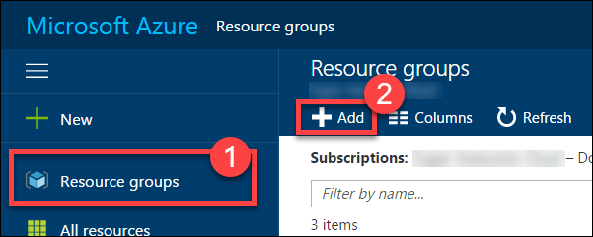

1. Specify the name of the resource group as **contososports**, and choose the Azure region you want to deploy the lab to. This resource group will be used throughout the rest of the lab. Click **Create** to create the resource group.

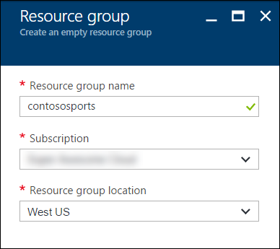

## Exercise 2: Proof of concept deployment

### Overview

Contoso has asked you to create a proof of concept deployment in Microsoft Azure by deploying the web, database, and API applications for the solution and then validating that the core functionality of the solution works. Ensure all resources use the same resource group that was created for the App Service Environment.

### Help references

|  |  |
| --- | --- |
| SQL firewall | https://azure.microsoft.com/en-us/documentation/articles/sql-database-configure-firewall-settings/ |
| Deploying a web app | https://azure.microsoft.com/en-us/documentation/articles/web-sites-deploy/ |
| Deploying an API app | https://azure.microsoft.com/en-us/documentation/articles/app-service-dotnet-deploy-api-app/ |
| Accessing an API app from a JavaScript client | https://azure.microsoft.com/en-us/documentation/articles/app-service-api-javascript-client/ |
| SQL Database Geo-Replication overview | https://azure.microsoft.com/en-us/documentation/articles/sql-database-geo-replication-overview/ |

### Task 1: Deploy the e-commerce website, SQL database, and storage

In this exercise, you will provision a website via the Azure Web App + SQL template using the Microsoft Azure Portal. You will then edit the necessary configuration files in the starter project and deploy the e-commerce website.

#### Subtask 1: Create the web app and SQL database instance

1. From the Azure Management portal <http://portal.azure.com>, using a new tab or instance, navigate to create **Web App + SQL**.
2. Click **New**, and in the Marketplace search text box enter **“Web App + S”**. Click the **Web App + SQL** item in the search results.

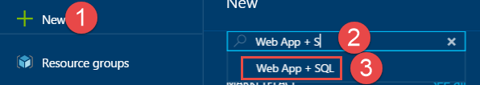

1. On the **Everything** blade select **Web App + SQL**.

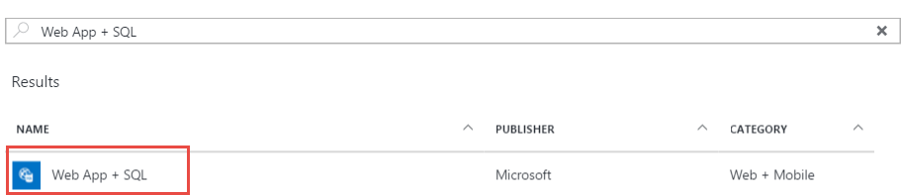

1. Check the box to pin to the dashboard, and then click **Create**.

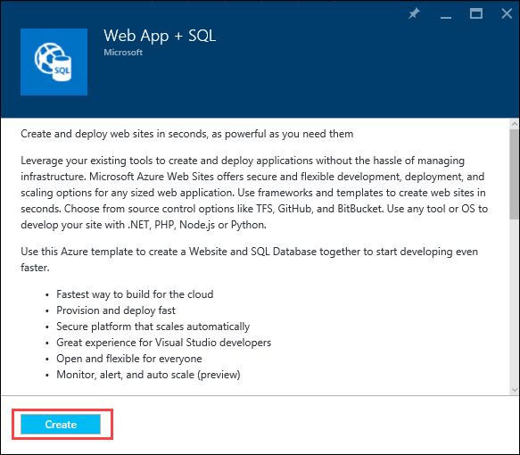

1. On the **Web App + SQL** blade select **App Service plan/Location, *Configure required settings***.

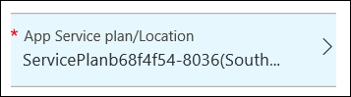

1. On the Web App blade specify the following configuration:
   1. Specify a unique and valid URL (until the green check mark appears)
   2. Specify the **contososports** resource group.
   3. Specify the name **ContosoSportsPlan** as the App Service plan and choose the same location as the Resource Group.

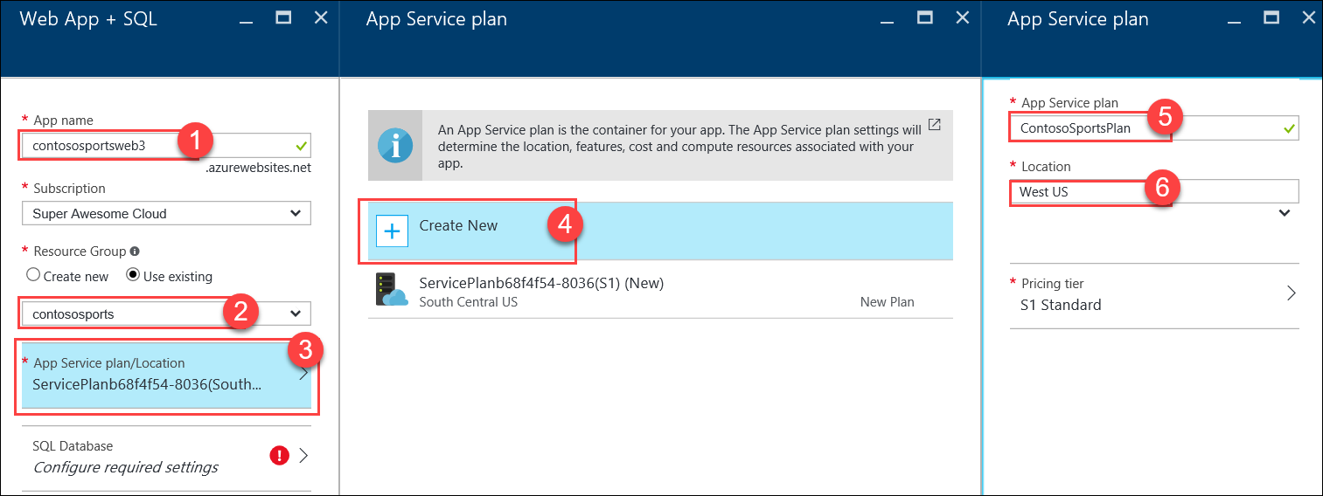

1. Click **OK** to save the configuration.

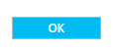

1. Select **SQL Database *Configure required settings***., then click **Create a new database**

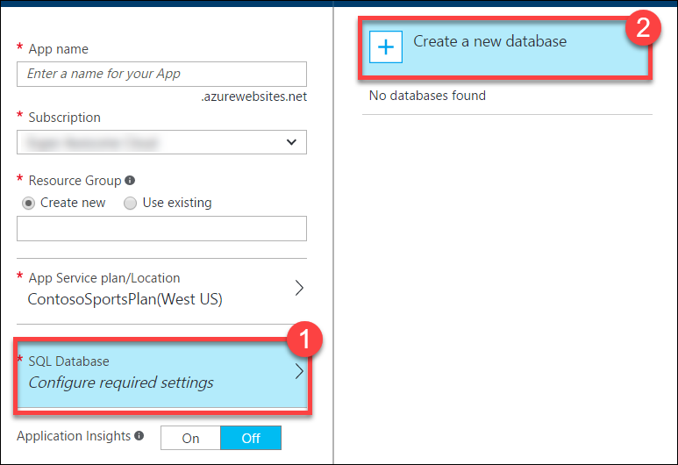

1. On the **SQL Database** blade, specify **ContosSportsDB** as the database name.

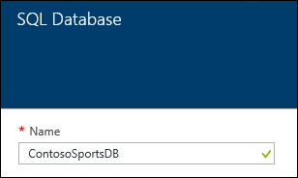

1. On the **SQL Database** blade, select **Target** **Server *Configure required settings***.

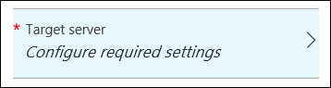

1. On the **New server** blade, specify the following configuration:
   1. Server name: a unique value (ensure the green checkmark appears)
   2. Server admin login: **demouser**
   3. **Password** and **Confirm Password**: demo@pass123
   4. Ensure the **Location** is the same region as the web app.

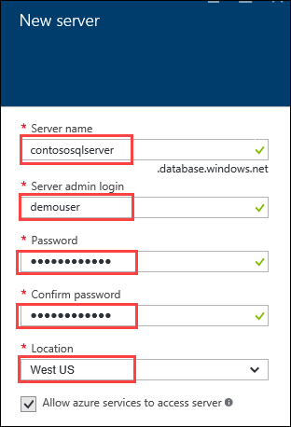

1. Once the values are accepted in the **New server** blade, click **Select**.



1. On the **SQL Database** blade, click **Select**.



1. After the values are accepted, click **Create**.



This may take a couple minutes to provision the Web App and SQL Database resources.

1. After the Web App and SQL Database are provisioned, click **More services**, **SQL databases**, and then click the name of the SQL Database you just created.

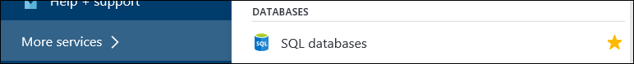

1. On the **SQL Database** blade, click the **Show database connection strings** link.

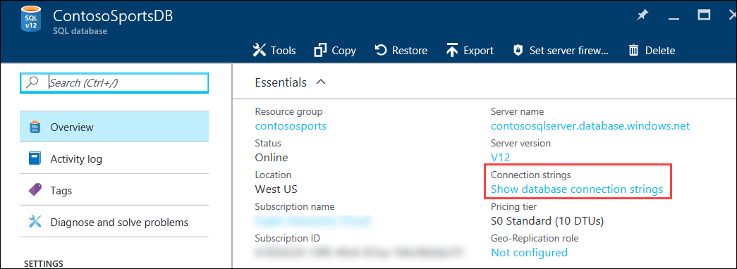

1. On the **Database connection strings** blade, select and copy the **ADO.NET** connection string, then save it in Notepad for use later.  
   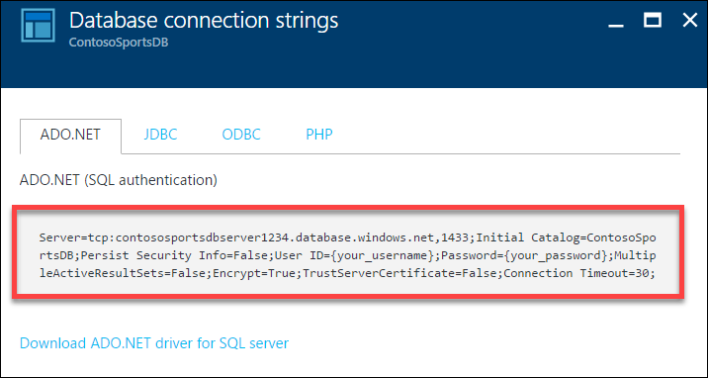
2. Click the SQL Database server name link.

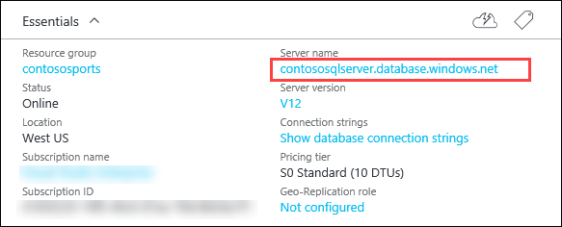

1. On the **SQL Server** blade under **Firewall**, click **Show firewall settings**.

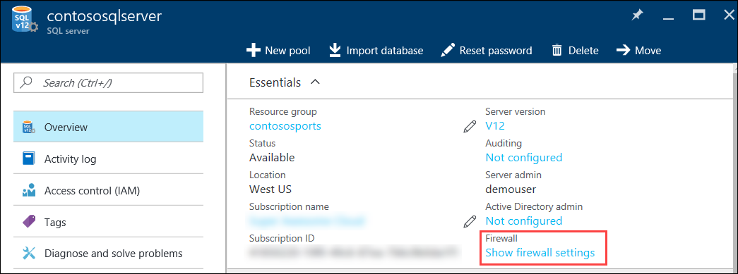

1. On the **Firewall Settings** blade, specify a new rule named **ALL**, with START IP **0.0.0.0**, and END IP **255.255.255.255**.

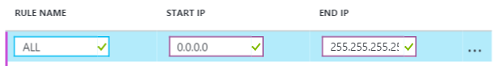

This is only done to make the lab easier to do. In Production, you do not want to open up your SQL Database to all IP Addresses this way. In Production, you will want to specify just the IP Addresses you wish to allow through the Firewall.

1. Click **Save**.

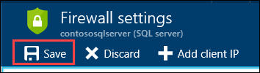

1. On the **Success!** dialog box click **OK**.

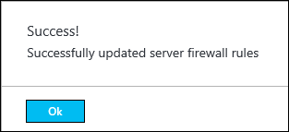

1. Close all configuration blades.

#### Subtask 2: Provision the storage account

1. Using a new tab or instance of your browser navigate to the Azure Management portal <http://portal.azure.com>.
2. Click **+New, Storage,** and **Storage account.**

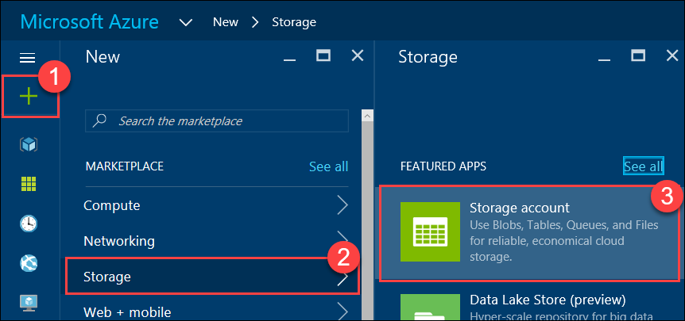

1. On the Create storage account blade specify the following configuration options:
   1. Name: unique value for the storage account (ensure the green check mark appears)
   2. Specify the Resource Group **contososports**
   3. Specify the same **Location** as the resource group.

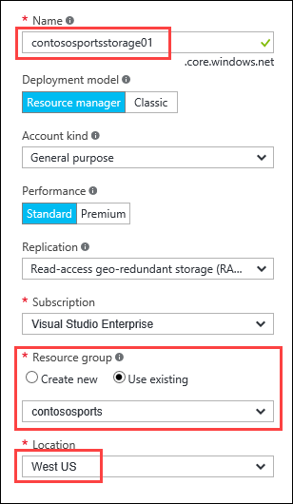

1. Click **Create**.

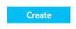

1. After the storage account has completed provisioning, open the storage account by clicking **More services** > **Storage accounts**, and then click the storage account name.

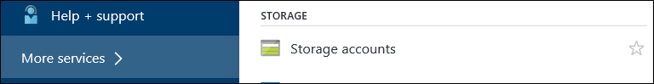

1. On the **Storage account** blade, click **All** **settings**.

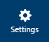

1. On the **Storage** account blade, scroll down to and select the **Access keys** option.

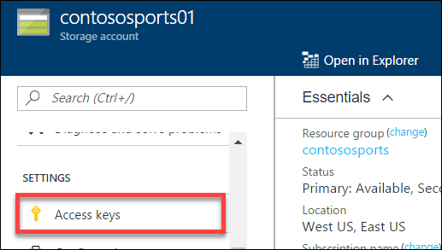

1. On the **Access keys** blade, click the ellipsis button by **key1**.

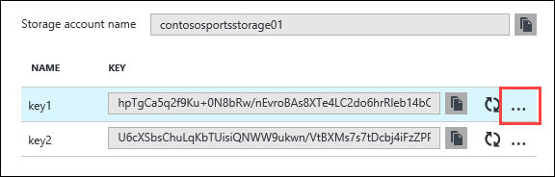

Then click **View Connection String**, and copy the value to the clipboard by selecting the value and pressing **CTRL-C**. Put the value in notepad for later reference.

#### Subtask 3: Update the configuration in the starter project

1. In the Azure Portal, click **Resource Groups**, and then click the **contososports** resource group.   
   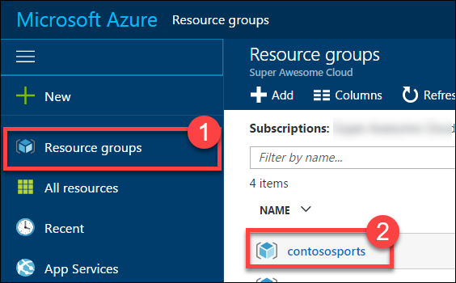
2. Click the **Web App** that was just created in a previous step.
3. On the **App Service** blade, scroll down in the left pane and click **Application settings**.  
   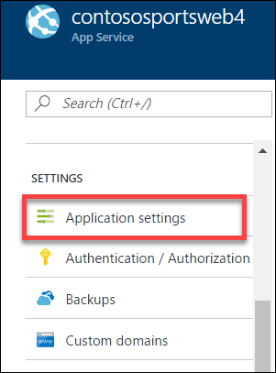
4. Scroll down and locate the **App settings** section.  
   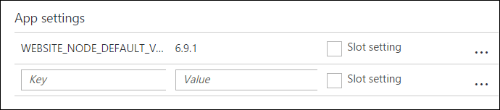
5. Add a new **App setting** with the following values:
   1. Key: **AzureQueueConnectionString**
   2. Value: **enter the Connection String for the Azure Account that was just created**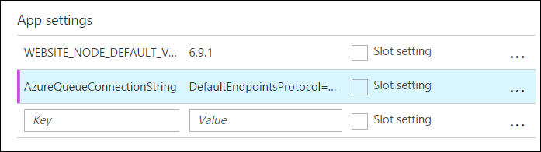
6. Locate **Connection Strings** below App settings.  
   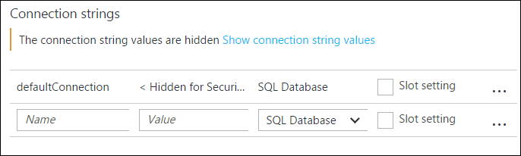
7. Add a new **Connection String** with the following values:
   1. Name: **ContosoSportsLeague**
   2. Value: **enter the Connection String for the SQL Database that was just created**
   3. Type: **SQL Database**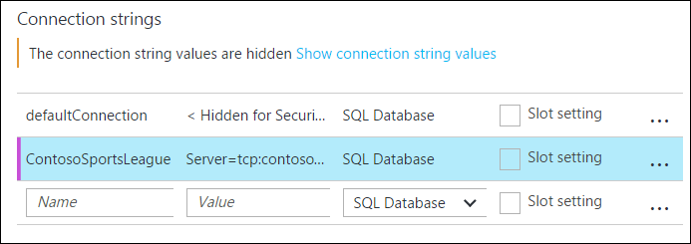

Ensure you replace the string placeholder values {your_username} {your_password_here} with the username and password respectively you setup during creation (demouser AND demo@pass123).



1. Click **Save**  
   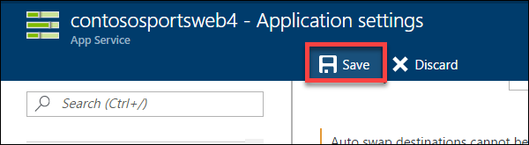

#### Subtask 4: Deploy the e-commerce web app from Visual Studio

1. Navigate to the **Contoso.Apps.SportsLeague.Web** project located in the **Web** folder using the **Solution Explorer** of Visual Studio.

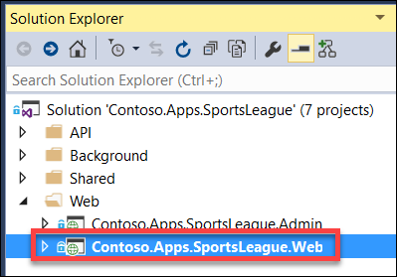

1. Right-click the **Contoso.Apps.SportsLeague.Web** project and click **Publish**.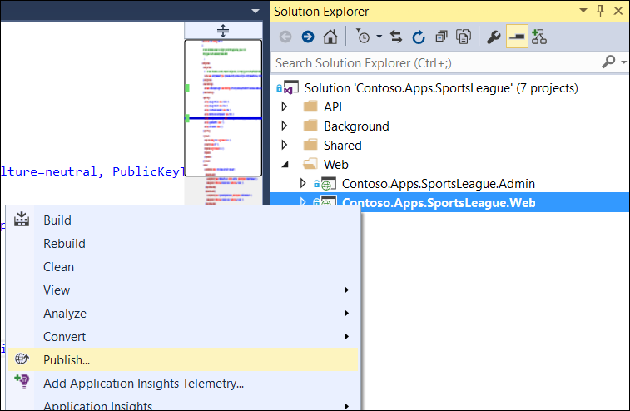  
   Choose **Microsoft Azure App Service** as the publish target.

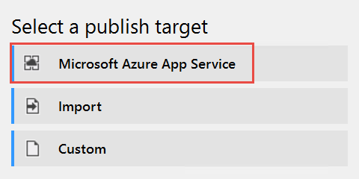

1. Log on with your credentials and ensure the subscription you published earlier is selected.

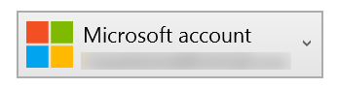

1. Select the Contoso Sports Web App.

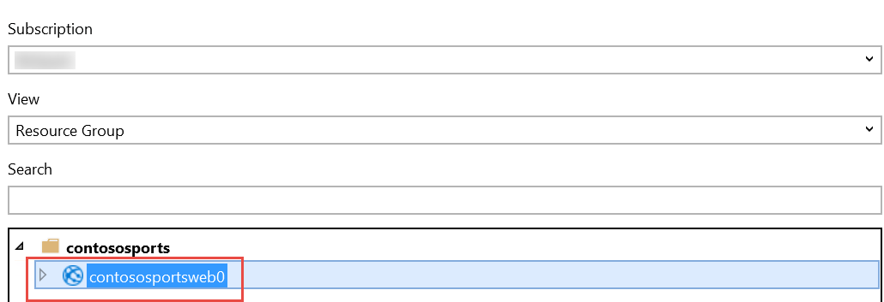

1. Click **OK**, and then click **Publish** to publish the web application.
2. In the Visual Studio **Output** view, you will see a status that indicates the web app was published successfully.

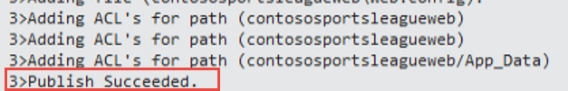

1. Validate the website by clicking the **Store** link on the menu. As long as products return, the connection to the database is successful.



### Task 2: Set up SQL Database Geo-Replication

In this exercise, the attendee will provision a secondary SQL Database and configure Geo-Replication using the Microsoft Azure Portal.

#### Subtask 1: Add secondary database

1. Using a new tab or instance of your browser navigate to the Azure Management Portal <http://portal.azure.com>
2. Click **More services,** then **SQL databases**, and then click the name of the SQL Database you created previously.  
   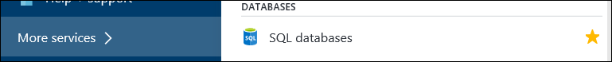
3. Under **Settings**, click **Geo-Replication**.  
   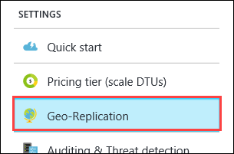
4. Select the Azure Region to place the Secondary within.  
   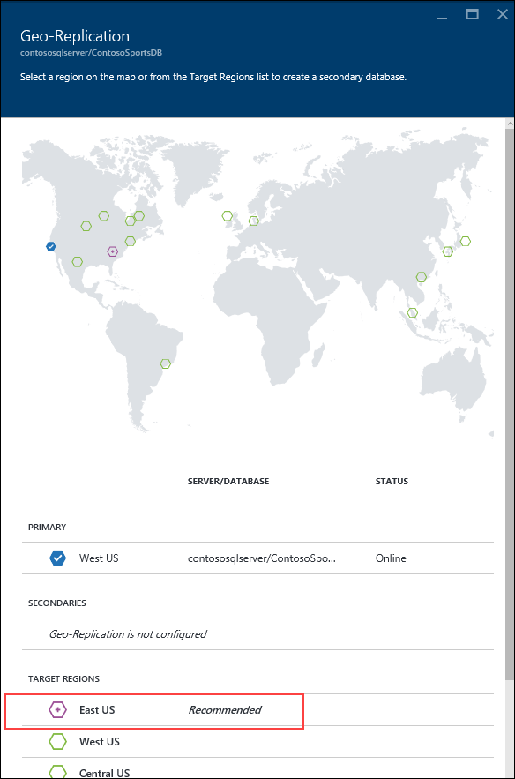

The Secondary Azure Region should be the Region Pair for the region the SQL Database is hosted in. The portal suggests the Region Pair to use by labeling it as “Recommended.”

1. On the **Create secondary** blade, select **Secondary Type** as **Readable**.
2. Select **Target server *Configure required settings***.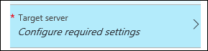
3. On the **New server** blade, specify the following configuration:
   1. Server name: a unique value (ensure the green checkmark appears)
   2. Server admin login: **demouser**
   3. Password and Confirm Password: **demo@pass123**

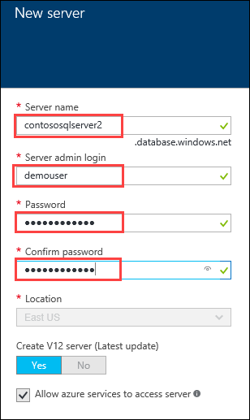

1. Once the values are accepted in the **New server** blade, click **Select**.  
   
2. On the **Create secondary** blade click **OK**.
3. After the Geo-Replication has finished provisioning, click **More services, SQL databases**.  
   
4. Click the name of the Secondary SQL Database you just created.  
   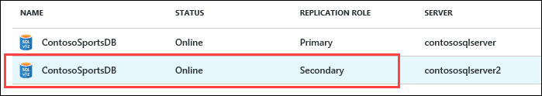
5. On the **SQL Database** blade, click the **Show database connection strings link**.  
   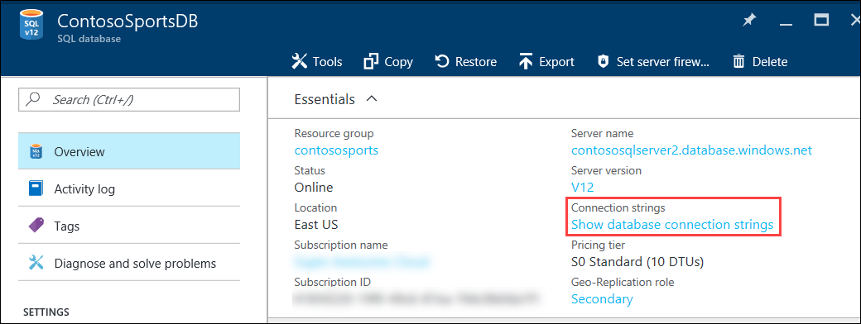
6. On the **Database connection strings** blade, select and copy the **ADO.NET** connection string, then save it in Notepad for use later.  
   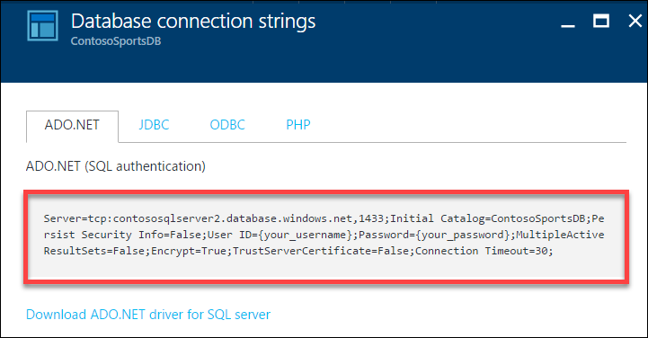  
   Click the SQL Database server name link.  
   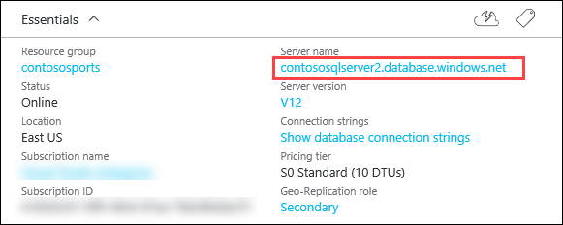
7. On the **SQL Server** blade, under **Firewall**, click **Show firewall settings**.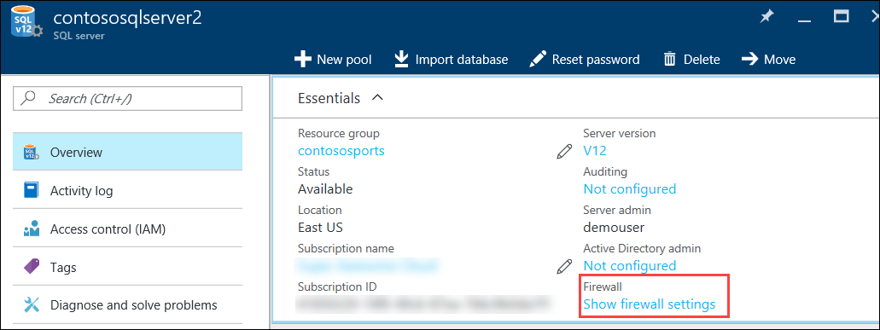
8. On the **Firewall Settings** blade, specify a new rule named **ALL**, with START IP **0.0.0.0**, and END IP **255.255.255.255**.  
   
9. Click **Save**.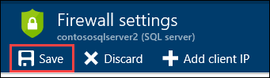
10. On the **Success!** dialog box click **OK**.  
    
11. Close all configuration blades.

#### Subtask 2: Failover secondary SQL database – OPTIONAL

Since the Replication and Failover process can take anywhere from 10 to 30 minutes to complete, you have the choice to skip Subtask 2 through 5, and skip directly to Task 3. However, if you have the time, it is recommended that you complete these steps.

1. Using a new tab or instance of your browser, navigate to the Azure Management Portal <http://portal.azure.com>.
2. Click **More services,** then **SQL databases**, and then click the name of the SQL Database you created previously.  
   
3. On the **Settings** blade, click **Geo-Replication**.  
   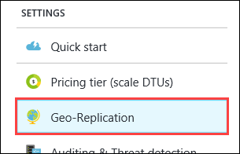
4. On the **Geo-Replication** blade, selectthe Secondary database.  
   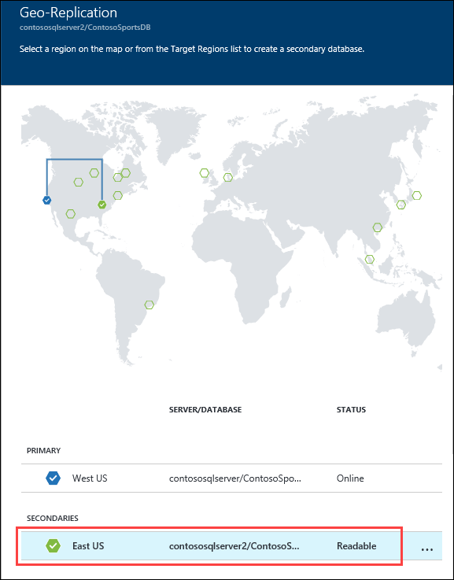
5. Click the **Failover** button.  
   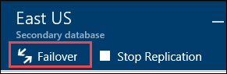
6. On the **Failover** prompt, click **Yes**.  
   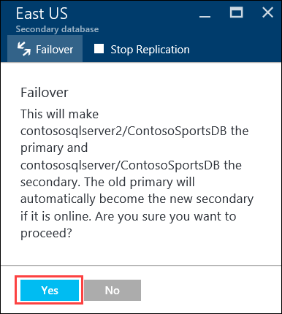

The Failover may take a few minutes to complete. You can continue with the next Subtask to modify the Web App to point to the Secondary SQL Database while the Failover is pending.

#### Subtask 3: Test e-commerce web app after Failover

1. In the Azure Portal, click **Resource Groups**, and then click the **contososports** resource group.   
   
2. Click the **Web App** that was just created in a previous step.
3. On the **App Service** blade, scroll down in the left pane and click **Application settings**.  
   
4. Scroll down and locate the **Connection strings** section.
5. Update the **ContosoSportsLeague** Connection String to the value of the Connection String for the **Secondary SQL Database.**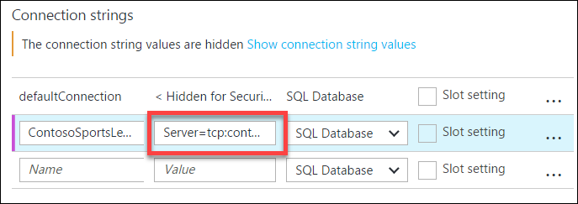

Ensure you replace the string placeholder values {your_username} {your_password_here} with the username and password respectively you setup during creation (demouser AND demo@pass123).



1. Click **Save**
2. On the **App Service** blade, click **Overview**.  
   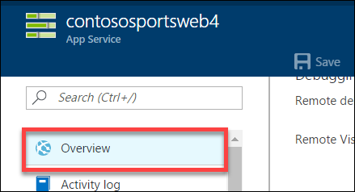
3. On the **Overview** pane, click the **URL** for the Web App to open it in a new browser tab.  
   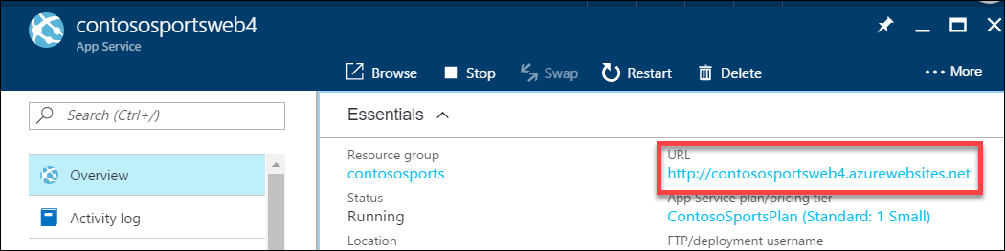
4. After the e-commerce web app loads in Internet Explorer, click **STORE** in the top navigation bar of the website.  
   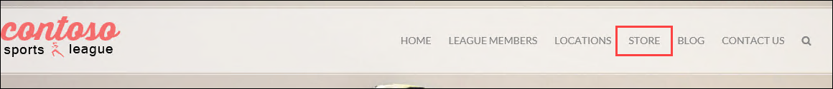
5. Verify the product list from the database displays  
   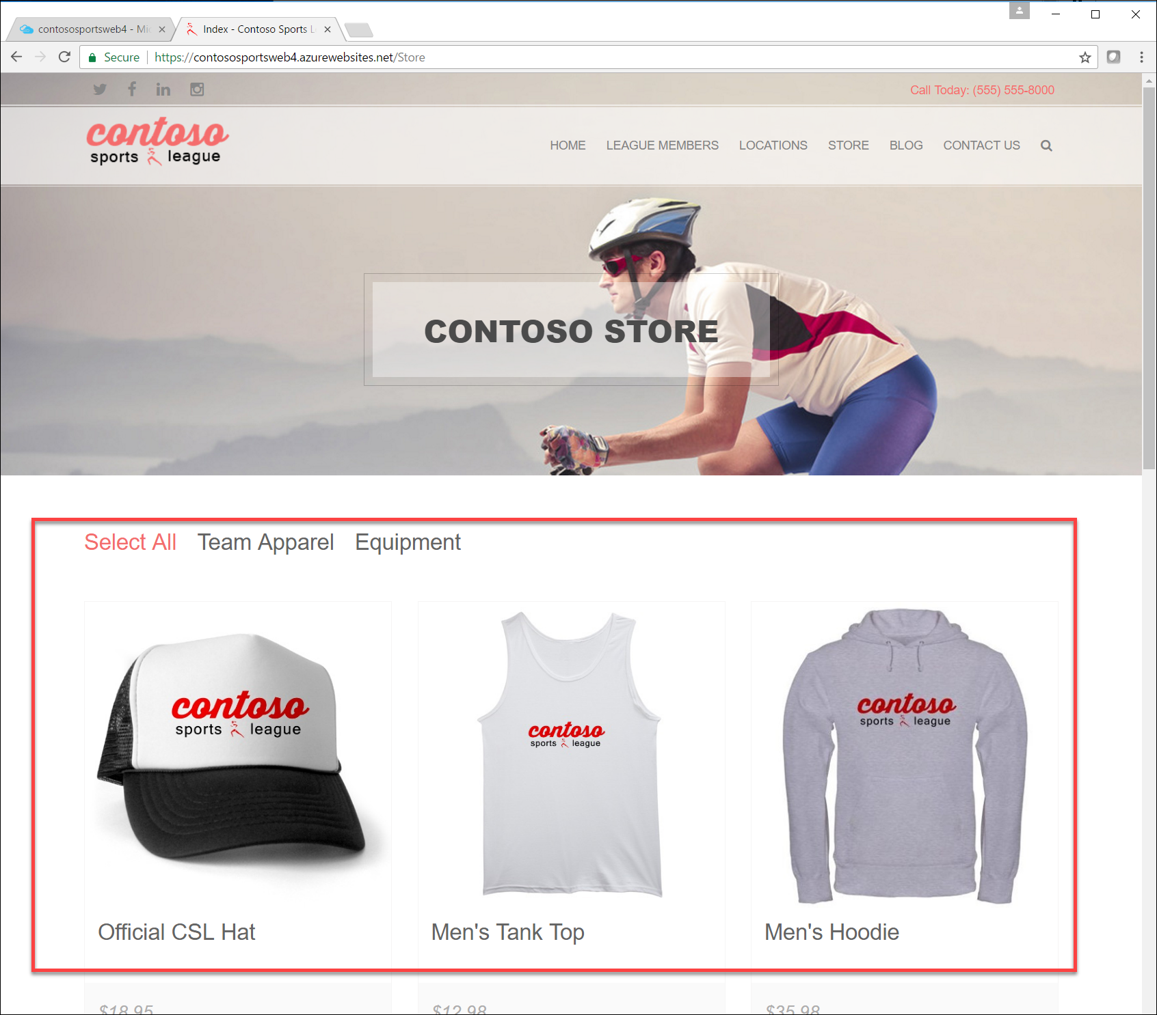

#### Subtask 4: Revert Failover back to Primary database

1. Using a new tab or instance of your browser navigate to the Azure Management Portal <http://portal.azure.com>
2. Click **More services,** then **SQL databases**, and then click the name of the SQL Database you created previously  
   
3. On the **Settings** blade, click **Geo-Replication**.  
   
4. On the **Geo-Replication** blade, selectthe Secondary database.  
   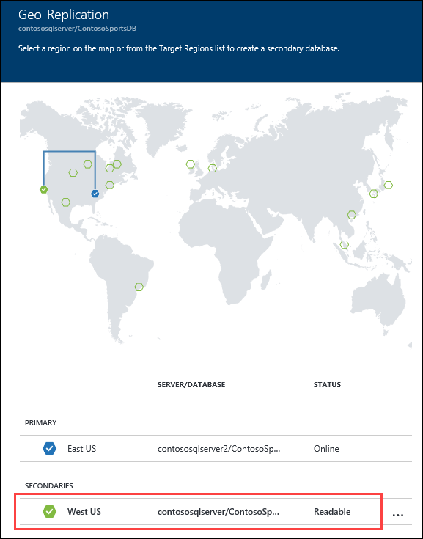
5. Click the **Failover** button.  
   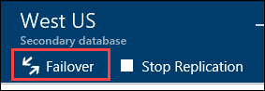
6. On the **Failover** prompt, click **Yes**.  
   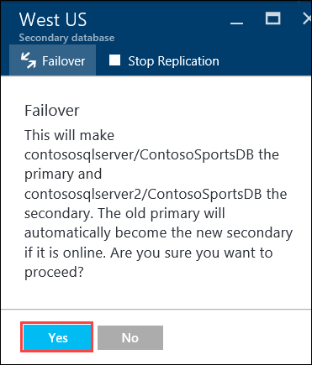

The Failover may take a few minutes to complete. You can continue with the next Subtask modifying the Web App to point back to the Primary SQL Database while the Failover is pending.

#### Subtask 5: Test e-commerce web app after reverting Failover

1. In the Azure Portal, click **Resource Groups**, and then click the **contososports** resource group.  
   
2. Click the **Web App** that was just created in a previous step.
3. On the **App Service** blade, scroll down in the left pane and click **Application settings**.  
   
4. Scroll down and locate the **Connection strings** section.
5. Update the **ContosoSportsLeague** Connection String to the value of the Connection String for the **Primary SQL Database**.

Ensure you replace the string placeholder values {your_username} {your_password_here} with the username and password, respectively, you set up during creation (demouser and demo@pass123).



1. Click **Save**.
2. On the **App Service** blade, click **Overview**.  
   
3. On the **Overview** pane, click the **URL** for the Web App to open it in a new browser tab.  
   
4. After the e-commerce web app loads in Internet Explorer, click **STORE** in the top navigation bar of the website.  
   

Verify the product list from the database displays.  


### Task 3: Deploying the call center admin website

In this exercise, the attendee will provision a website via the Azure Web App template using the Microsoft Azure Portal. The attendee will then edit the necessary configuration files in the Starter Project and deploy the call center admin website.

#### Subtask 1: Provision the call center admin web app

1. Using a new tab or instance of your browser navigate to the Azure Management portal <http://portal.azure.com>.
2. Click **New**, **Web + mobile**, and then click **Web App** 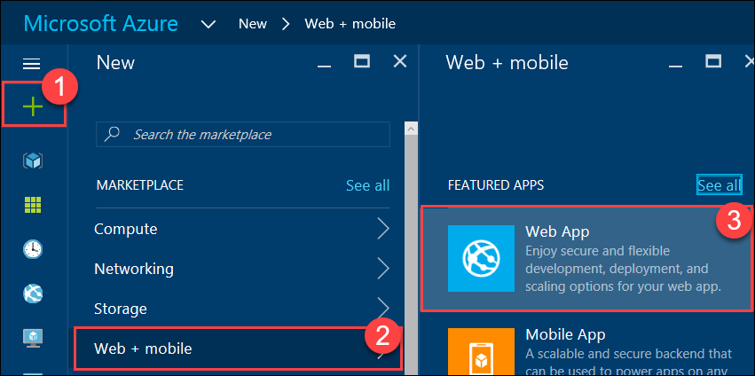
3. Specify a **unique URL** for the web app, and ensure the **same App Service Plan**, and **resource group** that you have used throughout the lab are selected.

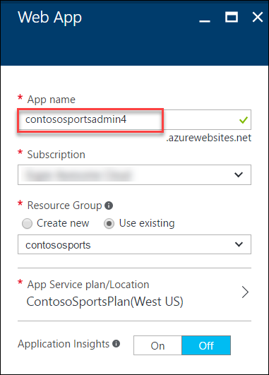

1. Click **App Service plan/Location** and select the **ContosoSportsPlan** that is used by the front-end Web App.  
   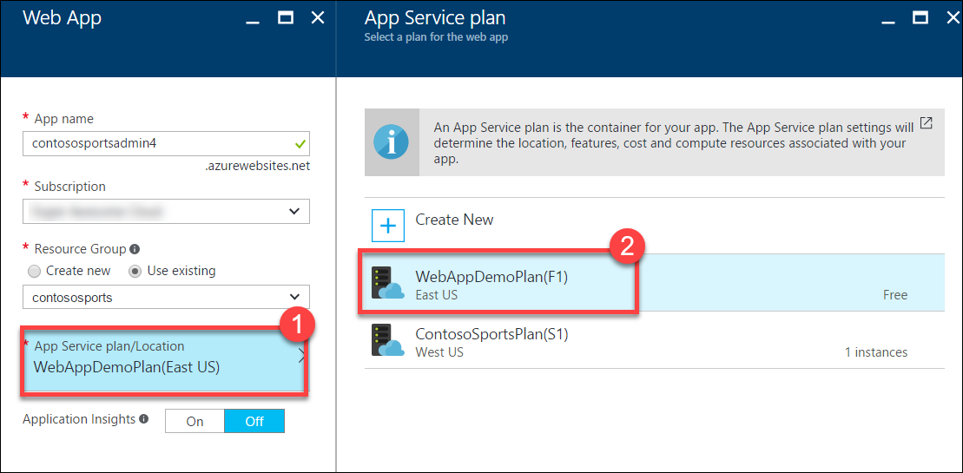
2. After the values are accepted click **Create**.



#### Subtask 2: Update the configuration in the starter project

1. Navigate to the **App Service** blade for the Call Center Admin app that was just provisioned.  
   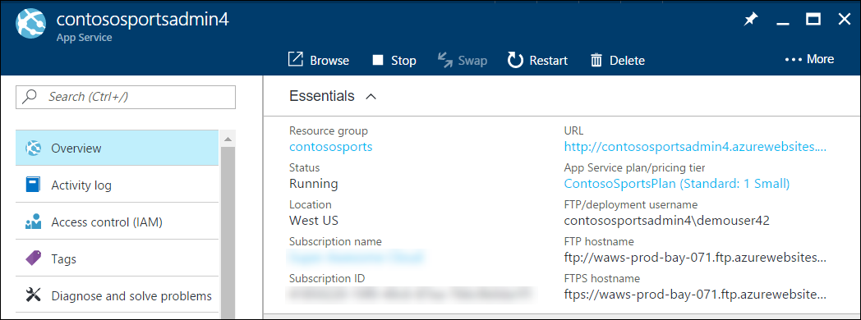
2. On the **App Service** blade, click **Application settings** in the left pane.

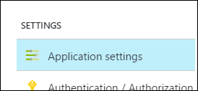

1. Scroll down and locate the **Connection strings** section.

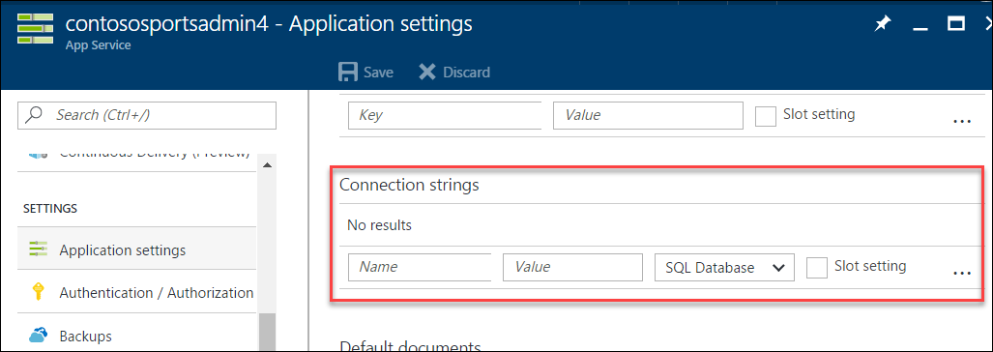

1. Add a new **Connection string** with the following values:
   1. Name: **ContosoSportsLeague**
   2. Value: **enter the Connection String for the SQL Database that was created**
   3. Type: **SQL Database**

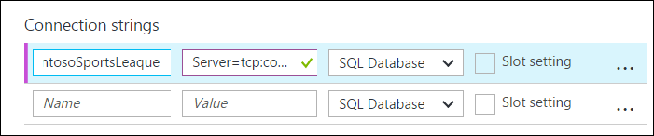

Ensure you replace the string placeholder values {your_username} {your_password_here} with the username and password respectively you setup during creation (demouser AND demo@pass123).



Click **Save**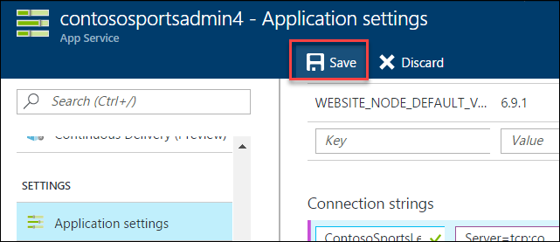

#### Subtask 3: Deploy the call center admin web app from Visual Studio

1. Navigate to the **Contoso.Apps.SportsLeague.Admin** project located in the **Web** folder using the **Solution Explorer** in Visual Studio.

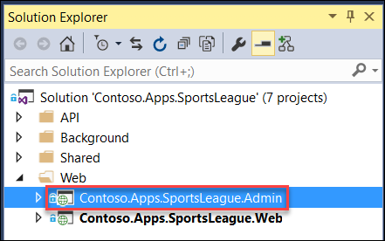

1. Right-click the **Contoso.Apps.SportsLeague.Admin** project and click **Publish**.

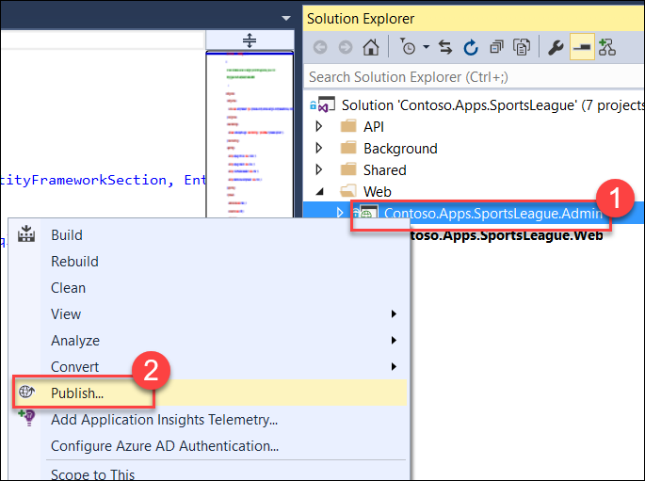

1. Choose **Microsoft Azure App Service** as the publish target.



1. Select the **Web App** for the Call Center Admin App.

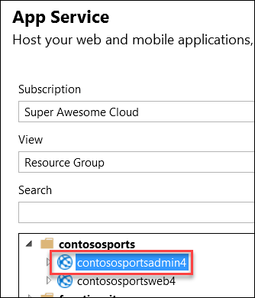

1. Click **OK**, and then click **Publish** to deploy the site.
2. The website should load and display the following:

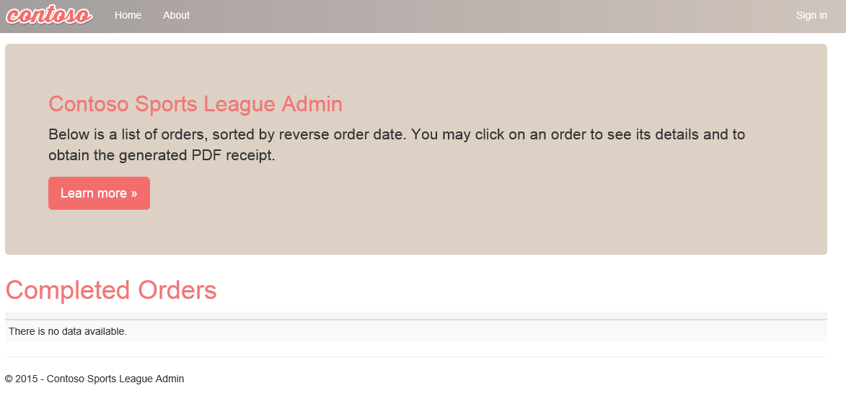

### Task 4: Deploying the payment gateway

In this exercise, the attendee will provision an Azure API app template using the Microsoft Azure Portal. The attendee will then deploy the payment gateway.

#### Subtask 1: Provision the payment gateway API app

1. Using a new tab or instance of your browser navigate to the Azure Management Portal <http://portal.azure.com>.
2. Click **+New**, then type **API App** into the **Search the marketplace** box, and press **Enter**.

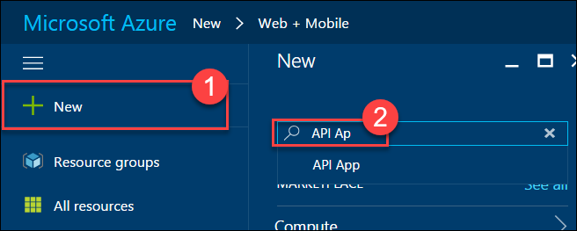

1. Click **API App** in the search results list.  
   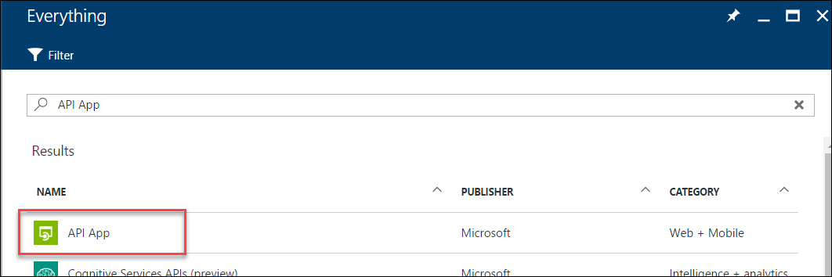
2. Click **Create**.  
   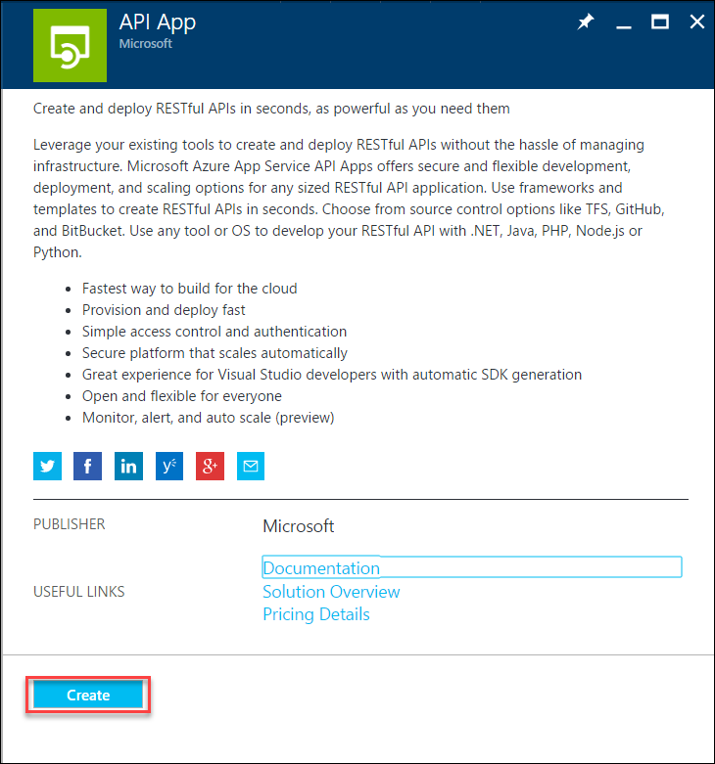
3. On the new **API App** blade, specify a unique name for the App Service Name, and ensure the previously used Resource Group and App Service Plan is selected.  
   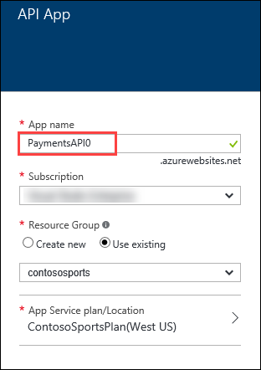
4. Click **App Service plan/Location** and select the same App Service Plan used for the other Web App services.  
   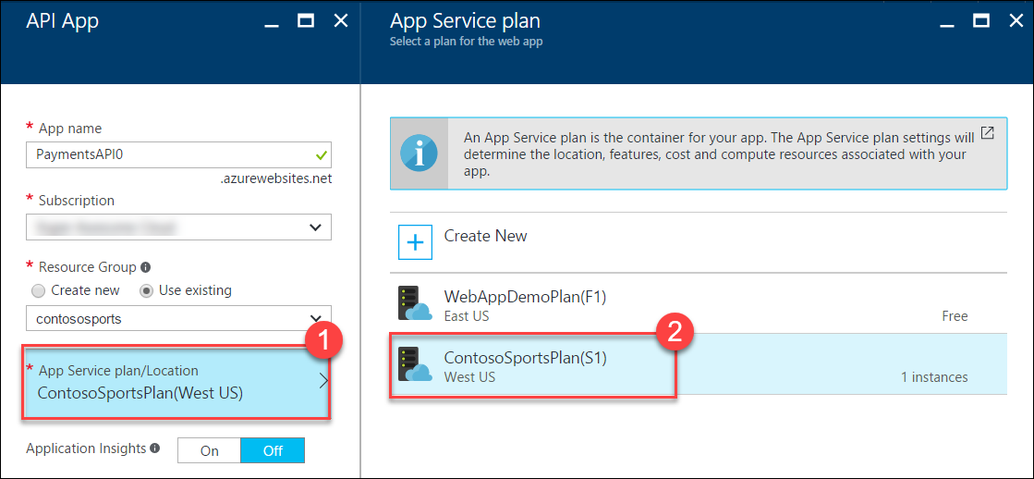
5. After the values are accepted click **Create**.  
   

#### Subtask 2: Deploy the Contoso.Apps.PaymentGateway project in Visual Studio

1. Navigate to the **Contoso.Apps.PaymentGateway** project located in the **APIs** folder using the **Solution Explorer** in Visual Studio.

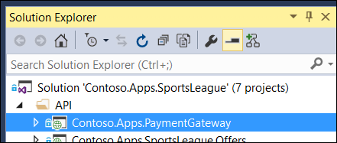

1. Right-click the **Contoso.Apps.PaymentGateway** project and click **Publish**.

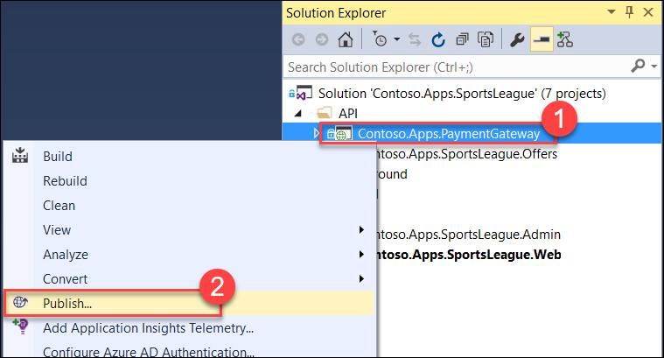

1. On the **Publish Web** dialog box,click **Microsoft Azure App Service**.

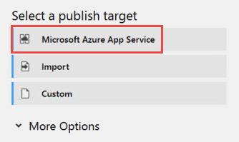

1. Select the Payment Gateway API app created earlier, click **OK**, and then **Publish**.

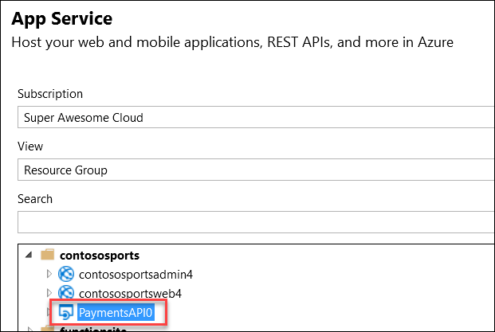

1. In the Visual Studio **Output** view you will see a status that indicates the web app was published successfully.



1. Record the value of the deployed **API App URL** for later use.

### Task 5: Deploying the offers Web API

In this exercise, the attendee will provision an Azure API app template using the Microsoft Azure Portal. The attendee will then deploy the offers Web API.

#### Subtask 1: Provision the offers Web API app

1. Using a new tab or instance of your browser navigate to the Azure Management Portal (<http://portal.azure.com>).
2. Click **+New**, then type **API App** into the Search the marketplace box, and press Enter.



1. Click **API App** in the search results list.  
   
2. Click **Create**.  
   
3. On the new **API App** blade, specify a unique name for the App Service Name, and ensure the previously used Resource Group and App Service Plan is selected.

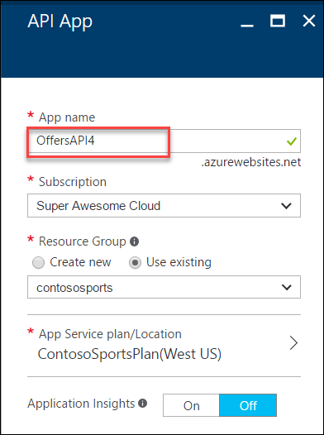

1. Click **App Service plan/Location** and select the same App Service Plan used for the other Web App services.  
   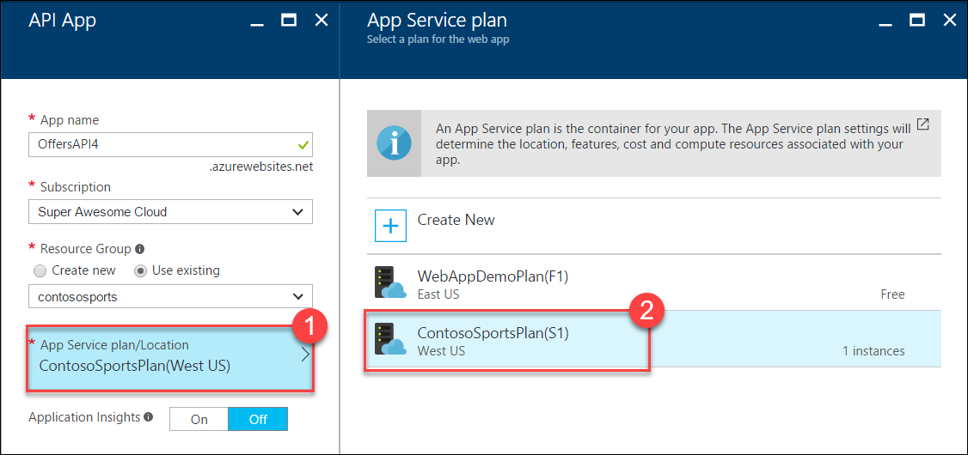
2. After the values are accepted click **Create**.  
   
3. When the web app template has completed provisioning, open the new API App by clicking **More services** > **App Services** > and then click the **Offers API** that was just created.

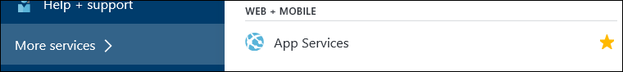

#### Subtask 2: Configure cross-origin resource sharing (CORS)

1. On the **App Service** blade, scroll down and click **CORS** within the API section of the left pane.

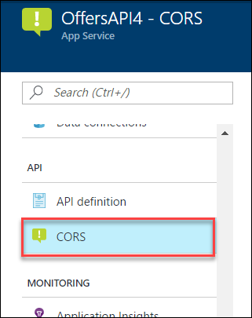

1. In the **ALLOWED ORIGINS** text box specify **\***, and click **Save**. 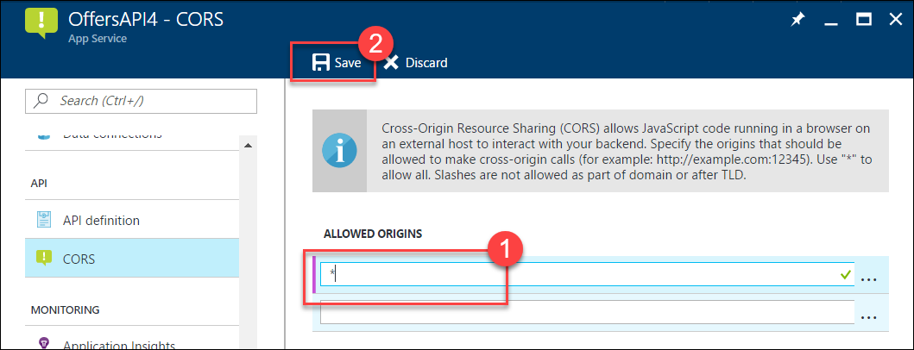

#### Subtask 3: Update the configuration in the starter project

1. On the **App Service** blade for the Offers API click **Application settings**.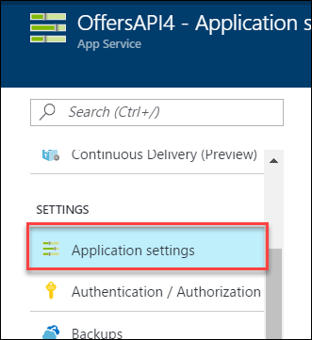
2. Scroll down and locate the **Connection strings** section.  
   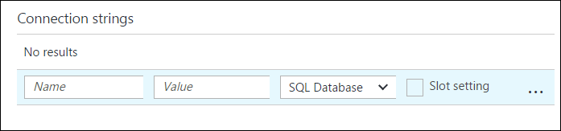
3. Add a new **Connection string** with the following values:
   1. Name: **ContosoSportsLeague**
   2. Value: **enter the Connection String for the SQL Database that was created**
   3. Type: **SQL Database**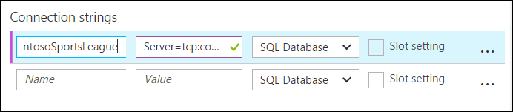

Ensure you replace the string placeholder values {your_username} {your_password_here} with the username and password respectively you setup during creation (demouser AND demo@pass123).



1. Click **Save**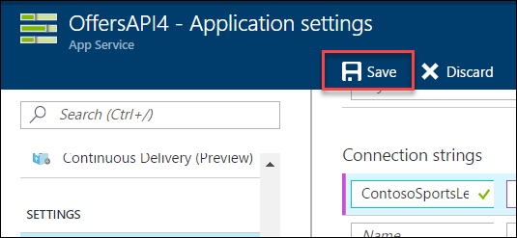

#### Subtask 4: Deploy the Contoso.Apps.SportsLeague.Offers project in Visual Studio

1. Navigate to the **Contoso.Apps.SportsLeague.Offers** project located in the **APIs** folder using the **Solution Explorer** in Visual Studio.

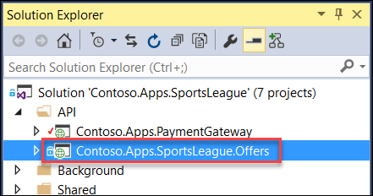

1. Right-click the **Contoso.Apps.SportsLeague.Offers** project and select **Publish**.

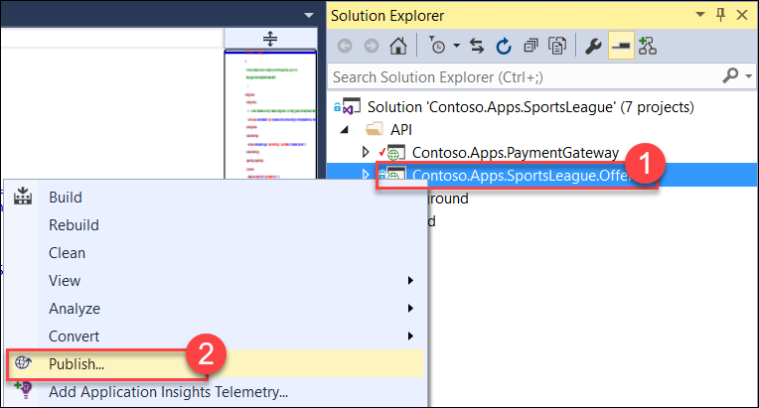

1. On the **Publish Web** dialog box,click **Microsoft Azure App Service**.



1. Select the Offers API app created earlier, click **OK**, and then **Publish**.

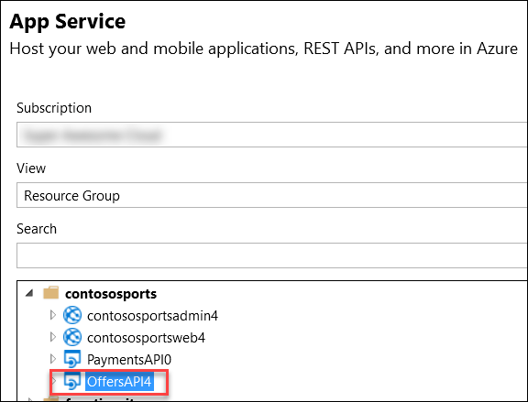

1. In the Visual Studio **Output** view you will see a status that the API app was published successfully.
2. Record the value of the deployed API app URL for later use.

\

### Task 6: Update and deploy the e-commerce website

#### Subtask 1: Update the Application Settings for the Web App that hosts the Contoso.Apps.SportsLeague.Web project

1. Using a new tab or instance of your browser navigate to the Azure Management Portal <http://portal.azure.com>.
2. Click **Resource groups**, then the **contososports** resource group.  
   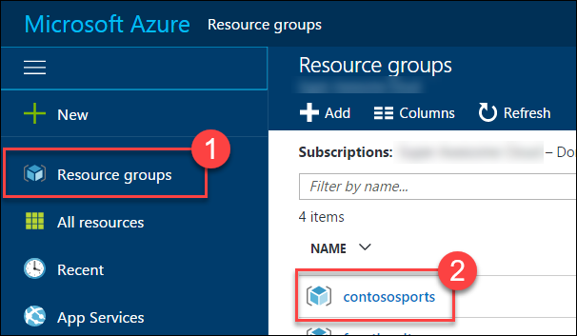
3. Click the **App Service Web App** for the front-end Web Application.   
   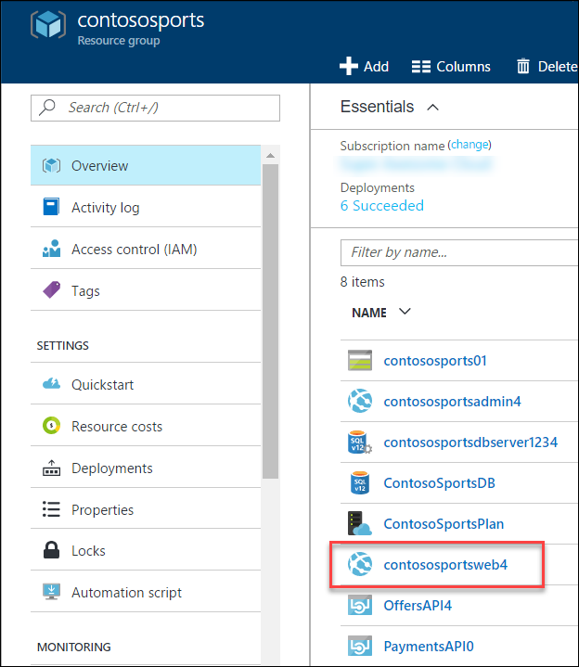
4. On the **App Service** blade, scroll down and click **Application settings** in the left pane.

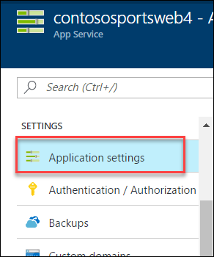

1. Scroll down and locate the **App settings** section  
   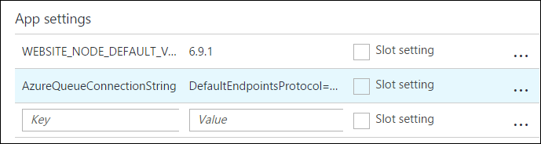
2. Add a new **App Setting** with the following values:
   1. Key: **paymentsAPIUrl**
   2. Value: enter the **HTTPS** URL for the Payments API App with **/api/nvp** appended to the end. Ex: https://paymentsapi0.azurewebsites.net/api/nvp  
      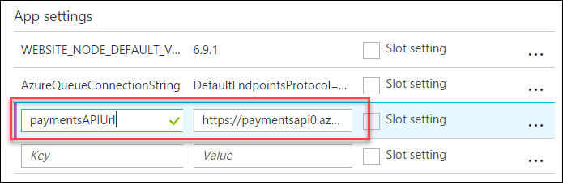
3. Add a new **App Setting** with the following values:
   1. Key: **offersAPIUrl**
   2. Value: enter the **HTTPS** URL for the Offers API App with **/api/get** appended to the end. Ex: https://offersapi4.azurewebsites.net/api/get  
      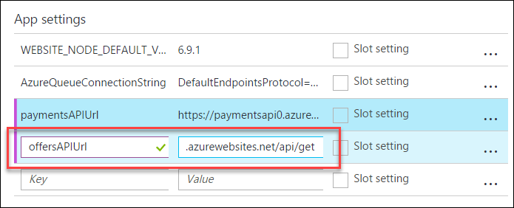
4. Click **Save**.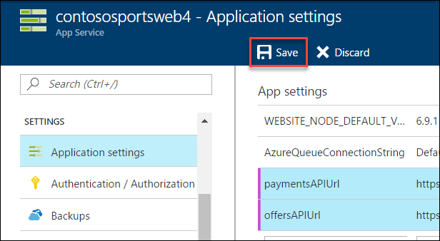

Note: Ensure that the API URLs both are using SSL (https://) or you will see a CORS errors.

#### Subtask 2: Validate App Settings are correct

1. On the **App Service** blade, click Overview.  
   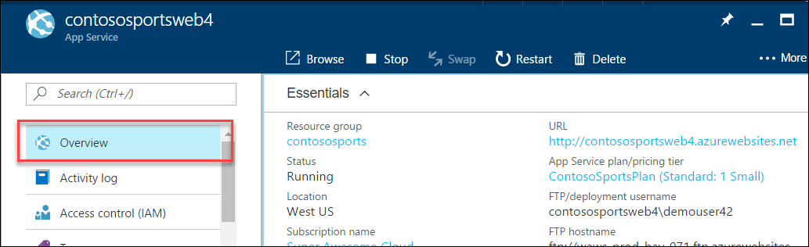
2. In the **Overview** pane, click the **URL** for the Web App to open it in a new browser tab.  
   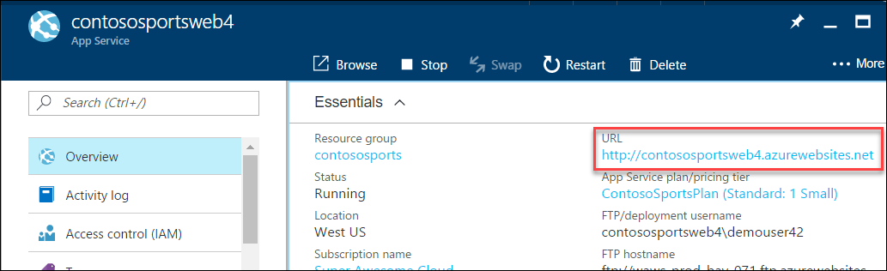
3. On the homepage, you should see the latest offers populated from the offers API.

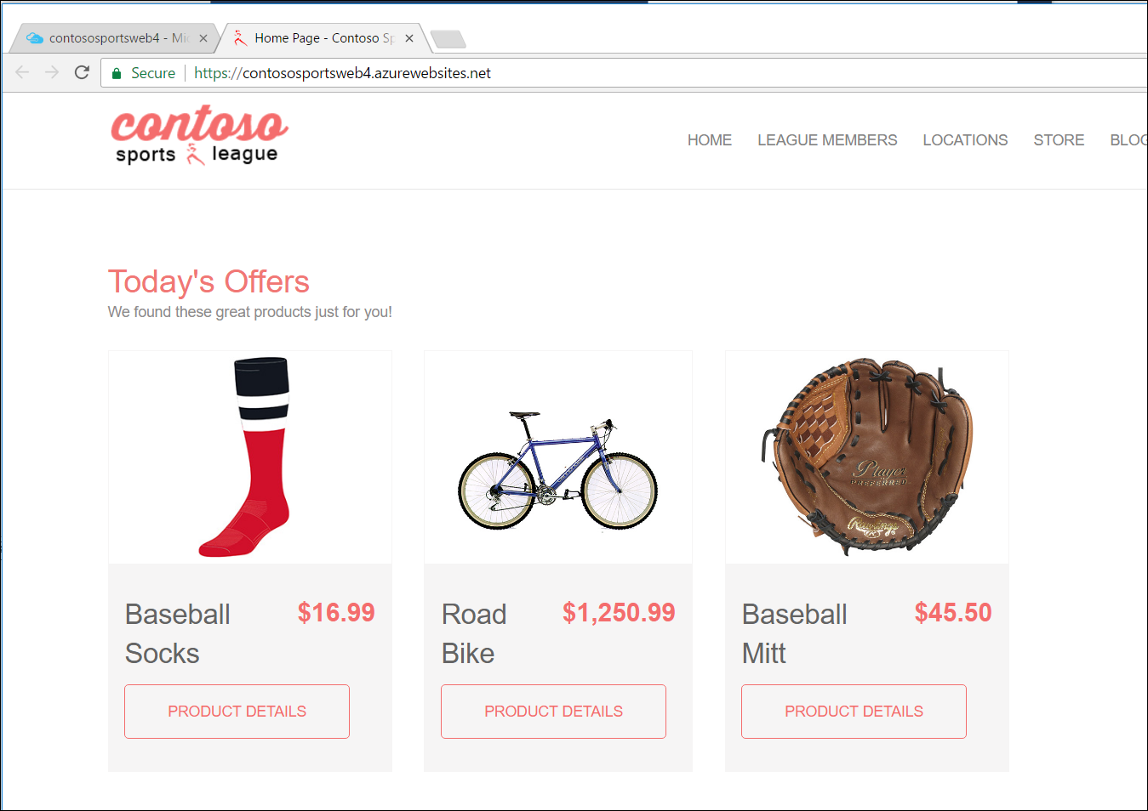

1. Submit several test orders to ensure that all pieces of the site are functional.

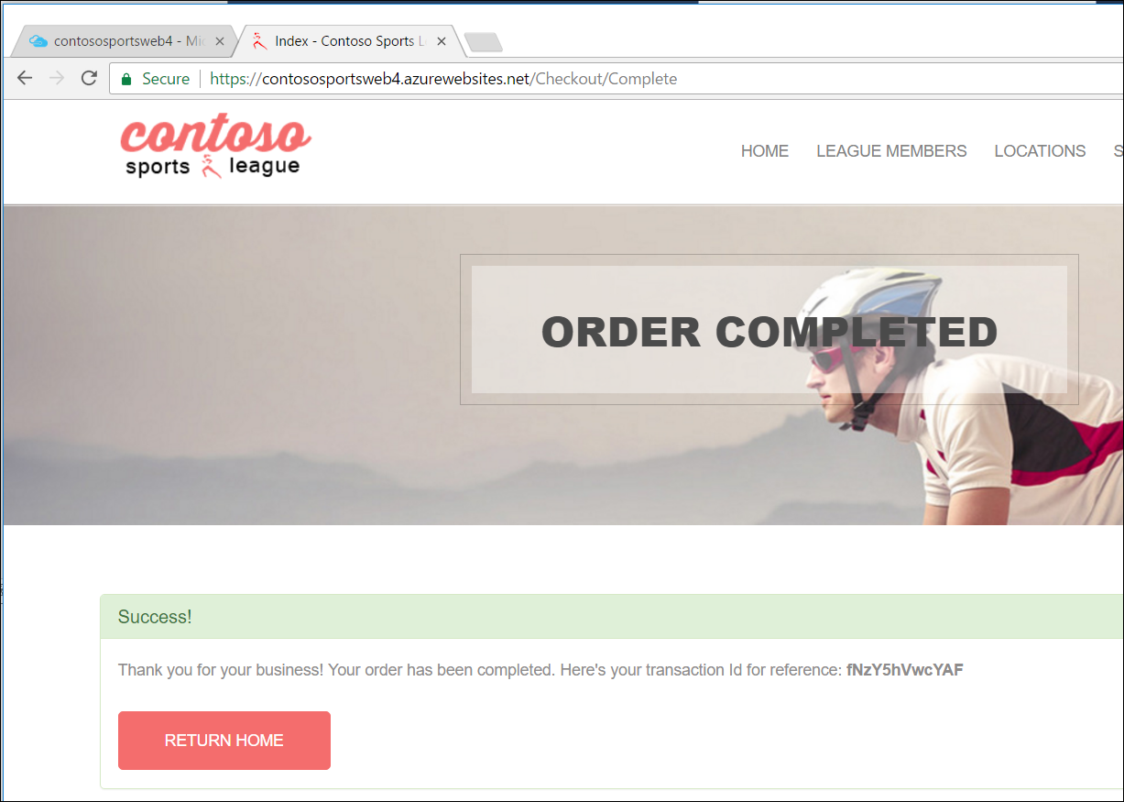

Proctor Note: If the attendee is still experiencing CORS errors, ensure the URLs to the web app in Azure local host are exact.

## Exercise 3: Identity and security

### Overview

The Contoso call center admin application will only be accessible by users of the Contoso Active Directory environment. You have been asked to create a new Azure AD Tenant and secure the application so only users from the tenant can log on.

### Help references

|  |  |
| --- | --- |
| What is Azure AD? | <https://azure.microsoft.com/en-us/documentation/articles/active-directory-whatis/> |
| Azure Web Apps authentication | <http://azure.microsoft.com/blog/2014/11/13/azure-websites-authentication-authorization/> |
| View your access and usage reports | <https://msdn.microsoft.com/en-us/library/azure/dn283934.aspx> |
| Custom branding an Azure AD Tenant | <https://msdn.microsoft.com/en-us/library/azure/Dn532270.aspx> |

Note: Tasks 1, 2, and 4 are optional and require global admin permissions on the AzureAD Tenant. Task 3 is also optional, but does require the permission to create an app in the Azure AD tenant.

### Task 1: Enable Azure AD Premium Trial

Note: this task is optional and is valid only if you are a global administrator on the Azure AD tenant associated with your subscription.

1. From the Azure Management portal <http://portal.azure.com>, using a new tab or instance
2. Click **More services** then **Azure Active Directory** under the SECURITY + IDENTITY section.  
   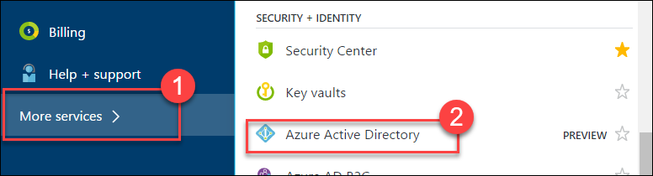
3. On the **Azure Active Directory** blade, locate and click the **Company branding** option.  
   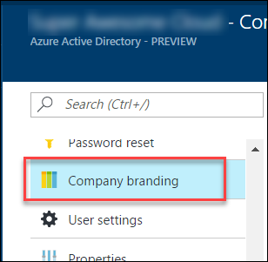
4. Click the option to **Get a free Premium trial**.  
   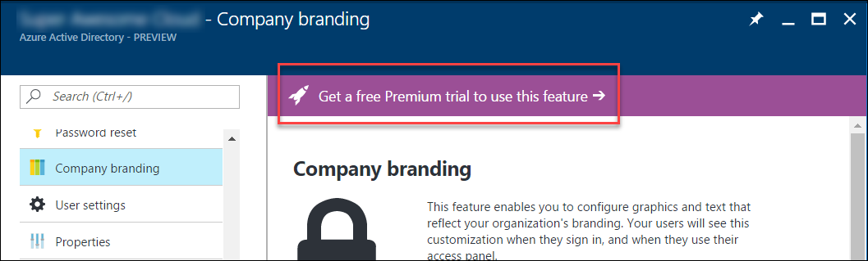

If you already have a Premium Azure Active Directory, then skip to Task 2.

1. On the **Activate** blade, click the **Free Trial** link within the AZURE AD PREMIUM box.  
   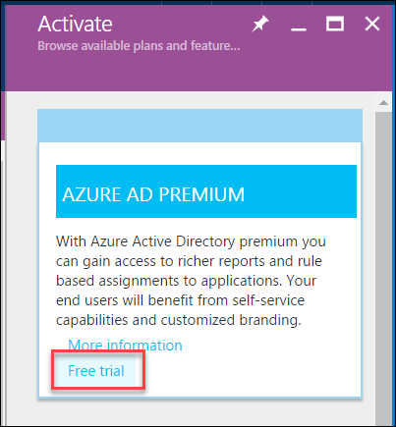
2. On the **Active Azure AD Premium trial** blade, click the **Activate** button.  
   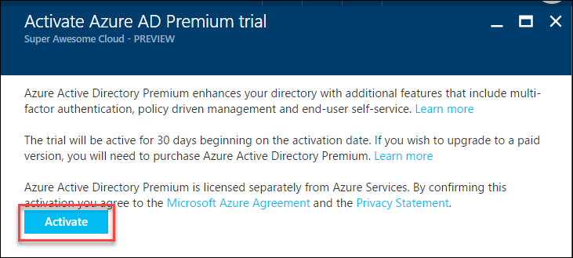
3. Close the **Azure Active Directory** blades.

### Task 2: Create a new Contoso user

Note: this task is optional and is valid only if you are a global administrator on the Azure AD tenant associated with your subscription.

1. From the Azure Management portal <http://portal.azure.com>, using a new tab or instance
2. Click **More services** then **Azure Active Directory** under the SECURITY + IDENTITY section.  
   
3. On the **Azure Active Directory** blade, click **Domain** names.  
   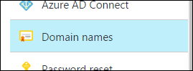
4. Copy the **Domain Name** for your Azure AD Tenant.  
   It will be in the format: *[your tenant].onmicrosoft.com*This will be used for creating the new user’s the Username.  
   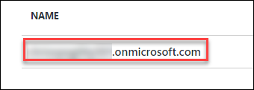
5. On the **Azure Active Directory** blade, click **Users and groups**, then **All users**.  
   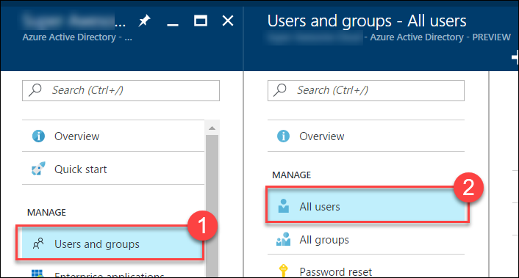
6. Click **+Add** to add a new user.  
   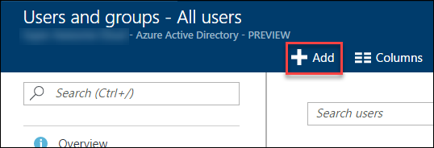
7. On the **User** blade, specify a user’s **Name** and **Username**.  
   Specify the **Username** to be at the domain name for your Azure AD Tenant.  
   For example: *tbaker@[your tenant].onmicrosoft.com*  
   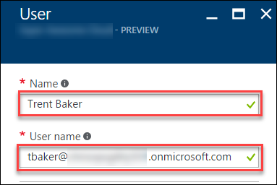
8. Click the **Show Password** check box, and make a note of the Password for use later.  
   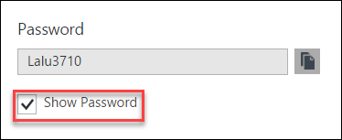
9. Click **Create**

### Task 3: Configure access control for the call center administration web application

Note: this task is optional and is valid only if you have the right to create applications in your Azure AD Tenant.

#### Subtask 1: Enable Azure AD Authentication

1. On the left navigation of the Azure Portal, click **App Services** (or click **More services** and then click **App Services**.



1. On the **web apps** page select the **call center administration web app**.

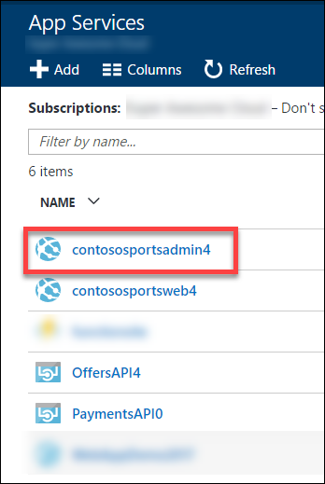

1. Click the **Authentication / Authorization** tile.

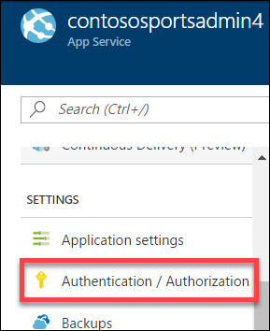

1. Change **App Service Authentication** to **On**, change the drop-down menu to **Log in with Azure Active Directory**

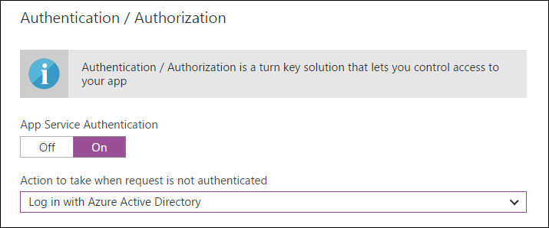

1. Click the **Azure Active Directory**.  
   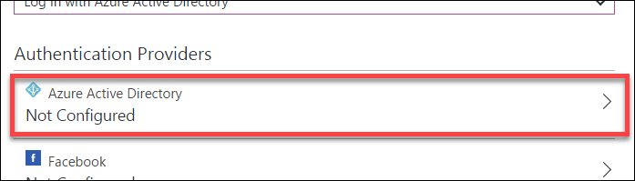
2. On the **Azure Active Directory Settings** blade, change **Management mode** to **Express**

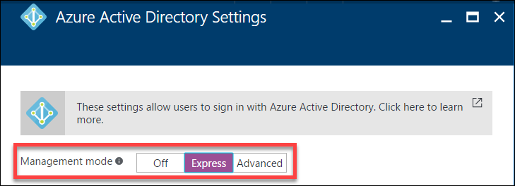

1. Click **OK**  
   
2. In the **Authentication / Authorization** blade click **Save**.

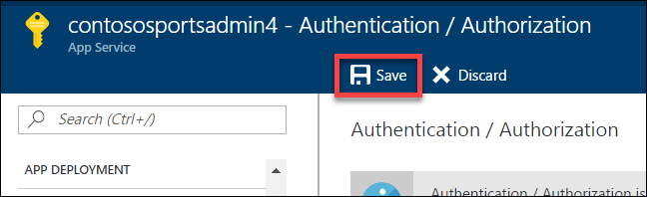

#### Subtask 2: Verify the call center administration website uses the access control logon

1. Close your browser (or use an alternative) and launch a browser is InPrivate or Incognito mode. Navigate to the **call center administration** website.
2. The browser will redirect to the non-branded Access Control logon URL. You can log on with your Microsoft account or the **Contoso test user** you created earlier.

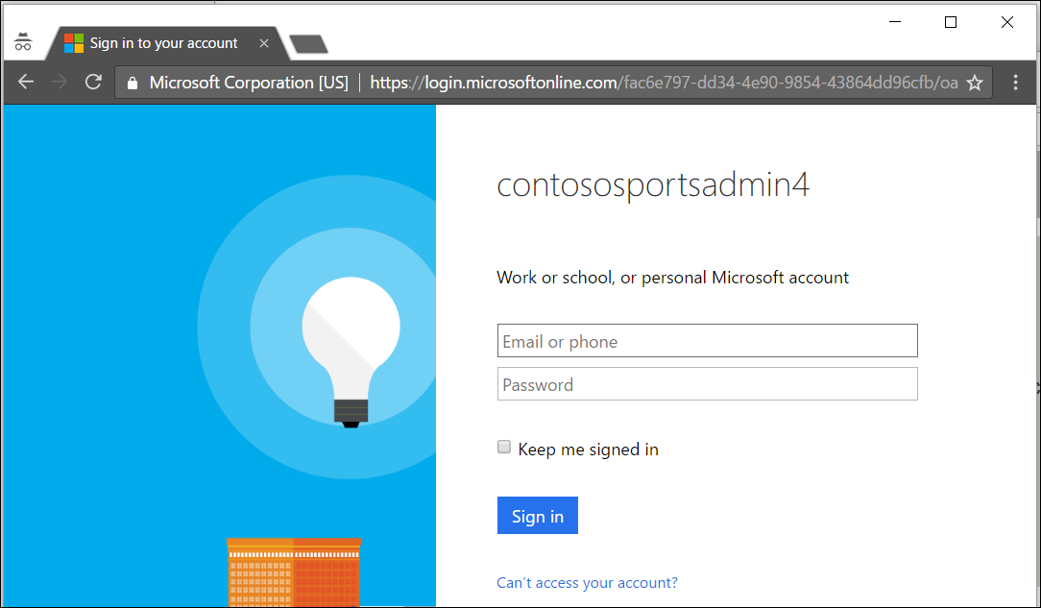

1. After you log on, your browser will be redirected to the Contoso Sports League Admin web page.

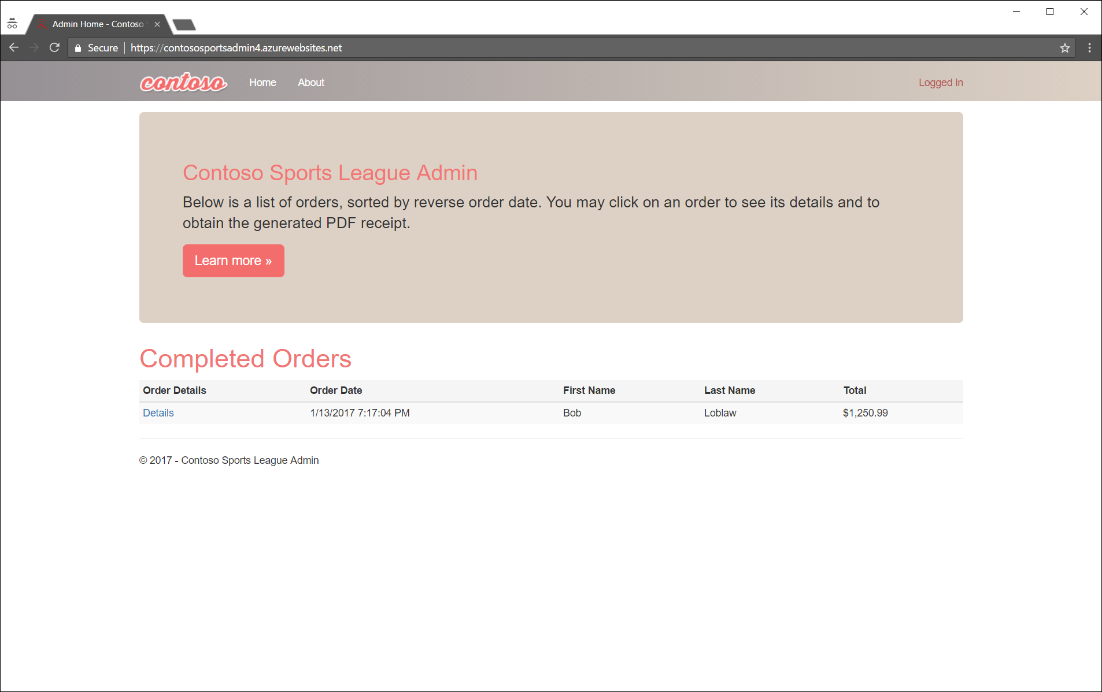

1. Verify that in the upper-right corner you see the link **Logged In**. If it is not configured you will see **Sign in**.

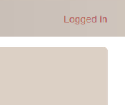 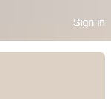

### Task 4: Apply custom branding for the Azure Active Directory logon page

Note: this task is optional and is valid only if you are a global administrator on the Azure AD tenant associated with your subscription and you completed the Enabling Azure AD Premium exercise.

1. From the Azure Management portal <http://portal.azure.com>, using a new tab or instance
2. Click **More services** then **Azure Active Directory** under the SECURITY + IDENTITY section.  
   
3. On the **Azure Active Directory** blade, click **Company branding**.  
   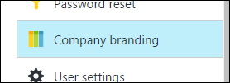
4. Click the **Configure company branding now** link.  
   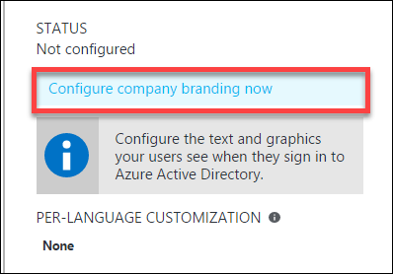
5. On the **Configure company branding** blade, select the **default_signin_illustration.jpg** image file from **C:\hackathon** for the **Sign-in page image**.  
   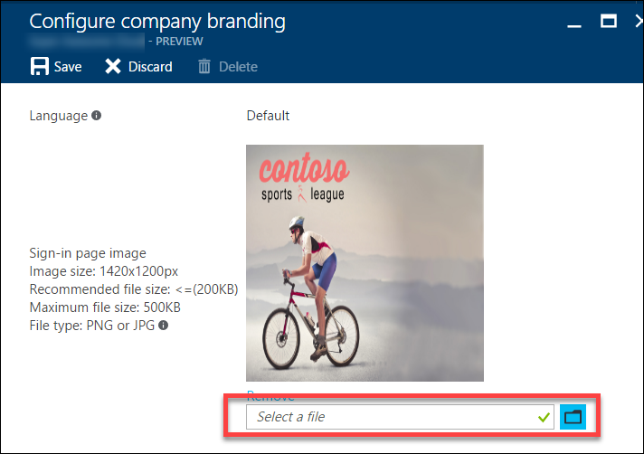
6. Select the **logo-60-280.png** image file from **C:\hackathon** for the **Banner image**  
   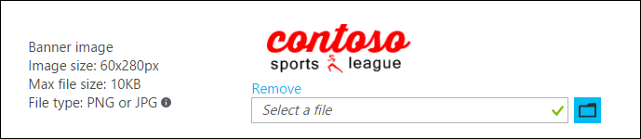

Click **Save**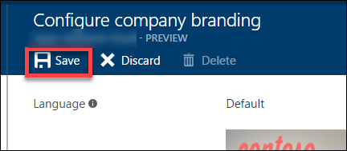

#### Subtask 2: Verify the branding has been successfully applied to the Azure Active Directory logon page

1. Close any previously authenticated browser sessions to the call center administration website, reopen using InPrivate or Incognito mode, and then navigate to the **call center administration** website.
2. The browser will redirect to the branded access control logon URL.

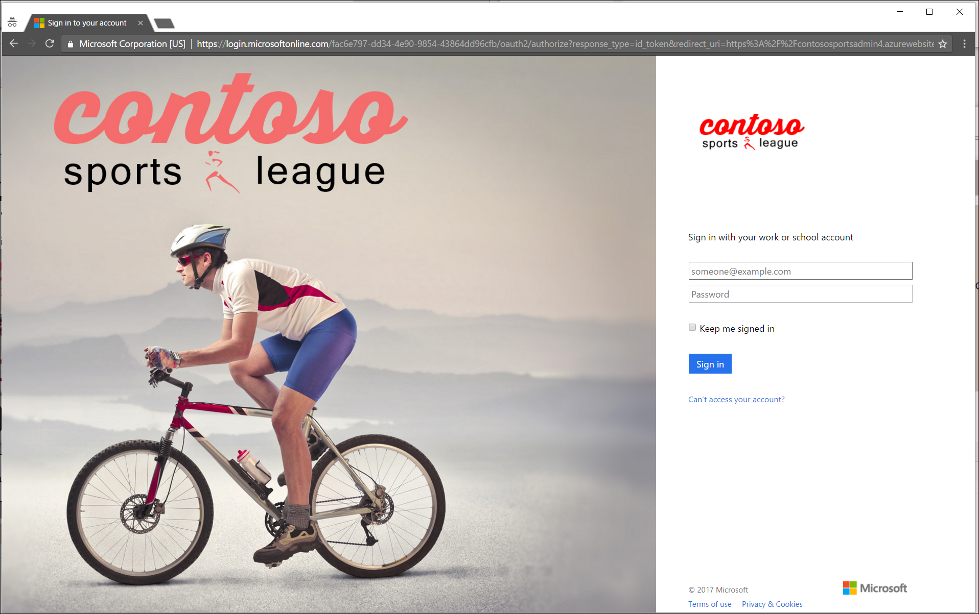

1. After you log on your browser will be redirected to the Contoso Sports League Admin web page.



1. Verify that in the upper-right corner you see the link **Logged in**.



## Exercise 4: Enabling Telemetry with Application Insights

### Overview

To configure the application for logging and diagnostics, you have been asked to configure Microsoft Azure Application Insights and add some custom telemetry.

### Help references

|  |  |
| --- | --- |
| Run performance tests on your app | http://blogs.msdn.com/b/visualstudioalm/archive/2015/09/15/announcing-public-preview-for-performance-load-testing-of-azure-webapp.aspx |
| Application Insights Custom Events | https://azure.microsoft.com/en-us/documentation/articles/app-insights-api-custom-events-metrics/ |
| Enabling Application Insights | https://azure.microsoft.com/en-us/documentation/articles/app-insights-start-monitoring-app-health-usage/ |
| Detect failures | https://azure.microsoft.com/en-us/documentation/articles/app-insights-asp-net-exceptions/ |
| Monitor performance problems | https://azure.microsoft.com/en-us/documentation/articles/app-insights-web-monitor-performance/ |

### Task 1: Configure the application for telemetry

#### Subtask 1: Add Application Insights Telemetry to the e-commerce website project

1. Open the Solution **Contoso.Apps.SportsLeague** in Visual Studio.
2. Navigate to the **Contoso.Apps.SportsLeague.Web** project located in the **Web** folder using the **Solution Explorer** in Visual Studio.

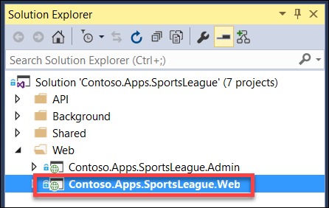

1. Right-click the **Contoso.Apps.SportsLeague.Web** project and select **Add Application Insights Telemetry**.

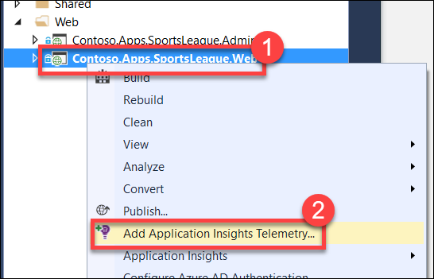

1. On the **Application Insights** dialog box, click the **Configure settings…** button

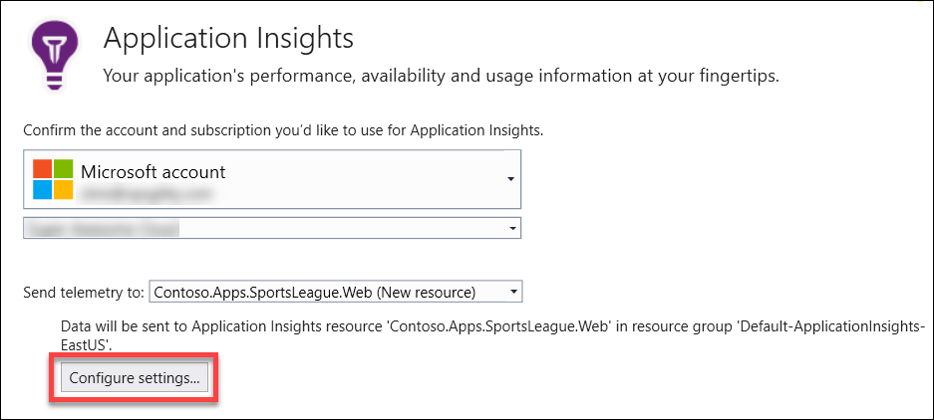

1. On the **Application Insights Configuration** dialog box, change the **Resource Group** to the **contososports** resource group that is used to host the Web App, and then click **OK**.  
   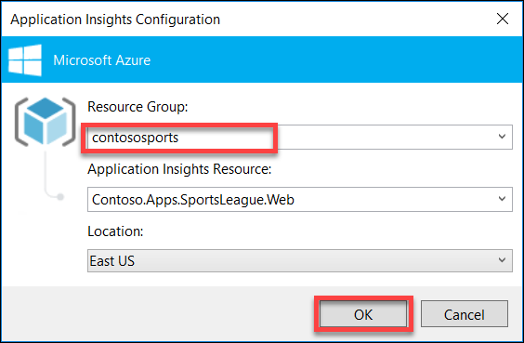
2. Click **Add**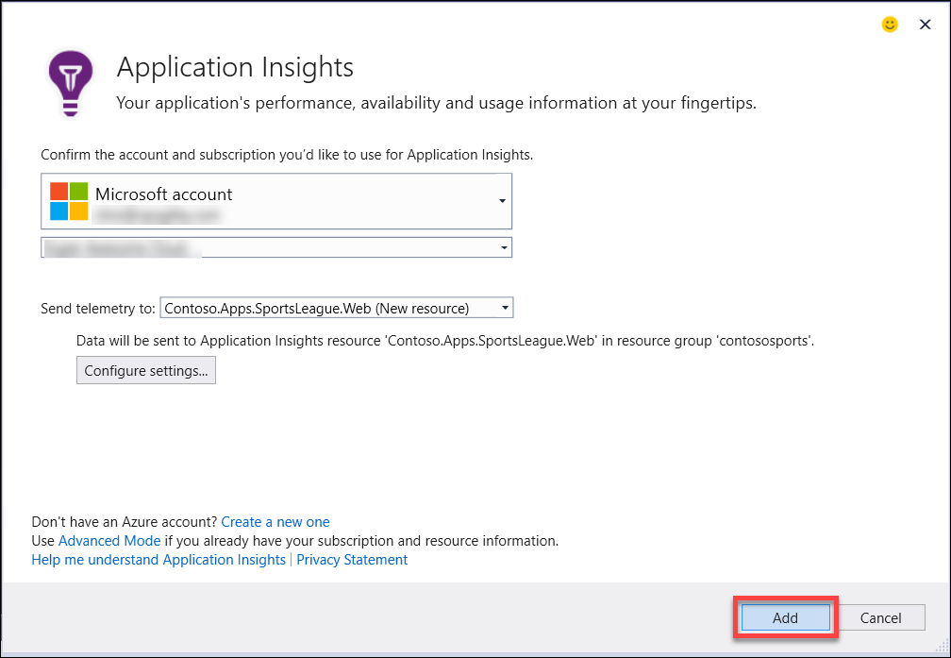
3. Once it completes, it displays the following Output and opens a new browser window

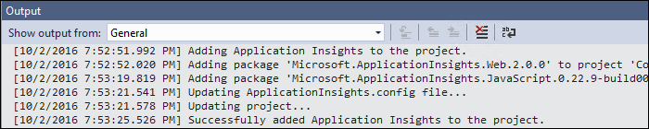

1. Open the file **\Helpers\TelemetryHelper.cs** located in the **Contoso.Apps.SportsLeague.Web** project.
2. Add the following using statement to the top of the file:

using Microsoft.ApplicationInsights;

1. Add the following code to the **TrackException** method to instantiate the telemetry client and track exceptions.

var client = new TelemetryClient();

client.TrackException(new Microsoft.ApplicationInsights.DataContracts.ExceptionTelemetry(exc));

1. Add the following code to the **TrackEvent** method to instantiate the telemetry client and track event data.

var client = new TelemetryClient();

client.TrackEvent(eventName, properties);

1. Save the **TelemetryHelper.cs** file.

#### Subtask 2: Enable client side telemetry

1. Open the Azure Management Portal (<http://portal.azure.com>). Click **More services**, and then click **Application Insights**.

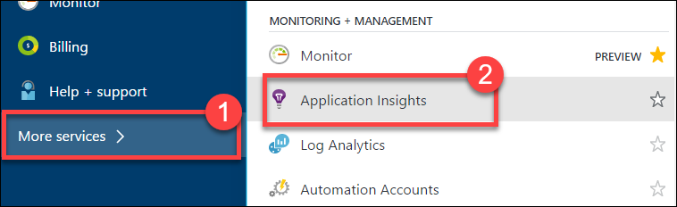

1. Click the Application Insights instance associated with the Contoso E-Commerce Site.

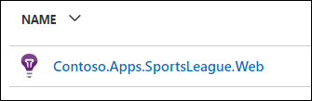

1. In settings menu click **Getting Started**.

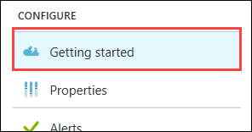

1. Next, click the **MONITOR AND DIAGNOSE CLIENT SIDE APPLICATION** arrow.**🡪**This will open the **Client application monitoring and diagnosis** blade.  
   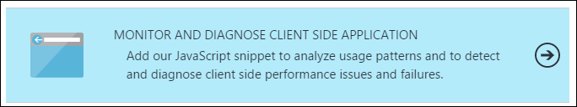
2. Select and copy the full contents of the JavaScript on the **Client application monitoring and diagnosis** blade.

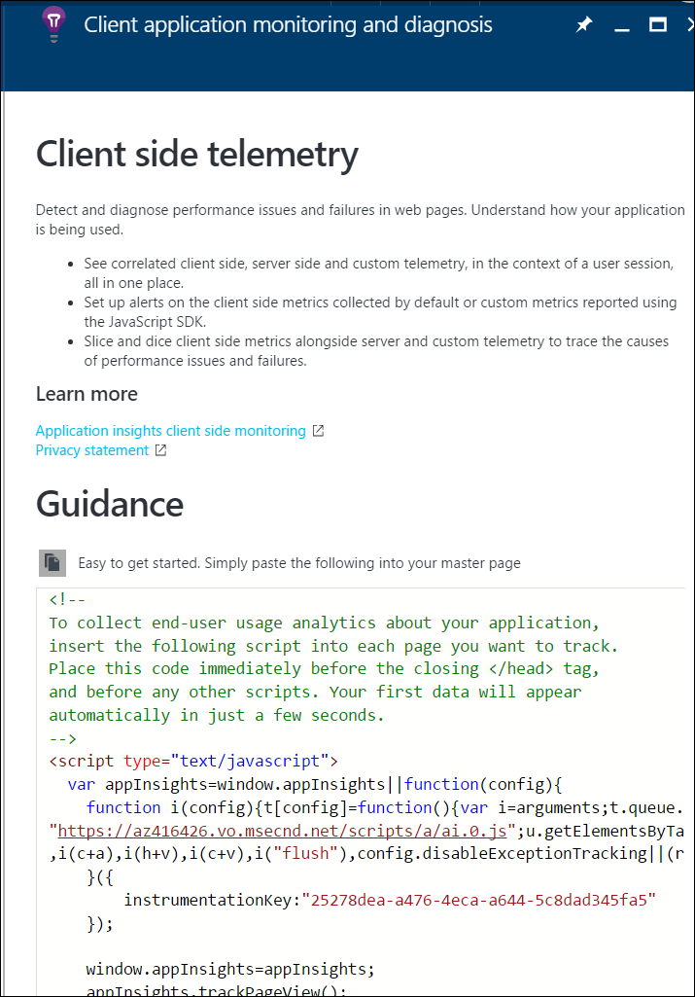

1. Navigate to the **Contoso.Apps.SportsLeague.Web** project located in the **Web** folder using the **Solution Explorer** in Visual Studio.
2. Open **Views** > **Shared** > **_Layout.cshtml**.

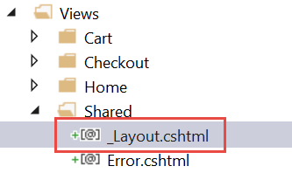

1. Paste in the code before the **</head>** tag.

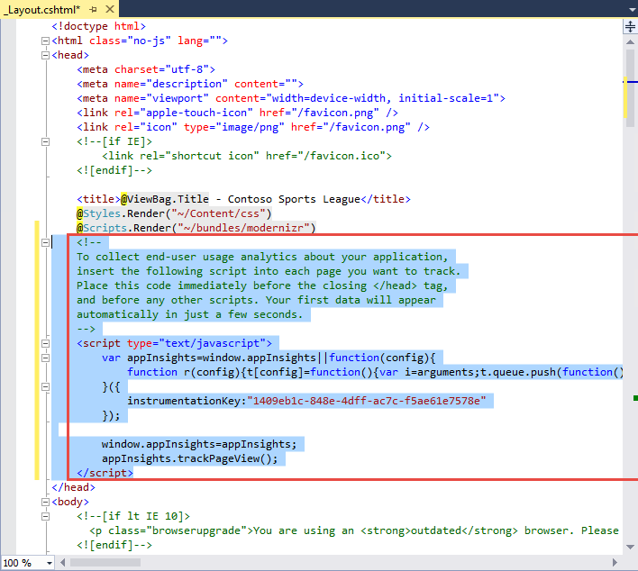

1. Save the **_Layout.cshtml** file.

#### Subtask 3: Deploy the e-commerce web app from Visual Studio

1. Navigate to the **Contoso.Apps.SportsLeague.Web** project located in the **Web** folder using the **Solution Explorer** in Visual Studio.

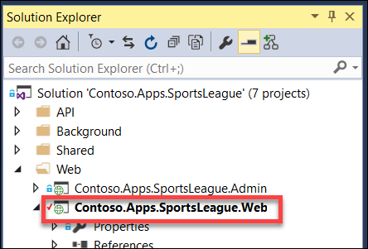

1. Right-click the **Contoso.Apps.SportsLeague.Web** project and select **Publish**.  
   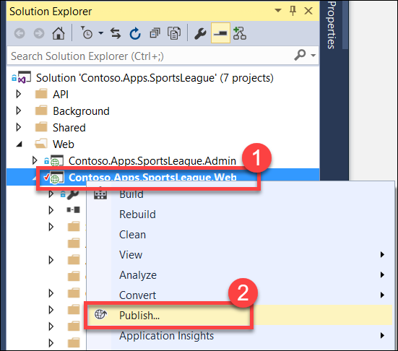
2. Click **Publish** again when the Publish dialog appears.
3. Click a few links on the published E-Commerce web site and submit several orders to generate some sample telemetry.

### Task 2: Creating the web performance test and load test

#### Subtask 1: Create the load test

1. Open the Azure Management Portal (<http://portal.azure.com>). Click **More services**, and then click **Application Insights**.

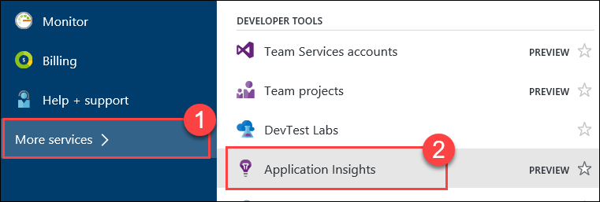

1. Click the Application Insights instance associated with the Contoso E-Commerce Site.

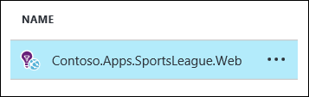

1. Click **Performance Testing**.

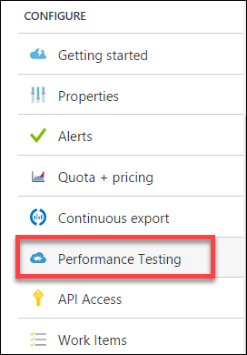

1. Click the Set Account button to associate/create a Visual Studio Team Services account.

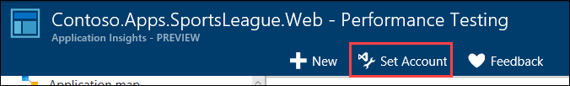

1. On the Account tile, click **Or Create New**.

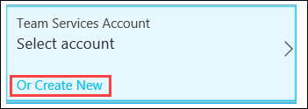

1. Specify a unique name for the account and select a region. Note the region may differ from the region you have deployed your resources.

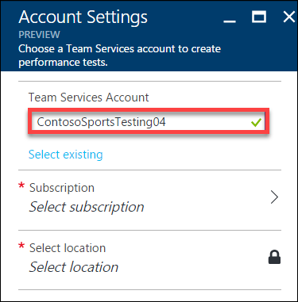

1. Click **Subscription**, and then select **your Subscription**.  
   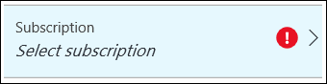
2. Click **Select location**, and then select a Location.  
   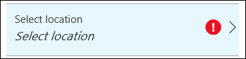
3. Click **OK**.

The VSTS account creation will take a minute to complete.

1. Click **New**.

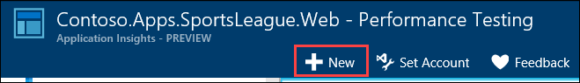

1. Click **Configure Test Using**.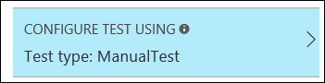
2. Specify the **URL** to the Contoso E-Commerce site, and then click **Done**.  
   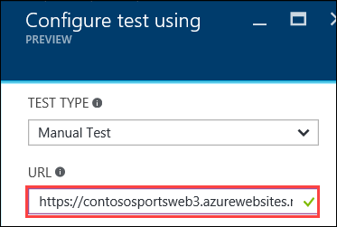
3. Name the test **ContosoSportsTest**, then click the **Run test** button.

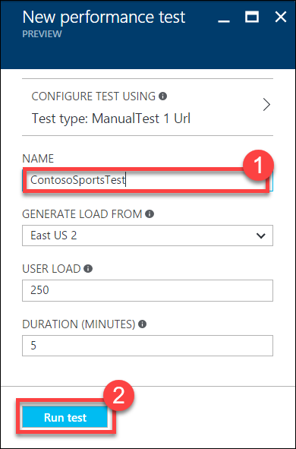

1. Wait until the load test has completed.

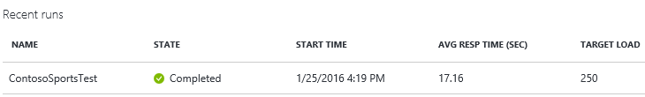

#### Subtask 2: View the Application Insights logs

1. Using a new tab or instance of your browser navigate to the Azure Management portal <http://portal.azure.com>.
2. On the left menu area, click **More services**.
3. On the **More services** blade select **Application Insights**.
4. On the **Application Insights** blade select, the Application Insights configuration you created for the e-commerce website.

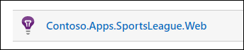

1. View the performance timeline to see the overall number of requests and page load time.

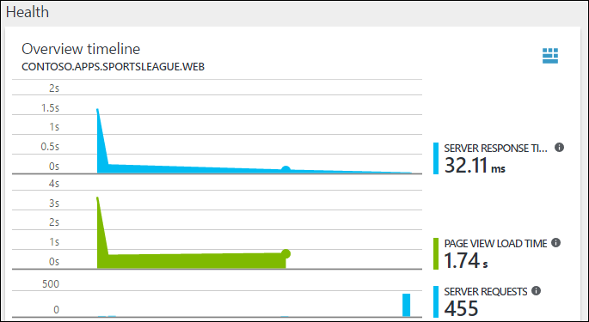

1. Under Investigate, click **Usage**.

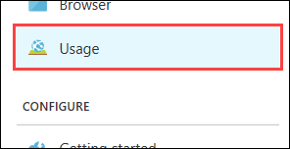

1. After several minutes you should see several Custom events from your previous order testing. This is reported through the TelemetryClient’s TrackEvent method.

Note: If you do not see data here come back later after the lab is complete.

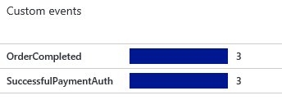

Drilling into the OrderCompleted events provides you with more detail about the specific order.

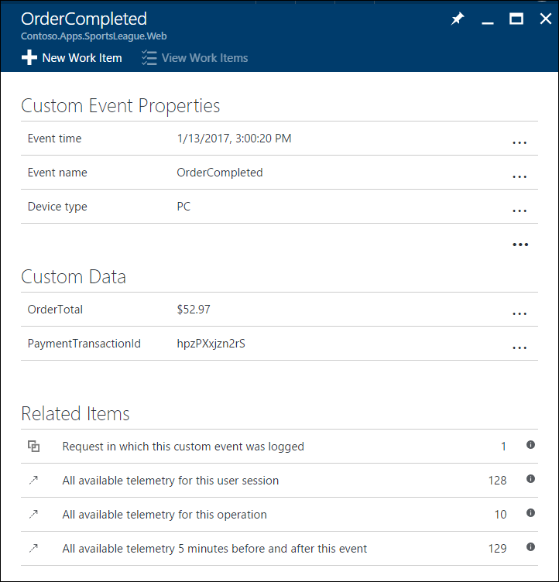

## Exercise 5: Automating backend processes

### Overview

Contoso wants to automate the process of generating receipts in PDF format and alerting users when their orders have been processed.

### Help references

|  |  |
| --- | --- |
| Deploying WebJobs using Visual Studio | https://docs.microsoft.com/en-us/azure/app-service-web/websites-dotnet-deploy-webjobs/ |
| Creating a Logic App | https://azure.microsoft.com/en-us/documentation/articles/app-service-logic-create-a-logic-app/ |
| Logic app connectors | https://azure.microsoft.com/en-us/documentation/articles/app-service-logic-connectors-list/ |

### Task 1: Enable receipt generation

#### Subtask 1: Provision Web App for Background Service Web Job

1. Using a new tab or instance of your browser navigate to the Azure Management portal <http://portal.azure.com>.
2. Click **New**, **Web + mobile**, and then click **Web App** 
3. Specify a **unique URL** for the web app, and ensure the **same App Service Plan**, and **resource group** that you have used throughout the lab are selected.  
   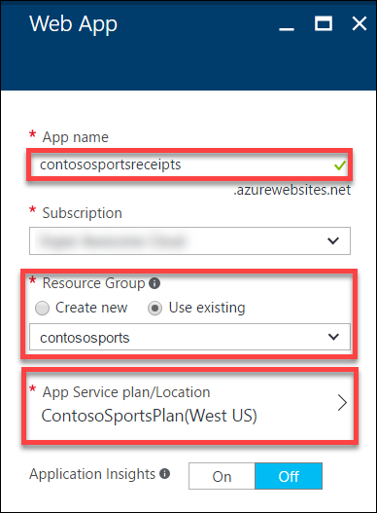
4. After the values are accepted click **Create**.  
   

#### Subtask 2: Update Application Settings configuration for Web Job

1. Click **Resource Groups**, then the **contososports** resource group, and then click the **Web App** that was just created.  
   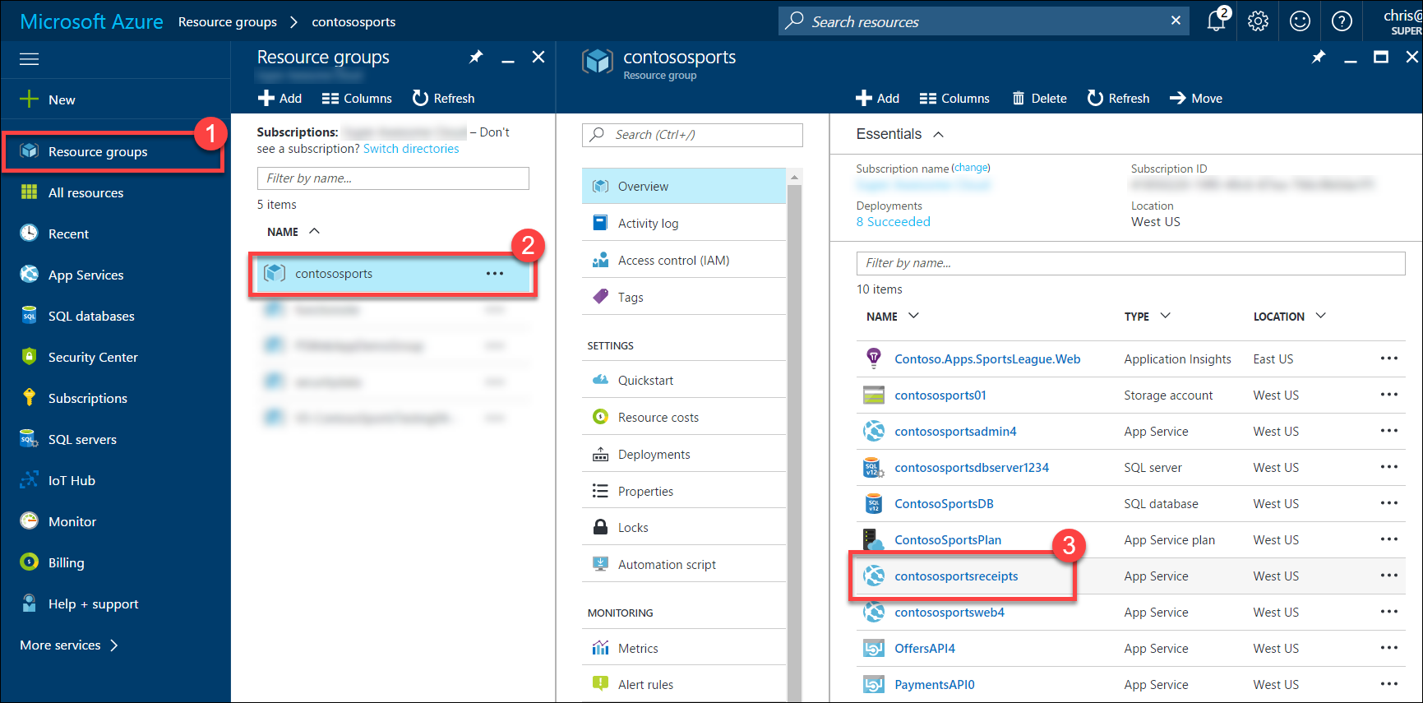
2. On the **App Service** blade, scroll down and click **Application settings** in the left pane.  
   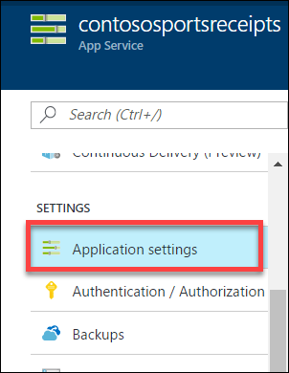
3. Scroll down and locate the **Connection Strings** section.  
   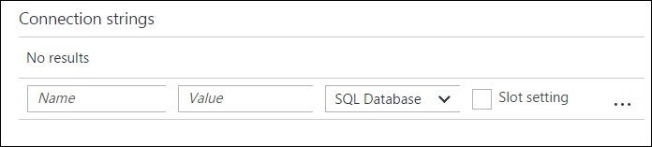
4. Add a new **Connection String** with the following values:
   1. Name: **WebJobsStorage**
   2. Value: **enter the Connection String for the Azure Storage Account that was copied earlier**
   3. Type: **Custom**  
      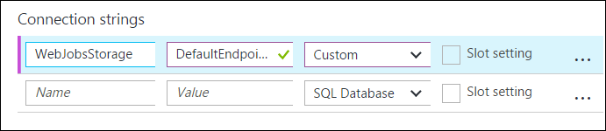
5. Add a new **Connection String** with the following values:
   1. Name: **ContosoSportsLeague**
   2. Value: **enter the** **Connection String for the SQL Database**
   3. Type: **SQL Database**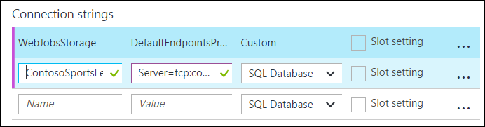
6. Click **Save**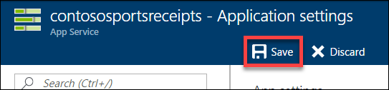
7. ?
8. ?

#### Subtask 3: Deploy the receipt generation Web Job

1. Open the **Contoso.Apps.SportsLeague** solution in Visual Studio.
2. Navigate to the **Contoso.Apps.SportsLeague.ReceiptProcessor** project located in the **Background** folder using the **Solution Explorer** in Visual Studio.  
   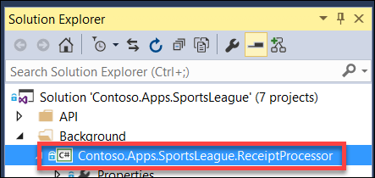
3. Right-click the **Contoso.Apps.SportsLeague.ReceiptProcessor** project and click **Publish as Azure Web Job…**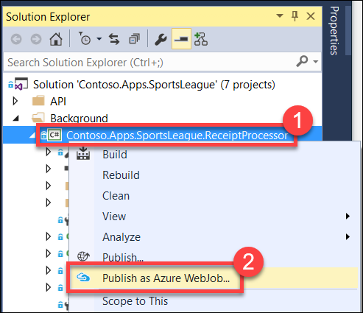
4. On the **Add Azure WebJob** dialog, change the **WebJob name** to **ReceiptProcessor**, then click **OK**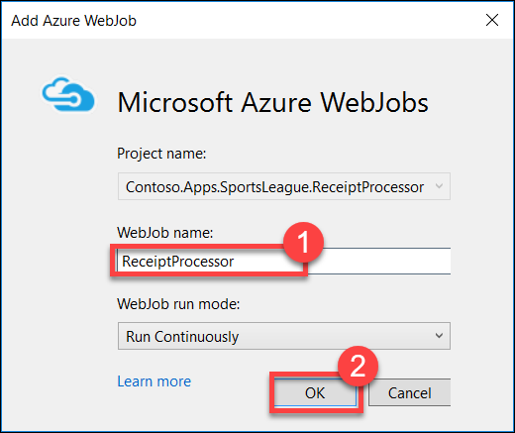
5. On the **Publish** dialog, select **Microsoft Azure App Service** as the Publish Target  
   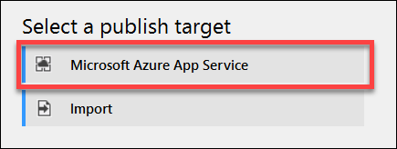
6. Expand the **contososports** resource group, then select the **Web App** that was just created, then click **OK**  
   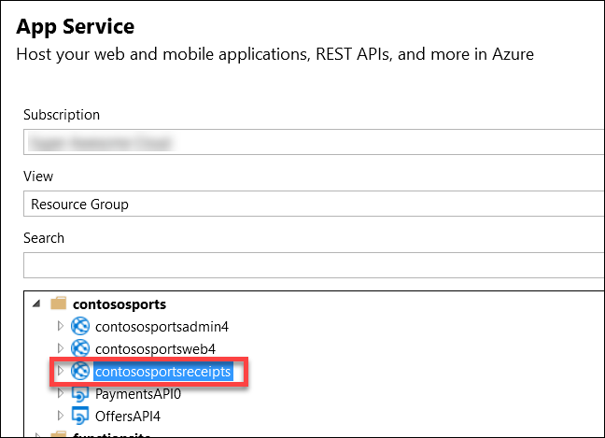
7. Click **Publish**
8. After the receipt generation service has been deployed, log in to the Call Center Admin site. Click **Details**.

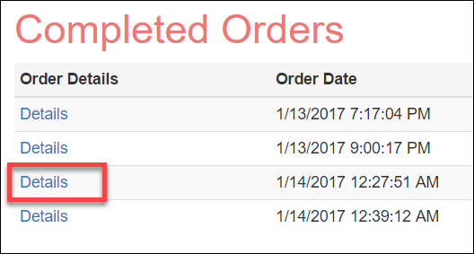

1. Verify that clicking on **Download receipt**, opens a *.pdf file of the receipt.

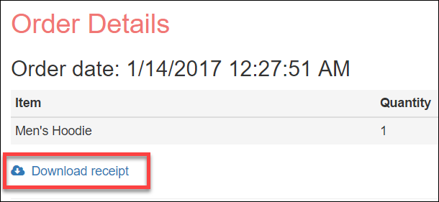

### Task 2: Order Notifications

#### Subtask 1: Configure your Twilio trial account

1. If you do not have a Twilio account, sign up for one for free at the following URL:   
   [**https://www.twilio.com/try-twilio**](https://www.twilio.com/try-twilio).



1. When you sign up for a free Twilio trial, you be asked to verify your personal phone number. This is an important security step that is mandatory for trying Twilio.  
   
2. Click **All Products & Services**.  
   
3. Click **Phone Numbers**.  
   
4. Click **Get Started**.  
   
5. Click the **Get your first Twilio phone number** button.  
   
6. Record the **Phone Number**, then click the **Choose this Number** button on the Your first Twilio Phone Number prompt, and then click **Done**  
   
7. Click **Home**, and then record the **Account SID** and **Auth Token** for use when configuring the Twilio Connector.  
   

#### Subtask 2: Create a new logic app

1. Open **SQL Server Management Studio** and Connect to the SQL Database for the **ContosoSportsDB** database.  
   
2. Under the **ContosoSportsDB** database, expand **Programmability**, right-click **Stored Procedures**, then click **New**, and **Stored Procedure…**  
   
3. Replace the Stored Procedure Template code with the following:

CREATE PROCEDURE [dbo].[GetUnprocessedOrders]

AS

declare @returnCode int

SELECT @returnCode = COUNT(*) FROM [dbo].[Orders] WHERE PaymentTransactionId is not null AND PaymentTransactionId <> '' AND Phone is not null AND Phone <> '' AND SMSOptIn = '1' AND SMSStatus is null

return @returnCode

GO

1. Click **Execute** in the toolbar or press the **F5** key.  
   
2. Delete the SQL script for the Stored Procedure from the code editor, and replace it with the following:

CREATE PROCEDURE [dbo].[ProcessOrders]

AS

SELECT * FROM [dbo].[Orders] WHERE PaymentTransactionId is not null AND PaymentTransactionId <> '' AND Phone is not null AND Phone <> '' AND SMSOptIn = '1' AND SMSStatus is null;

UPDATE [dbo].[Orders] SET SMSStatus = 'sent' WHERE PaymentTransactionId is not null AND PaymentTransactionId <> '' AND Phone is not null AND Phone <> '' AND SMSOptIn = '1' AND SMSStatus is null;

1. Click **Execute** in the toolbar or press the **F5** key.  
   
2. Open the Azure Management Portal (<http://portal.azure.com>), click **+New**, then **Web + Mobile,** and then **Logic App.**



1. On the **Create logic app** blade, assign a value for **Name**, and set the Resource Group to **contososports**.



1. Open the Logic App by clicking **More services > Logic Apps**, and click the Logic App just created.



1. Select the **Blank LogicApp** Template.  
   
2. On the **Logic Apps Designer**, click **Recurrence**.



1. Set the **FREQUENCY** to **MINUTE**, and **INTERVAL** to 1.



1. Click the **New Step**, and then click **Add an action**.



1. Type **SQL Server** into the filter box, and click the **SQL Server – Execute stored procedure** action.



1. The first time you add a SQL action you will be prompted for the connection information. Name the connection **ContosoDB**, and input the server and database details used earlier, and then click **Create**.   
   
2. Select the **[dbo].[GetUnprocessedOrders]** stored procedure from the drop-down menu on the **Procedure Name** field.



1. Click **New Step** and click the **Add a condition** link.



1. Specify **ReturnCode** for the OBJECT NAME, set the RELATIONSHIP to **is greater than**, and set the VALUE to **0**.



1. Click the **Add an action** link on the **If yes** condition.



1. Type **SQL Server** into the filter box, then click the **SQL Server – Execute stored procedure** action.



1. Select the **ProcessOrders** stored procedure in the **Procedure Name** drop-down menu.



1. Click the **Add an action** link.



1. Type **Twilio** in the filter box, then click the **Twilio – Send Text Message (SMS)** connector.



1. Set the **Connection Name** to **Twilio**, then specify your Twilio **Account SID** and **Authentication Token**, and then click the **Create** button.



1. Using the drop-down menu, select your Twilio number for the **FROM PHONE NUMBER** field. Specify a placeholder phone number in the **TO PHONE NUMBER**, and a **TEXT** message.  
   
2. On the **Logic Apps Designer** toolbar, click the **Code View** button.



1. Find the **Send_Text_Message_(SMS)** action, then modify the body property of the Twilio action:



1. Add the following code between Hello and the comma.

**@{item()['FirstName']}**



1. Modify the **to** property to pull the phone number from the item.

**@{item()['Phone']}**



1. Immediately before the **Send_Text_Message_(SMS)** create a new line and add the following code:

"forEach_email": {

"type": "Foreach",

"foreach": "@body('Execute_stored_procedure_2')['ResultSets']['Table1']",

"actions": {

1. Remove the **runAfter** block from the **Send_Text_Message_(SMS)** action.  
   
2. Locating the closing bracket of the **Send_Text_Message_(SMS)** action, then create a new line after it and add the following code:

},

"runAfter": {

"Execute_stored_procedure_2": [

"Succeeded"

]

}

}

1. After the code for the **Send_Text_Message_(SMS)** has been modified to be contained within the **forEach_email** action, it should look like the following:



1. Click **Save** on the toolbar to enable the logic app.



Your workflow should look like below, and you should receive a text for each order you have placed



## Exercise 6: SQL Data Warehouse

### Overview

Contoso wants to setup a SQL Data Warehouse in Microsoft Azure to enable data analytics capabilities.

### Help references

|  |  |
| --- | --- |
| Create an Azure SQL Data Warehouse | https://azure.microsoft.com/en-us/documentation/articles/sql-data-warehouse-get-started-provision/ |
| SQL Data Warehouse Migration Utility | https://azure.microsoft.com/en-us/documentation/articles/sql-data-warehouse-migrate-migration-utility/ |
| Introduction to Azure Data Factory Service | https://azure.microsoft.com/en-us/documentation/articles/data-factory-introduction/ |

### Task 1: Create SQL Data Warehouse

In this exercise, you will provision a SQL Data Warehouse using the Microsoft Azure Portal.

#### Subtask 1: Create SQL Data Warehouse

1. Navigate to the Azure Management Portal <http://portal.azure.com>, using a new tab or browser instance.
2. Click **+New**, select **Databases**, then **SQL Data Warehouse**.  
   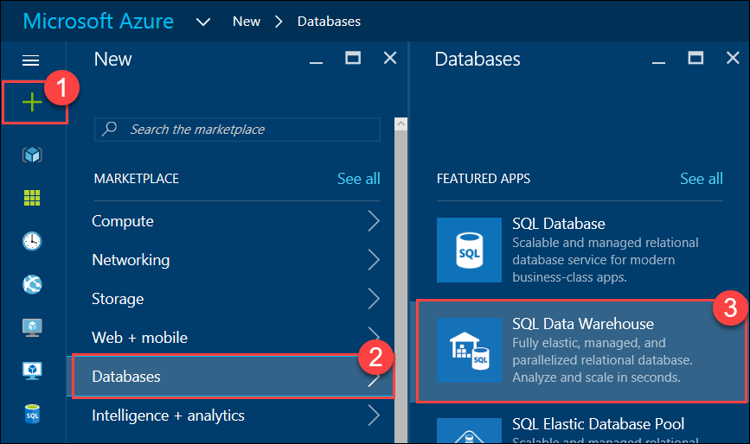
3. On the **SQL Data Warehouse** blade, specify the following configuration:
   1. Specify **ContosoSportsDWDB** as the Database name
   2. Specify the **contososports** Resource group.
   3. Specify **100 DWU** for the Performance  
        
      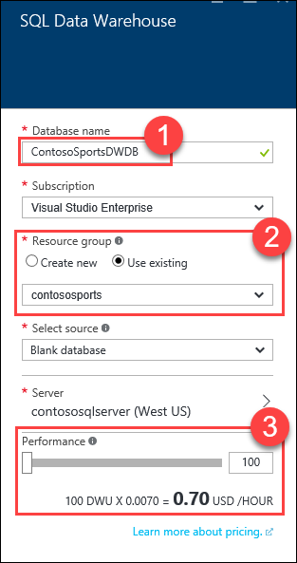
4. Click **Server**, then click **Create a new server**.  
   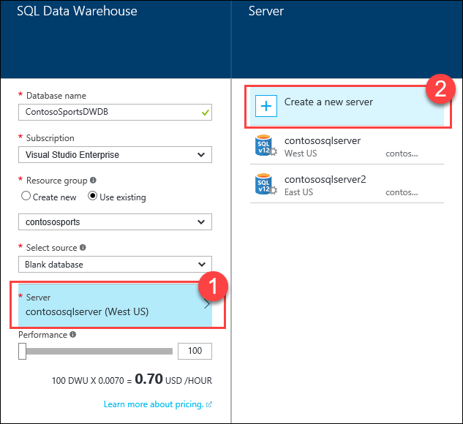
5. On the **New server** blade, specify the following configuration:
   1. Server name: a unique value (ensure the green checkmark appears)
   2. Server admin login: **demouser**
   3. **Password** and  **Confirm Password**: demo@pass123
   4. Ensure the **Location** is the same region as the SQL Database for the Web App  
        
      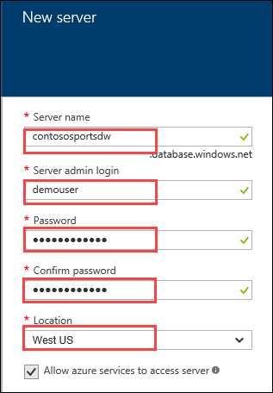
6. Click **Select**.
7. On the **SQL Data Warehouse** blade, click **Create**.
8. Click **More services**, and then **SQL data warehouses**.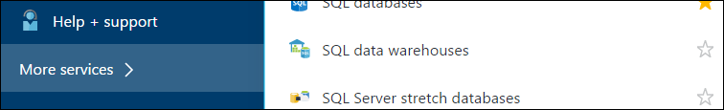
9. Click the SQL Data Warehouse that was just created, and click the **Server name** on the SQL Data Warehouse blade.  
   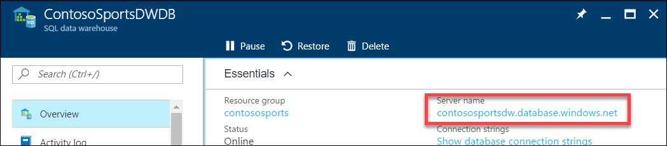
10. On the **SQL Server** blade, click **Show firewall settings**.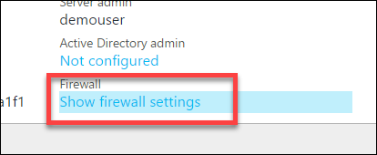
11. Click the **Add client IP** button.  
    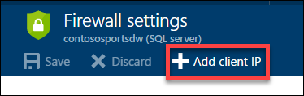
12. Click **Save.**  
    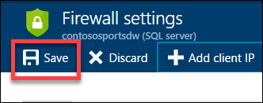

#### Subtask 2: Initialize SQL Data Warehouse database

1. Download and Install the Data Warehouse Migration Utility  
   <https://www.microsoft.com/en-us/download/details.aspx?id=49100>
2. Run the Data Warehouse Migration Utility (DataSourceMigrationEngine.exe)

The utility is installed into the following folder:  
*C:\Program Files (x86)\Data Warehouse Migration Utility*

Also, an Icon to run the utility will be placed on the Desktop.  
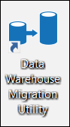

1. In the Migration Utility specify the **Azure SQL Database** Source Type, and click **Next**.  
     
   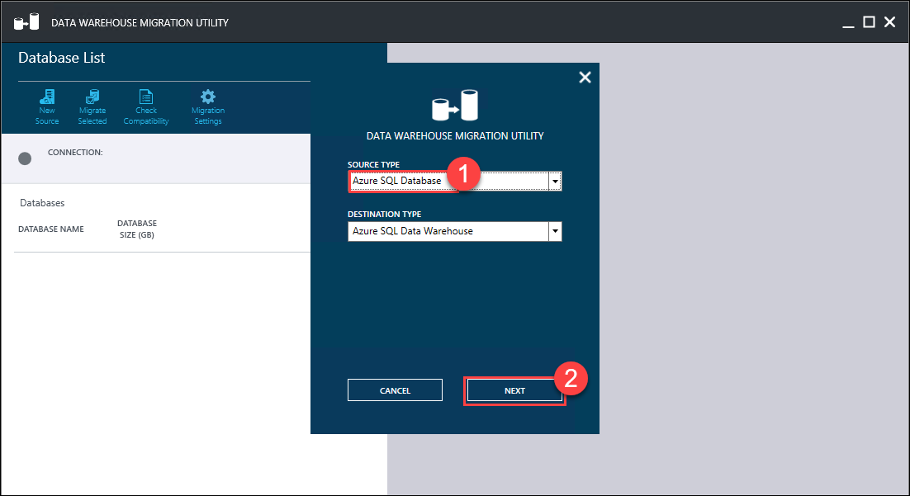
2. In the **Migration Source** step, specify the following configuration:
   1. Specify the **Server name** of the Azure SQL database server; this needs to be the full server DNS name: *{server name}.database.windows.net*
   2. Specify the **User Name** to login to the server: demouser
   3. Specify the **Password** to login to the server: demo@pass123  
        
      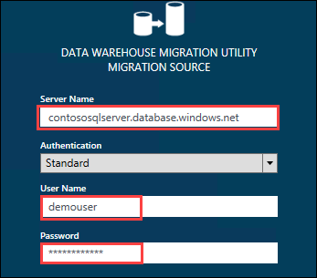
3. Click **CONNECT**
4. Select the database, then click the **Migrate Selected** button  
   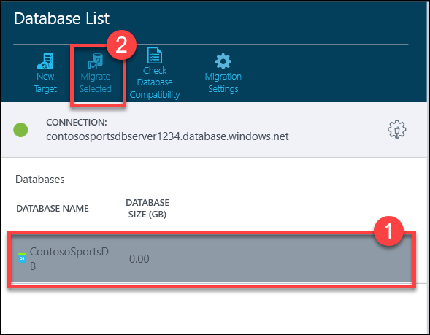
5. In the **Migrate Database** pane, select the **dbo.Orders** and **dbo.OrderDetails** tables.  
   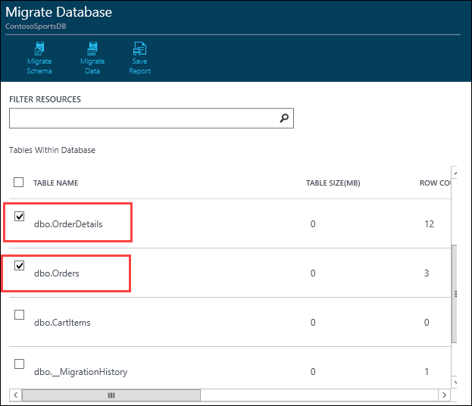
6. Click the **Migrate Schema** button  
   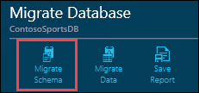
7. On the **Migrate** Schema pane, click the **Run Script** button  
   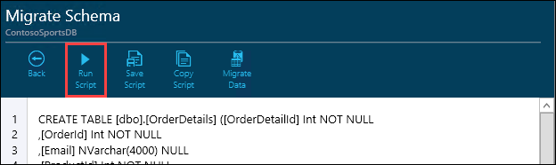
8. In the **Migration Destination** dialog, specify the following configuration:
   1. Specify the **Server name** of the Azure SQL Data Warehouse server; this needs to be the full server DNS name: {server name}.database.windows.net
   2. Specify the **User Name** to login to the server: demouser
   3. Specify the **Password** to login to the server: demo@pass123  
        
      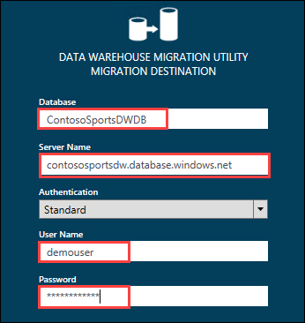
9. Click **OK**
10. Click **OK** on the **Script Applied Successfully** prompt  
    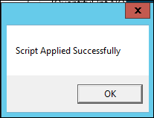
11. Click the **Migrate Data** button  
    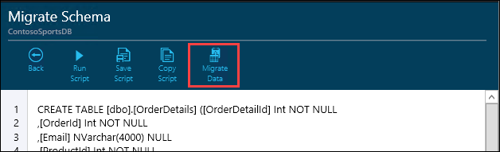
12. Click the **Run Migration** button  
    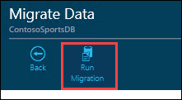
13. On the **Data Warehouse Migration Utility** dialog, Change the **Package Path** to a folder within **C:\hackathon**, click **Next**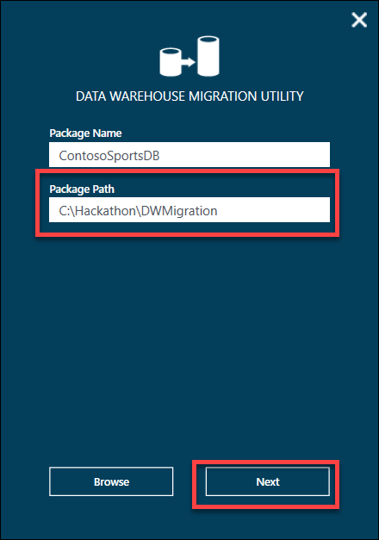
14. Click the **Generate** button  
    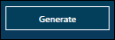
15. Click **OK** on the **Package(s) Generated Successfully** prompt  
    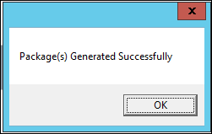

This will generate two .bat scripts for exporting the data and then importing it into the SQL Data Warehouse using BCP.

1. Open a **Command Prompt** window and change location to the **Package Path** folder that was uses where the packages were generated.  
   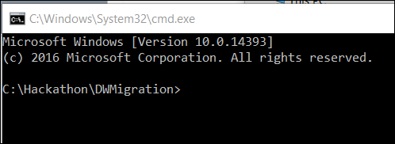
2. Run the **ContosoSportsDB_Export.bat** script  
   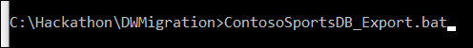
3. Run the **ContosoSportsDB_Import.bat** script  
   

### Task 2: Configure Azure Data Factory

In this exercise, you will provision an Azure Data Factory using the Microsoft Azure Portal. You will then configure a Pipeline to archive data from the applications SQL Database into the SQL Data Warehouse you created previously.

#### Subtask 1: Create Azure Data Factory

1. Navigate to the Azure Management Portal <http://portal.azure.com>, using a new tab or browser instance
2. Click **+New**, select the **Intelligence + analytics**, then **Data Factory**  
   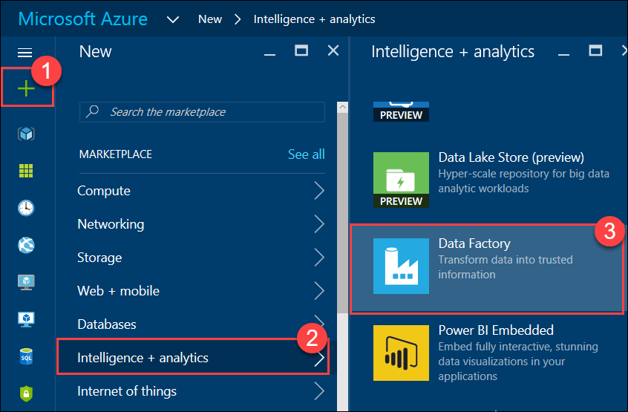
3. On the **New data factory** blade, specify the following configuration:
   1. Specify **ContosoSportsDataFactory** as the Name
   2. Specify the **contososports** Resource group
   3. Ensure the **Location** is the same region as the SQL Data Warehouse  
        
      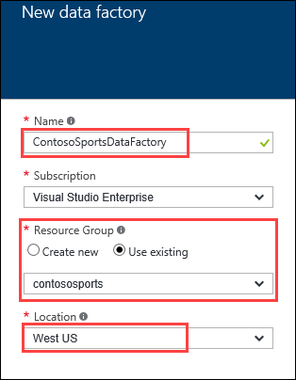

Currently, Data Factory is only available in a few regions. If it is not available in your desired Azure Region, then choose the region closest to the region SQL Data Warehouse is located instead.

1. Click **Create**

#### Subtask 2: Configure Pipeline

1. Navigate to the Azure Management Portal <http://portal.azure.com>, using a new tab or browser instance
2. Click **More services**, **Data factories**, and then click the name of the Data Factory you created previously
3. On the **Data factory** blade, click **Copy data**.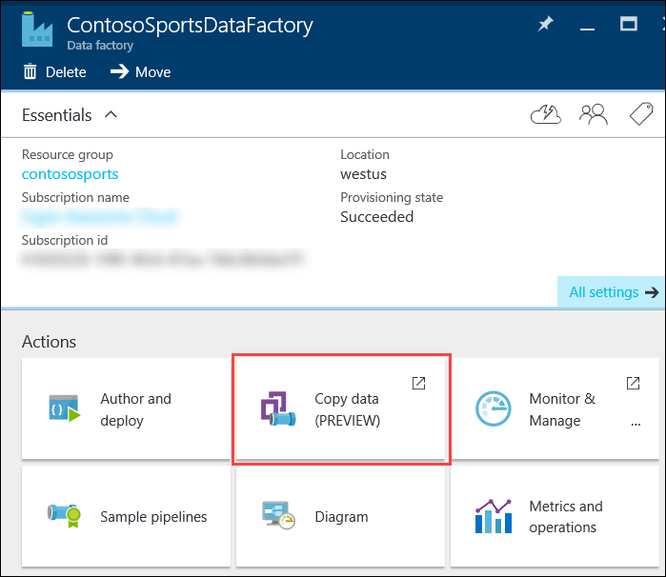

Clicking on Copy data will open up the Data Factory tool in a new browser tab.

1. Update the **Recurring pattern** to run every 15 minutes, and click **Next**  
   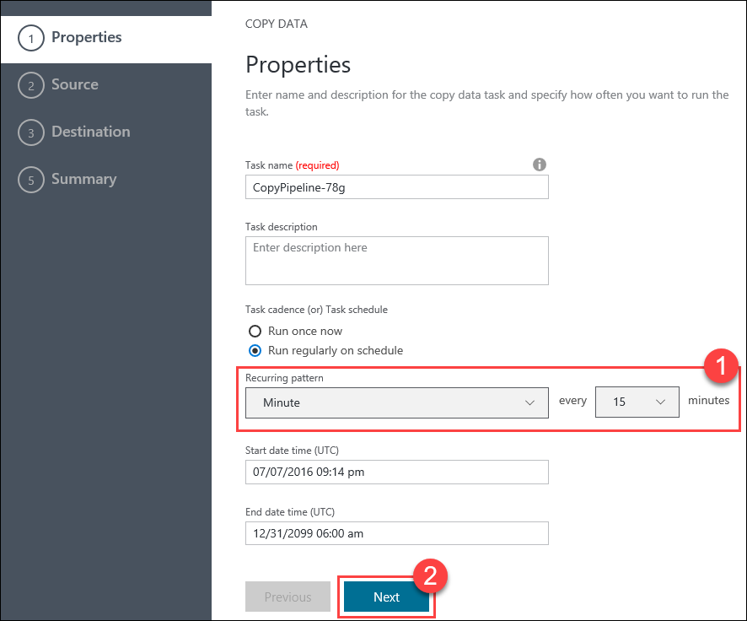
2. Select the **Azure SQL Database** data source, and click **Next**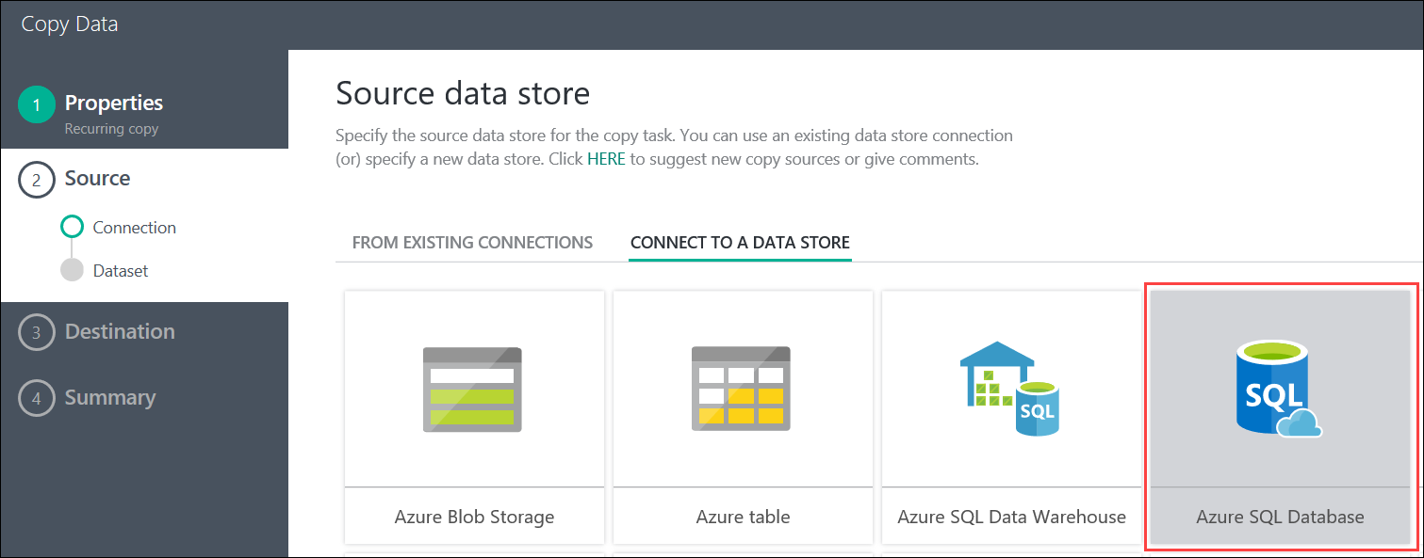
3. On the **Specify the Azure SQL database** step, specify the following configuration:
   1. Specify the **SQL Database Server** that contains the SQL database for the Web App
   2. Specify the **ContosoSportsDB** database
   3. Specify the User name for the database server: demouser
   4. Specify the Password for the database server: demo@pass123

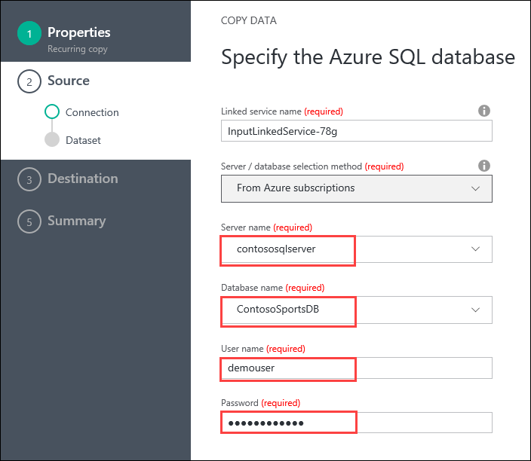

1. Click **Next**



1. Select the **Orders** and **OrderDetails** tables in the list of Existing Table, then click **Next**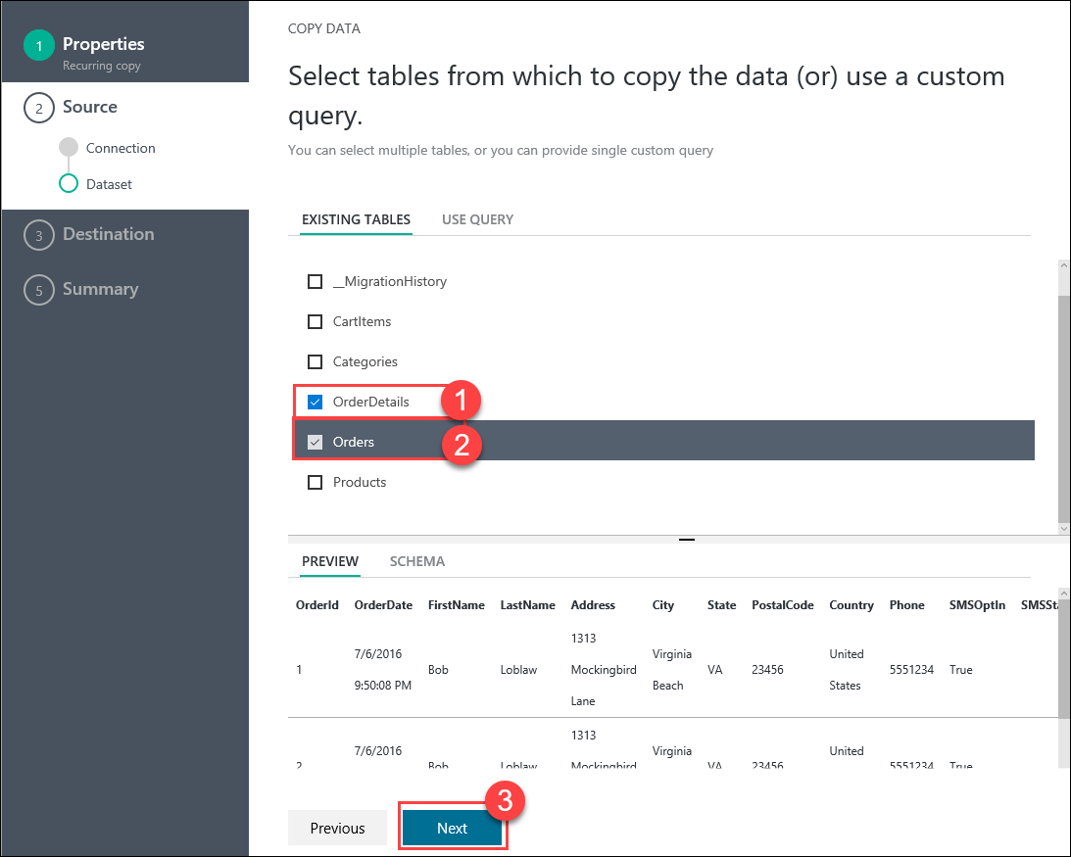
2. On the **Apply filter** step, set the **Orders** filter to **None**, andclick **Next**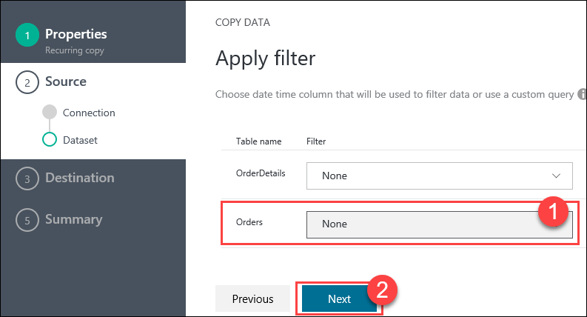
3. On the **Destination data store** step, select **Azure SQL Data Warehouse**, then click **Next**  
   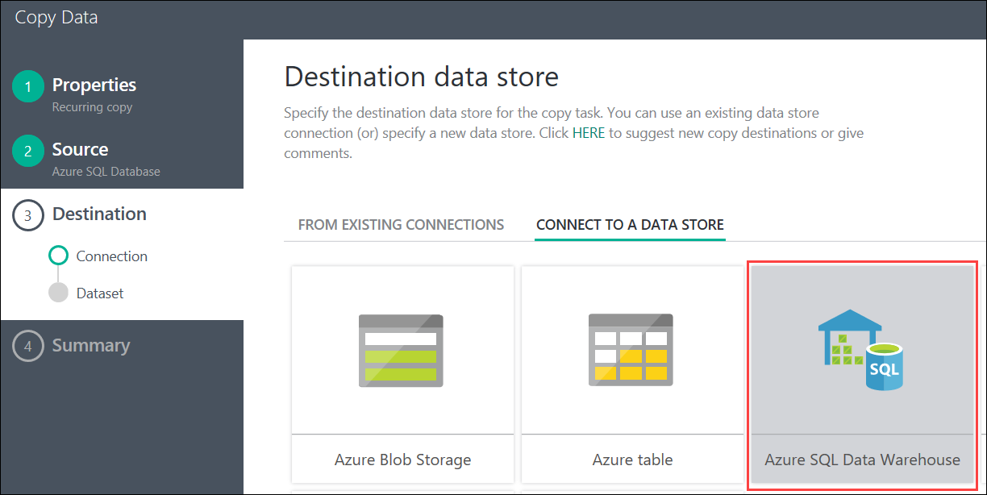
4. Specify the following configuration for the Azure SQL Data Warehouse:
   1. Specify the **Server name** for the SQL Data Warehouse
   2. Specify the **ContosoSportsDWDB** database
   3. Specify the User name for the Data Warehouse server: demouser
   4. Specify the Password for the Data Warehouse server: demo@pass123  
      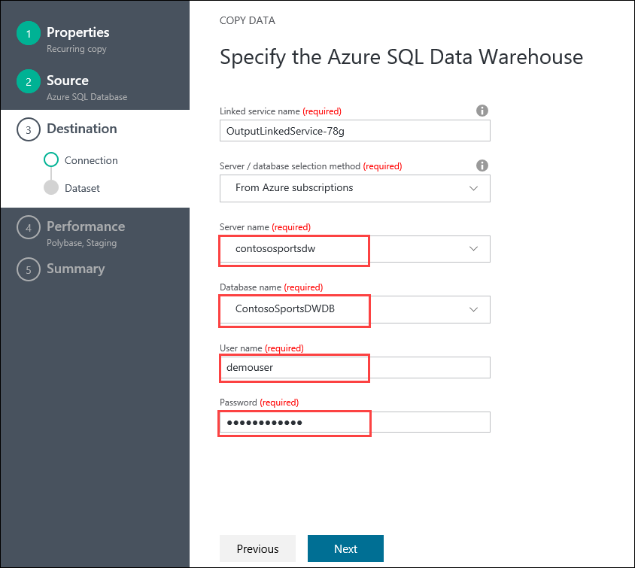
5. Click **Next**
6. On the **Destination Table Mapping** step, specify the following configuration:
   1. Specify the source OrderDetails to map to the **OrderDetails** destination table
   2. Specify the source Orders to map to the **Orders** destination table  
        
      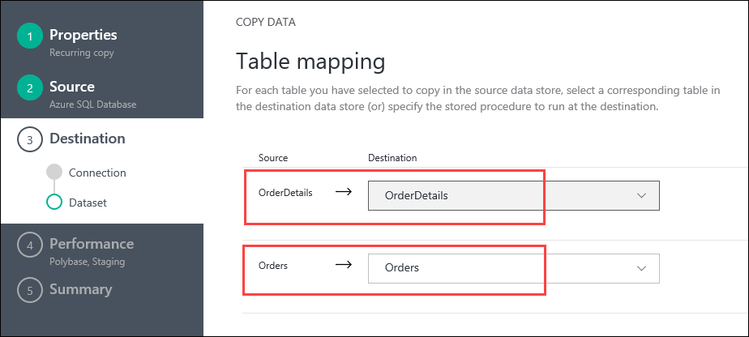
7. Click **Next**
8. On the **Destination Schema mapping** step, select the **OrderDetails** mappings and enter the following configuration:
   1. Set the Method to **Custom script**
   2. Set the Custom script to the following:

delete from OrderDetails

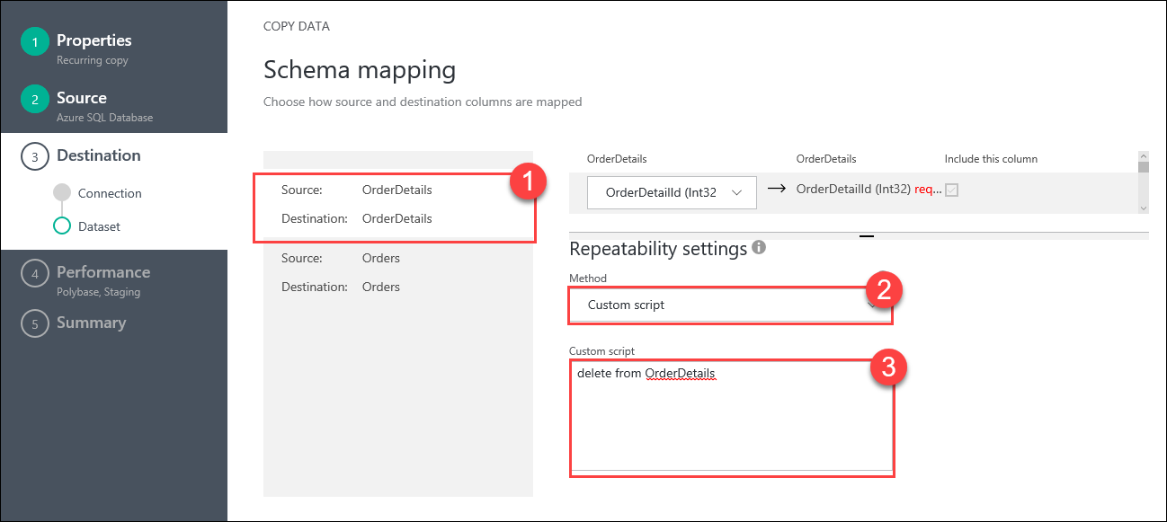

1. Select the **Orders** mappings and enter the following configuration:
   1. Set the Method to **Custom script**
   2. Set the Custom script to the following:

delete from Orders

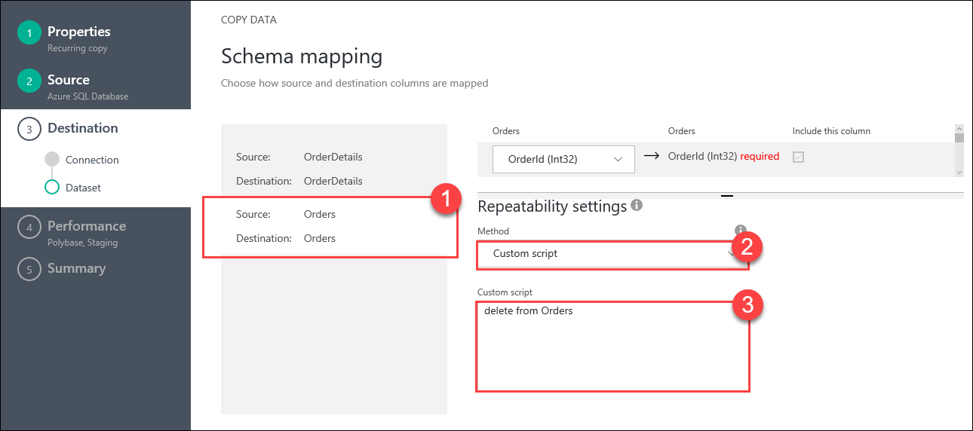

Note: These two DELETE custom scripts will ensure all previous row are deleted from the tables in the SQL Data Warehouse before data is copied over from the SQL Database each time the Pipeline runs.

1. Click **Next**
2. On the **Performance settings** step, expand **Advanced settings**, then **uncheck** the **Allow polybase** check box  
   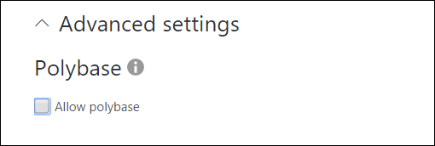

Note: The check box must be unchecked. With the current database schema in the web app, if Polybase is allowed then the Pipeline will error that the length of row exceeds maximum allowed for the Orders table data migration.

1. Set the **User staging account** to **New connection**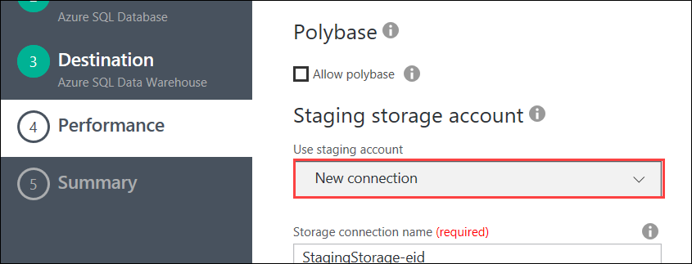
2. For **Staging storage account**, set the **Storage account name** to the Azure Storage Account that was previously created for Web App  
   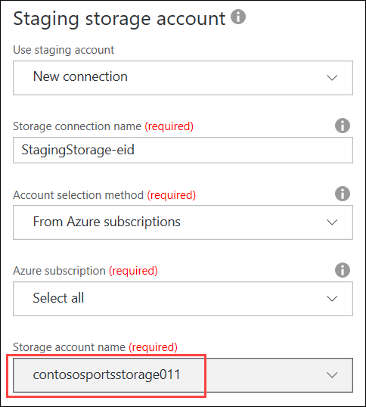
3. Click **Next**  
   
4. On the **Summary** step, click **Finish**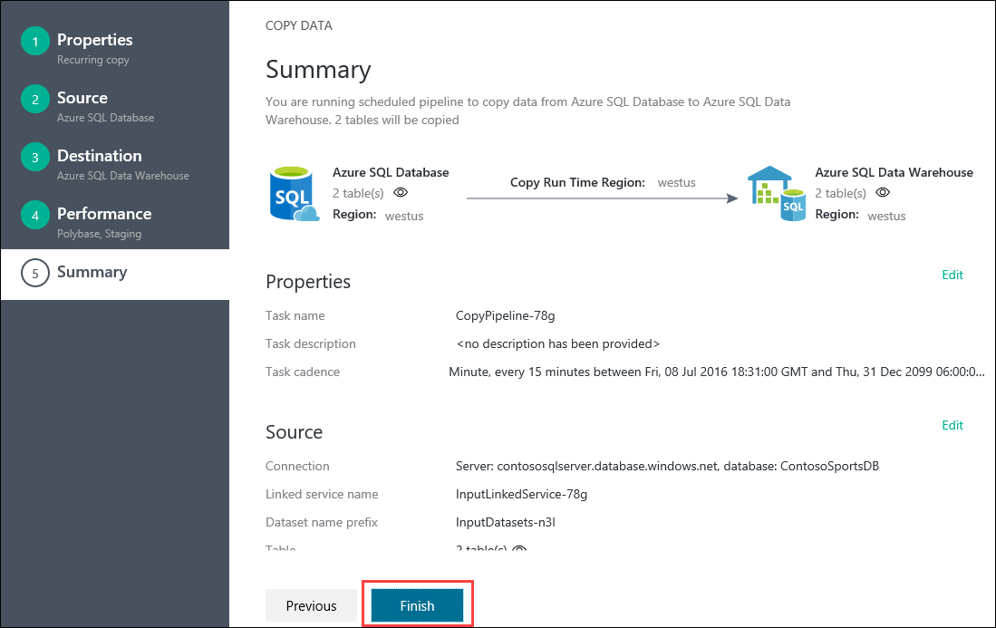
5. Once deployment is complete the deployment steps will show all green checkmarks